SPRING TERM – OPENING MINDS – YEAR 7

Topic: India

Credo Reference to India – From Lancashire Digital Library Online
Lots of facts and images
https://search.credoreference.com/search/image?searchPhrase=India
https://search.credoreference.com/content/entry/philipency/india/0

India: A People Partitioned
https://www.bbc.co.uk/programmes/p034m6hb

Mumbai - Credo Reference to India – From Lancashire Digital Library Online
Lots of facts and images
https://search.credoreference.com/search/all?concept=Mumbai
India

BBC – Education

https://www.bbc.co.uk/teach/class-clips-video/geography-ks3-exploration-india/zjpdcqt

https://www.bbc.co.uk/teach/class-clips-video/geography-ks3-india-tomorrow/zbs2t39

https://www.bbc.co.uk/teach/class-clips-video/geography-ks3-rural-life-in-india/z4bhf4j

https://www.bbc.co.uk/teach/class-clips-video/geography-ks3-the-scale-of-india/zvs2t39

https://www.bbc.co.uk/teach/class-clips-video/geography-ks3-the-ganges-in-india/zmjrkmn

https://www.bbc.co.uk/teach/class-clips-video/geography-ks3-the-impact-of-urbanisation-on-bangalore-india/zj9ygwx

https://www.bbc.co.uk/teach/class-clips-video/geography-ks3-working-life-in-bangalore-india/znx8qp3

https://www.bbc.co.uk/teach/class-clips-video/history-ks2-ks3-jobs-in-900AD-baghdad/zf4hf4j

https://www.bbc.co.uk/teach/class-clips-video/history-ks2-ks3-great-fashion-in-baghdad-900ad/z7nd7nb

https://www.bbc.co.uk/teach/class-clips-video/history-ks2-ks3-how-houses-looked-in-baghdad-900ad/zrjvrj6

https://www.bbc.co.uk/teach/class-clips-video/history-ks2-ks3-invention-and-innovation-in-baghdad-900ad/zmnfjhv

https://www.bbc.co.uk/teach/class-clips-video/history-ks2-ks3-what-food-did-they-eat-in-baghdad-900ad/zdxc8xs

Websites

BBC News India

https://www.bbc.co.uk/news/world/asia/india

BBC - India Profile

https://www.bbc.co.uk/news/world-south-asia-12641776

YouTube

History of India
https://www.bing.com/videos/search?q=indian+rulers&docid=607993787870676452&mid=7AA6A4BA36DB074C00D07AA6A4BA36DB074C00D0&view=detail&FORM=VIRE&adlt=strict

British Library
Historical background to the relationship between India and Britain
https://www.bl.uk/asians-in-britain/about

Trace the long history of Asians in Britain
https://www.bl.uk/asians-in-britain

Ducksters education website – Timeline of History of India
https://www.ducksters.com/geography/country/india_history_timeline.php

School Library Books

Title | Author | Description | Image | Classification
India and Mumbai | Vaughan, Jenny | A high-end geography series that explores some of the fastest-developing countries and cities in the world and assesses how they are dealing with the challenges of the 21st century. Topics looked at include: population structure, the economy, environmental sustainability and the outlook for the future | 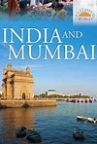 | 915
Ganges, The | Manning, Paul | River Adventures takes intrepid young explorers on fascinating journeys of discovery along some of the world`s major rivers, from source to mouth. Along the way, readers find out about geography, settlement and trade, history, buildings and culture | 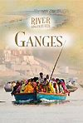 | 915.41
Mumbai | Green, Jen | By 2007, the world will pass from being a mainly rural to a mainly urban population. Large cities, including mega cities with more than 10 million people, present key challenges relating to sustainable development and citizenship. | 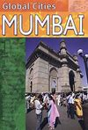 | 915.4
india | Bojang, Ali Brownlie | India is a comprehensive study of the population, landscape, economy, politics, transport, health, culture, religion, tourism, environment and history | 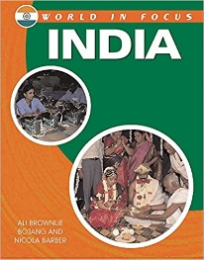 | 915.4
Living in India | Thomson, Ruth | Focuses on people's everyday lives in India. This work contains specially commissioned photographs | 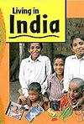 | 915.4
India | Brownlie Bojang, Ali | History, geography, wildlife, infrastructure, culture, and peoples | 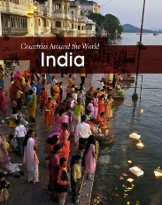 | 915.4
India | Atkinson, Tim. | Packed with photographs, maps and graphs, the 'Discover Countries' series tells you all you need to know about the countries of the world, from landscape and climate to facts on population, industry, wildlife and the environment. | 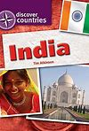 | 915.4
Indian Culture | Ganeri, Anita | "This work covers a vast array of subjects on Indian culture - from fine arts to ceremonies, and from legends to the culture's global influence." | 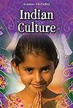 | 306.0954
7481Illustrated Family Encyclopedia u-z | Various | Volume 8  H-K  Look under ‘I’ for India | 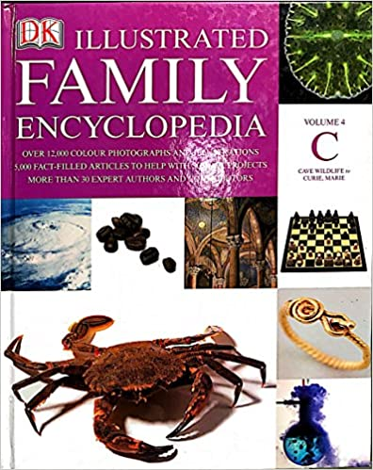 | 306.0954
The British World Book Encyclopaedia - Ci-Cz |  | Volume 10  ‘I’ |  | 030

