Online Safety Newsletter

September 2022

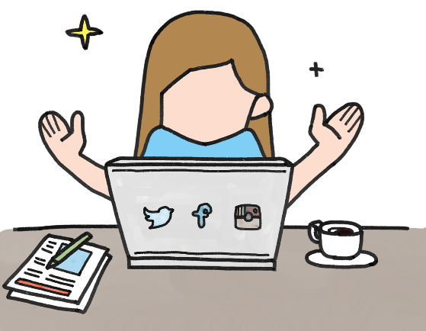
Instagram

Instagram is used to post photos and videos. Users can also DM (direct message), send disappearing messages, add to their stories (these disappear after 24 hours) and broadcast live. You should be over 13 years of age to set up an account. To create an account, you must enter a date of birth (but this is not verified).

Account Privacy
When you set up your account, it is automatically set as public. This means that anybody can see what you share. We would recommend changing this to private so only those your child approves to follow them can see their content. To change a profile to private go to profile, tap Settings, tap Privacy, then under Account Privacy, tap to toggle Private Account on.

IMPORTANT: Even if your child has set their Instagram profile to private, your child’s bio (at the top of their profile) can still be seen by everyone. Check they have not included any personal information in their photo and bio info (e.g., they should not be wearing their school uniform in their photo).

Other additional privacy settings include:
- Story control – you can choose to allow message replies from ‘your followers’, ‘followers you follow back’ or turn off.
- Sharing – you can choose whether follows can share your photos and videos from your story in a message.
- Hidden words – turn this option on to hide comments that may be offensive in a separate section.
- Activity status – if switched on, other accounts you follow and anyone you message can see when you were last active or if you are currently on.

Make sure your child understands that there is a risk that content they upload can never be removed (other users can screenshot it for example) so they must only share content that they are comfortable with others seeing.

New Supervision features
You can now supervise your child’s Instagram accounts. This gives you the ability to see who they follow and who follows them, see how much time they are spending on Instagram, set daily time limits and schedule breaks. Your child can also easily share when they have made any reports to Instagram with you. Learn more here: https://familycenter.instagram.com/our-products/family-center/

Safety Features
Ensure your child knows how to report posts and people as well as how to unfollow and block people, delete and turn off comments. View here: https://help.instagram.com/269765046710559/?helpref=hc_fnav

More information
Visit the family centre to learn more about the features available: https://familycenter.instagram.com/
Users of this guide do so at their own discretion. No liability is entered into. Current as of the date released 1.09.22.

What is Skin Gambling?

A skin is something that gamers either purchase or win and can use them to change the appearance of their character, for example a new outfit. They do not usually enhance the character’s ability. Skins can range in price, depending on their popularity or how rare they are. Skin gambling occurs when gamers use their skins to bet on online games. Read this article to find out more:
https://saferinternet.org.uk/blog/what-is-skin-gambling-in-gaming

Discord
Discord is a social networking app used by gamers to chat to each other. There can be in app purchases through Discord’s premium subscription service. The minimum age to access Discord is 13. The Apple App store rates it as 17+. Discord is made up of servers, which are spaces for groups to chat, upload files and share images etc. Anybody can set up a server and they can either be public or private. Users can video call and send direct messages to other individuals or groups.

Children who play online games such as Fortnite may use Discord to chat about the game (rather than the game’s own chat facility).
How can I make it safer?
Omegle

You must be 18+ to use or 13+ with parental permission. Omegle is a social networking/chat website that connects two strangers together for either a text or a video chat. Chats are anonymous unless a user provides this information. Omegle states that “Omegle video chat is moderated. However, moderation is not perfect. You may still encounter people who misbehave.”

What should I be aware of?
- No registration is required to access Omegle (therefore no age verification) and there are no reporting facilities.
- Users are given an option to save the chat's log and share the link. It is also possible for other users to take screenshots of text and video chats.

We recommend that Omegle is not used by children due to the potential imagery shared and language used which can be explicit.

You can find out more information from Internet Matters, including ways of keeping your child safe:

https://www.internetmatters.org/hub/news-blogs/what-is-omegle-what-parents-need-to-know/

Discord have created this article, which outlines four steps to creating a safer account, including how to block users.

- https://discord.com/safety/360043857751-Four-steps-to-a-super-safe-account

What do I need to be aware of?
We always encourage you to chat to your child to see why they use different apps/websites and ensure that they know how to block users and what to do if they see any inappropriate content. It is important to be aware that Discord does include video/voice calling which cannot be filtered. Discord is used by an array of users and therefore adult content can be found on Discord as well as inappropriate language. Discord have produced this article, which answers common questions:
- https://discord.com/safety/360044149591-Answering-parents'-and-educators'-top-questions

Further information
- https://www.childnet.com/blog/what-is-discord-a-guide-for-parents-and-carers
What is your child doing online?

??

Is your child playing or watching others play games online? Your child could be using Twitch, Steam, Roblox, YouTube etc to access games or watch others play. We need to make sure that what they are viewing is appropriate for them. It is important to talk to your child to see what they are interested in so you can have a look first to see if they are appropriate. For example, there are games that may appear to be appropriate but are actually horror/survival games and characters can turn more sinister as the game progresses. It is important to remember that children may be playing the game, watching videos of it on sites such as YouTube or playing replicated versions on Roblox for example.

More information
https://www.nspcc.org.uk/keeping-children-safe/online-safety/online-games/

