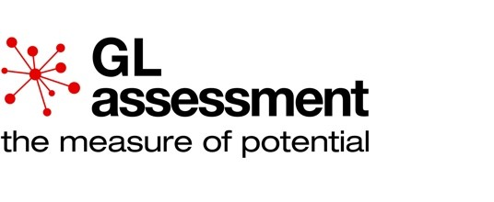
GL Assessment is part of the GL Education Group.
P.A.S.S. Survey © W3 Insights Ltd, 2002-2013. All rights reserved.
Survey report
In case of enquiries please contact GL Assessment by emailing info@gl-assessment.co.uk.
School:
Walton-le-Dale High School
Survey date :
14/12/2020
Level :
PASS 3
28/01/2021
Report generated on
PASS Survey report

School: Walton-le-Dale High School
Group: Unknown
Survey date: 14/12/2020 | Level: PASS 3 | No. of students: 107
What is PASS?
The success of young people’s educational experience is heavily determined by the attitudes that they bring to their learning, their sense of aspiration and the feelings they have about their place in the broader social context of the school. The PASS diagnostic is a powerful, multi-factorial measure of students attitudes to school, learning and success. Its robust nature enables the data it yields to be used as a means of establishing baselines and to support effective planning, implementation and evaluation of interventions at individual, group and whole school levels.
The data can be combined with other student data e.g. GL Assessment’s Cognitive Abilities Test, progress measures or National Curriculum assessments. This gives staff in school, in collaboration with the young people, greater opportunity to make informed decisions about their future learning and to help them towards further success.
Why use PASS?
The benefits of PASS are extensive. In particular, it helps schools and professionals to:
- Establish their students’ perceptions of their school and learning experience;
- Help teaching staff, support staff and senior leaders to challenge their own assumptions about the school and its students;
- Respond to improvement needs as identified by the students;
- Inform teaching and learning strategies and intervention programmes to help raise standards of attainment and student well-being;
- Address challenging behaviour – a key requirement of the new inspection framework;
- Address attendance issues through the identification of underlying factors as well identifying those most risk at of becoming alienated;
- Support emotionally vulnerable young people and those with possible mental health issues, to ensure those most at risk do not slip through the net;
- Provide an objective means for joint collaborative problem-solving, working with parents, carers and extended families, external agencies and other professionals supporting young people.
In addition:
- PASS can provide information for the school’s self-evaluation, as a consultation with its students;
- PASS can provide evidence of students’ perceptions of the school and their learning experience for your Ofsted Inspection as well as demonstrating the involvement of your students in the decisions affecting their education and the development of the school.
- PASS can provide evidence for the need for specific school developments, projects or major changes in the school, e.g. moving to a new building.
The PASS factors are:
Factor 1 – Feelings about school | Measuring students’ sense of well-being, safety and comfort in school.
Factor 2 – Perceived learning capability | Measures students’ views of how positive and successful they feel in their specific capabilities as learners.
Factor 3 – Self-regard as a learner | Measures the impact of their learning on their concept of self more generally.
Factor 4 – Preparedness for learning | Measures students’ perceptions of their behaviour and attitude in learning situations (including metacognitive skills).
Factor 5 – Attitudes to teachers | Measures students’ perceptions of their relationships with teachers.
Factor 6 – General work ethic | Measures students’ attitudes and responses to work in general.
 | Measures students’ confidence in approaching and
Factor 7 – Confidence in learning | dealing with learning and perseverance when presented with challenging tasks, and includes associated feelings such as a ‘high’ anxiety element.
Factor 8 – Attitudes to attendance | Measures students’ attitudes to attendance at school.
Factor 9 – Response to curriculum demands | Measures students’ perceptions of the appropriateness of the level of difficulty of work they are asked to complete.

Understanding the PASS report
In the report you will find three levels of analysis. Note that analysis of custom groups depends on the information submitted to the PASS survey register on Testwise. You can add this information and re-run the report at any time.
Level 1 Analysis
- Whole cohort analysis
Level 2 Analysis
- Analysis by gender
- Analysis by year group
- Analysis by ethnic group, FSM status, SEN status, EAL status and custom groups.
- Analysis by year group and gender
- Analysis by ethnic group and gender
Level 3 Analysis
- Individual profiles
- Item level analysis
For each group (Level 1 and 2 analysis), two types of information are presented:
Non-standardised, or percentage, scores look at the school on its own. They are the results of the survey from the school alone and do not include any comparisons with other schools. They are particularly useful for the senior leadership team within the school to obtain an overall view of how the students feel about the school as a whole, what they are satisfied with, and where they feel there is room for improvement. Percentage scores are shown in the bar charts.
The non-standardised score is particularly useful when comparing two consecutive surveys to measure changes across time.
When looking at the scores together, it is important to note that the distribution of national scores is not even, and there may be a significantly high number of schools with high levels of satisfaction. Therefore, it is often found that small increases in the non-standardised percentage scores can lead to large increases in percentile scores especially where a school crosses a percentile rank threshold between two surveys. Individual profiles and item level analysis show percentiles only.
In looking at the results of the PASS survey it is important that you:
- identify what supports your perceptions about your students’ attitudes to school and their learning experience;
- identify what does not support your perceptions about your students’ attitudes to school and their learning experience;
- use your professional judgement to address what doesn’t match your assumptions.
- continue to involve your students in any work developed from the PASS survey, e.g. through assemblies, school councils, focus groups, individual discussions, etc.
To help you make best use of the information, we have provided for your use along with this report the PASS Survey Report Workbook available on the GL Assessment website:
http://www.gl-assessment.co.uk/passworkbook
The figures in the table below each chart show the school’s standardised scores. The numbers represent the percentile rank for each factor based on the percentage score shown in the chart. These percentiles are benchmarked against national norms providing a standardised indication of attitudes in the school. In the example shown, a score of 61% for Factor 1 puts the cohort in the 21.4th percentile, meaning that they are equally as or more positive than 21.4% of the population on that measure but less positive than 78.6%. PASS is standardised by key stage, so your percentile scores are separated accordingly.

Example analysis
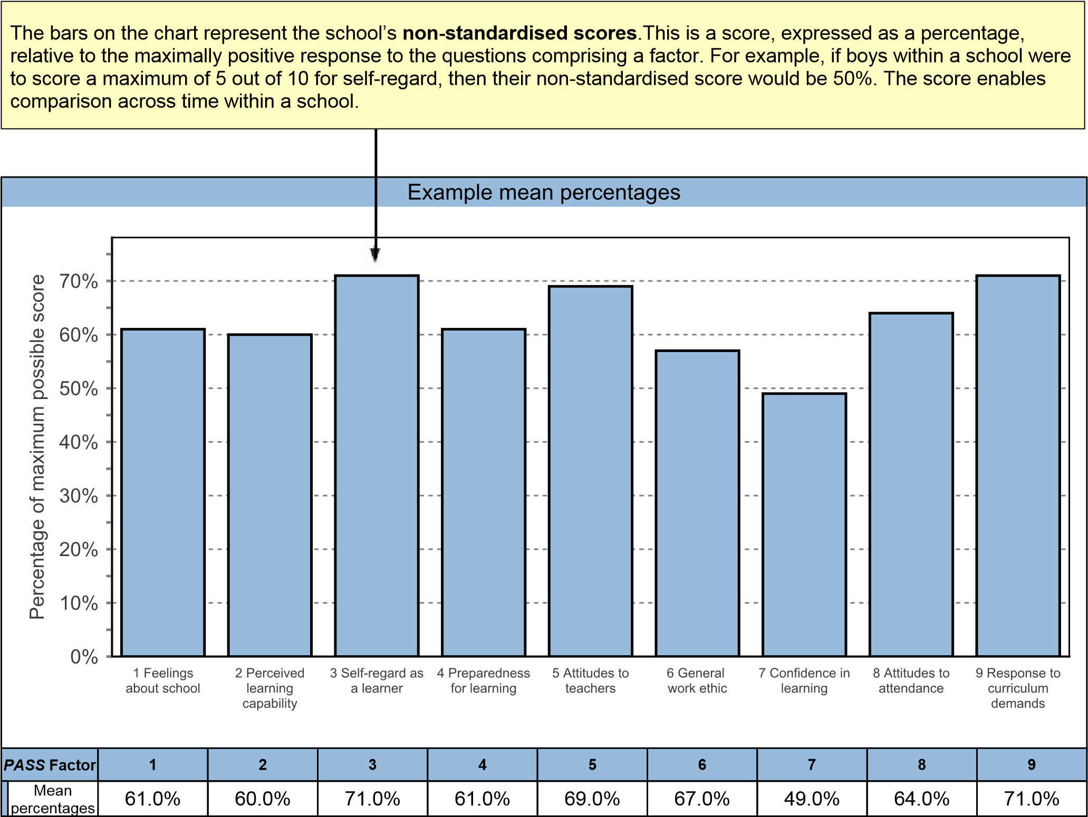
 |  |  | Example percentiles
PASS Factor | 1 | 2 | 3 | 4 | 5 | 6 | 7 | 8 | 9
 | Feelings about school | Perceived learning capability | Self-regard as a learner | Preparedness for learning | Attitudes to teachers | General work ethic | Confidence in learning | Attitudes to attendance | Response to curriculum demands
Percentile score | 21.4 | 7.5 | 73.4 | 4.9 | 16.9 | 19.8 | 16.1 | 33.5 | 62.3

Interpreting percentile scores
The colour coding used in the report should be interpreted as a guide to help schools see at a glance the level of satisfaction that cohorts or individuals have with their school experience. Those found to be in the lowest 5% compared to the UK population should be taken as an immediate concern for the school. The average range of responses lies between the 16th and 84th percentile. Your PASS survey report interprets factor and item responses based on the following percentile values:
High satisfaction with their school experience | Students/Cohorts in the 31st – 100th percentile
Moderate satisfaction with their school experience | Students/Cohorts in the 21st – 30th percentile
Low moderate satisfaction with their school experience | Students/Cohorts in the 6th – 20th percentile
Low satisfaction with their school experience | Students/Cohorts in the lowest 5% of responses
Attention should be paid to the exact percentiles shown in the standardised score tables:
- Some factor responses shown in green may show a significantly high level of satisfaction and act as evidence of the success of the school’s existing programmes;
- Other factor responses categorised as moderate satisfaction may have figures close to those categorised as high satisfaction but that, in combination with other factor responses, may be of either concern or encouragement to the school depending on the context.
A PASS survey report provides a picture of the school from the student’s perspective and may challenge the assumptions held by the school’s teachers, senior leaders and other staff. Successful use of PASS data requires an analysis across factors and regular comparison of the data with the particular context of the school.

School: Walton-le-Dale High School
Group: Unknown
Survey date: 14/12/2020 | Level: PASS 3 | No. of students: 107

School respondent analysis

 |  | Category |  |  | Frequency | Percentage
Gender |  | Boys |  |  | 56 | 52.3%
 |  | Girls |  |  | 51 | 47.7%
Year |  | Year 11 |  |  | 107 | 100.0%
Ethnic group |  | White - British |  |  | 97 | 90.7%
 |  | Any other ethnic group |  |  | 3 | 2.8%
 |  | Black Caribbean |  |  | 2 | 1.9%
 |  | Any other Asian background |  |  | 1 | 0.9%
 |  | Any other White background |  |  | 1 | 0.9%
 |  | Any other mixed background |  |  | 1 | 0.9%
 |  | Indian |  |  | 1 | 0.9%
 |  | White and Asian |  |  | 1 | 0.9%
Free school meals |  | No |  |  | 93 | 86.9%
 |  | Yes |  |  | 14 | 13.1%
Special education |  | Not known |  |  | 71 | 66.4%
 |  | No Special Educational Need |  |  | 26 | 24.3%
 |  | SEN Support |  |  | 10 | 9.3%
EAL |  | Not known |  |  | 106 | 99.1%
 |  | No |  |  | 1 | 0.9%
Year and gender |  | Year 11 Boys |  |  | 56 | 52.3%
 |  | Year 11 Girls |  |  | 51 | 47.7%
Ethnic group and gender |  | White - British Boys |  |  | 53 | 49.5%
 |  | White - British Girls |  |  | 44 | 41.1%
 |  | Any other ethnic group Girls |  |  | 2 | 1.9%
 |  | Black Caribbean Boys |  |  | 2 | 1.9%
 |  | Any other Asian background Girls |  |  | 1 | 0.9%
 |  | Any other White background Girls |  |  | 1 | 0.9%
 |  | Any other ethnic group Boys |  |  | 1 | 0.9%
 |  | Any other mixed background Girls |  |  | 1 | 0.9%
 |  | Indian Girls |  |  | 1 | 0.9%
 |  | White and Asian Girls |  |  | 1 | 0.9%
 | School: Walton-le-Dale High School
 | Group: Unknown
 | Survey date: 14/12/2020 |  | Level: PASS 3 | No. of students: 107

PASS factor analysis
PASS
Survey report

Level 1: Whole cohort profile
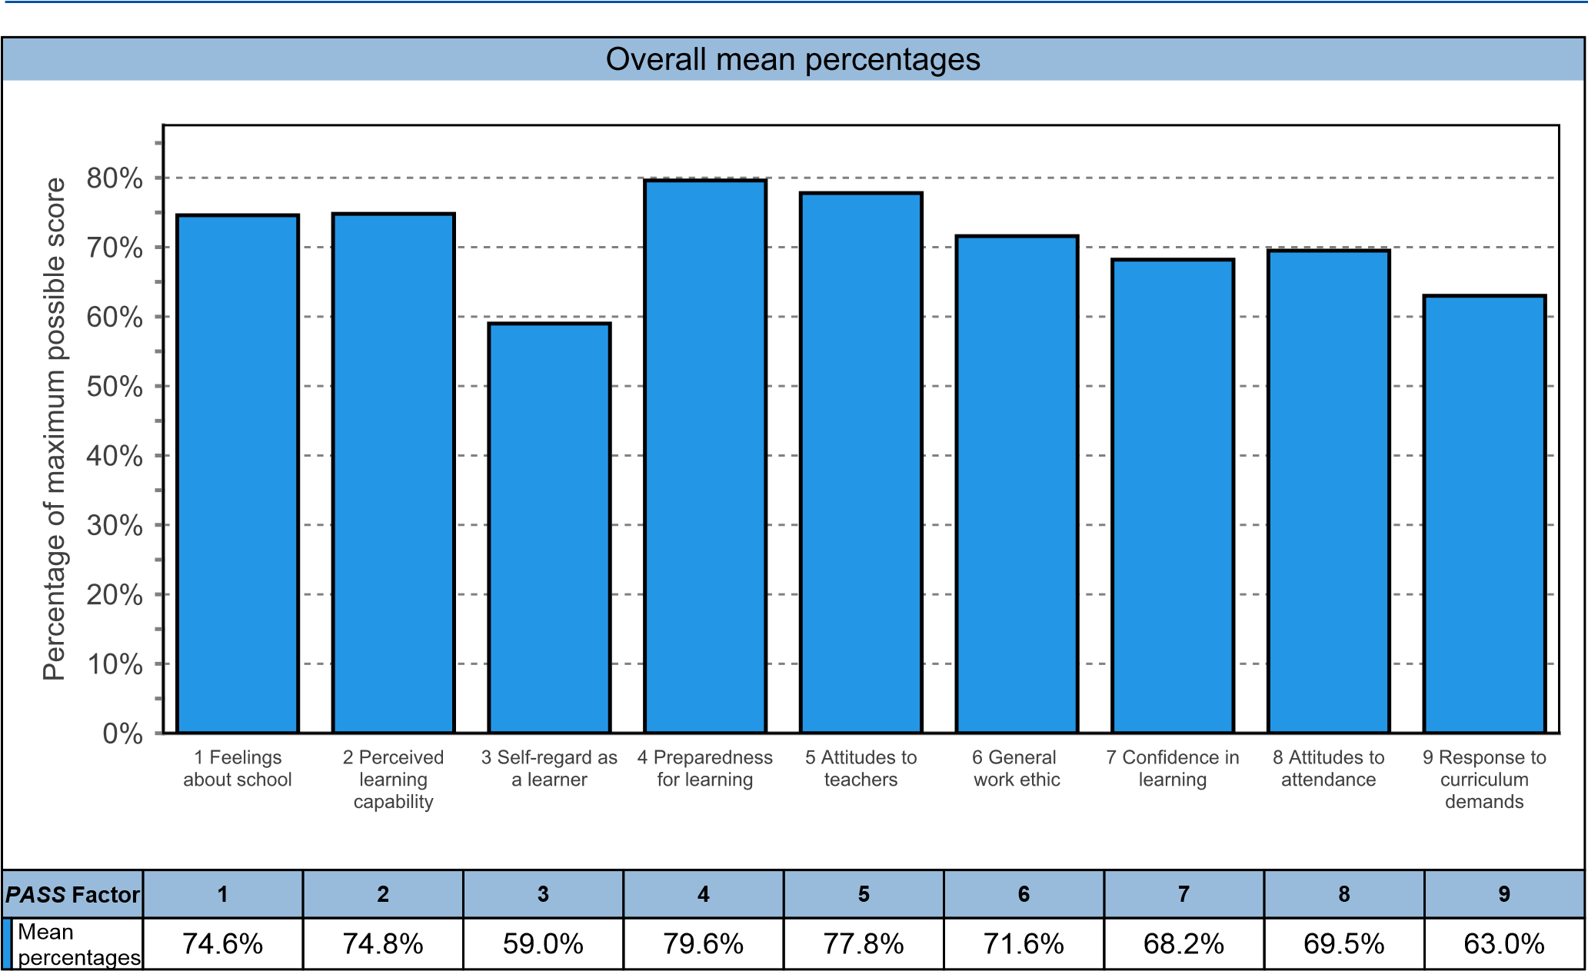
 |  |  | Overall percentiles
PASS Factor | 1 | 2 | 3 | 4 |  | 5 | 6 |  | 7 | 8 | 9
 | Feelings about school | Perceived learning capability | Self-regard as a learner | Preparedness for learning |  | Attitudes to teachers | General work ethic |  | Confidence in learning | Attitudes to attendance | Response to curriculum demands
Percentile score | 55.2 | 51.5 | 33.6 | 60.5 |  | 57.4 | 36.3 |  | 66.4 | 50.3 | 45.2
School: Walton-le-Dale High School
Group: Unknown
Survey date: 14/12/2020 |  |  |  |  | Level: PASS 3 |  |  | No. of students: 107

Level 2: Gender
PASS
Survey report

PASS factors analysed by gender
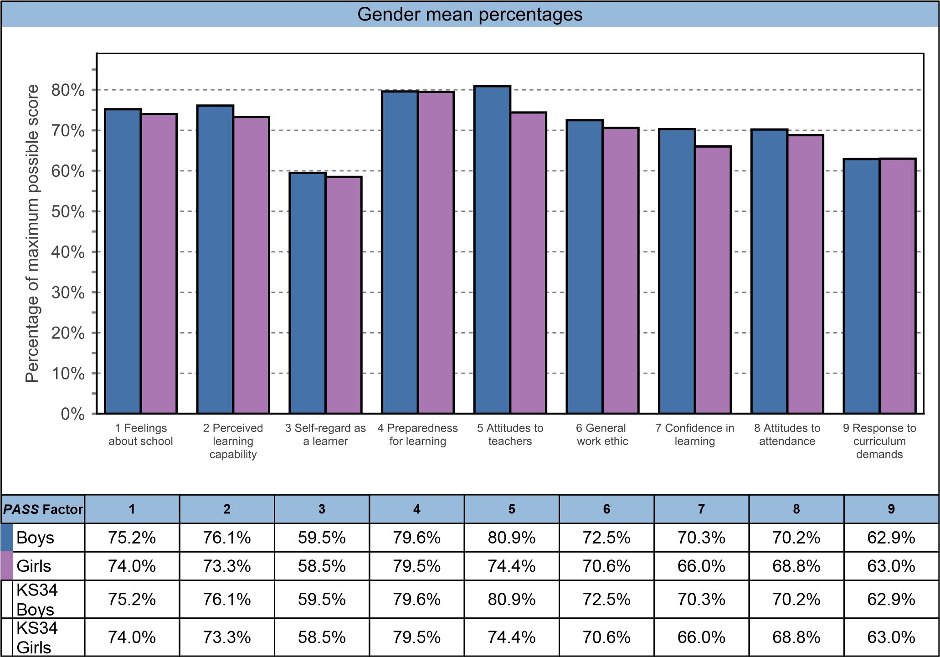
 |  |  | Gender percentiles
PASS Factor | 1 | 2 | 3 | 4 | 5 | 6 | 7 | 8 | 9
 | Feelings about school | Perceived learning capability | Self-regard as a learner | Preparedness for learning | Attitudes to teachers | General work ethic | Confidence in learning | Attitudes to attendance | Response to curriculum demands
KS34 Boys | 57.4 | 49.2 | 33.4 | 63.4 | 72.6 | 58.9 | 63.6 | 53.4 | 47.1
KS34  Girls | 52.9 | 43.3 | 33.7 | 57.6 | 58.4 | 37.2 | 60.6 | 47.1 | 43.2

School: Walton-le-Dale High School
Group: Unknown
Survey date: 14/12/2020 | Level: PASS 3 | No. of students: 107

Level 2: Year group

PASS factors analysed by year group
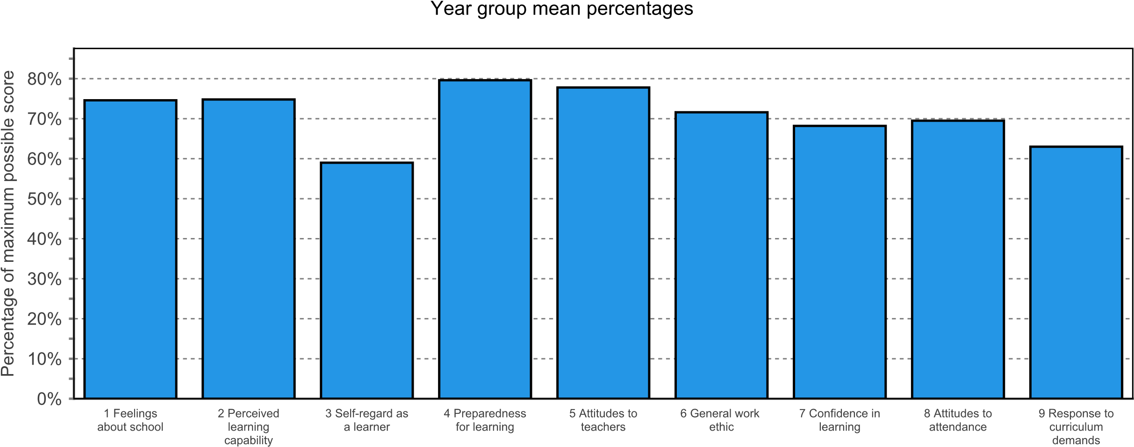
 |  | PASS Factor
 |  | 1 |  |  | 2 |  | 3 |  | 4 |  | 5 |  |  | 6 |  | 7 |  | 8 |  | 9
Year 11 |  | 74.6% |  |  | 74.8% |  | 59.0% |  | 79.6% |  | 77.8% |  |  | 71.6% |  | 68.2% |  | 69.5% |  | 63.0%
 |  |  |  |  |  |  |  |  |  | Year group percentiles
 |  |  | 1 |  |  | 2 |  | 3 |  | 4 |  | 5 |  |  | 6 |  | 7 |  | 8 |  | 9
 |  |  | Feelings about school |  |  | Perceived learning capability |  | Self-regard as a learner |  | Preparedness for learning |  | Attitudes to teachers |  |  | General work ethic |  | Confidence in learning |  | Attitudes to attendance |  | Response to curriculum demands
Year 11 |  |  | 64.0 |  |  | 53.9 |  | 34.4 |  | 68.7 |  | 67.0 |  |  | 44.5 |  | 68.9 |  | 54.5 |  | 47.9
 | Survey date: 14/12/2020 |  |  | Level: PASS 3 |  |  |  |  |  |  |  |  | No. of students: 107

Level 2: Ethnic group

PASS factors analysed by ethnic group
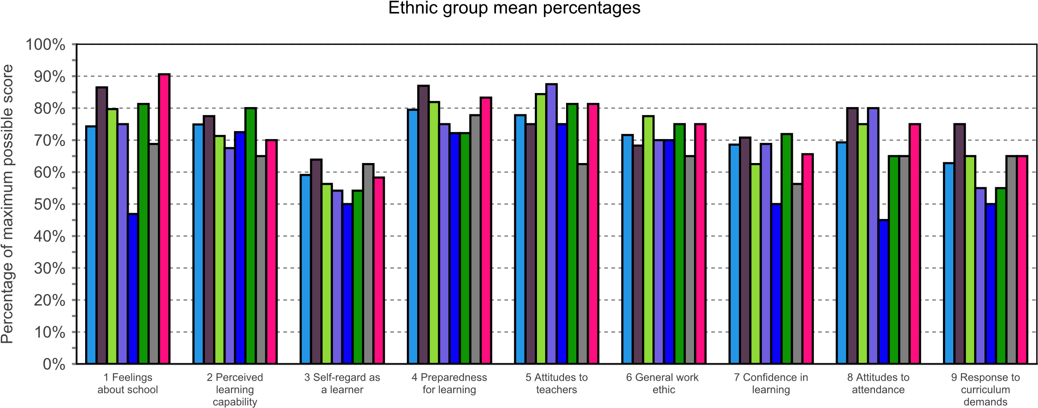
 | PASS Factor
 | 1 | 2 | 3 | 4 | 5 | 6 | 7 | 8 | 9
White - British | 74.3% | 74.9% | 59.1% | 79.5% | 77.8% | 71.6% | 68.6% | 69.3% | 62.8%
Any other ethnic group | 86.5% | 77.5% | 63.9% | 87.0% | 75.0% | 68.3% | 70.8% | 80.0% | 75.0%
Black Caribbean | 79.7% | 71.3% | 56.3% | 81.9% | 84.4% | 77.5% | 62.5% | 75.0% | 65.0%
Any other Asian background | 75.0% | 67.5% | 54.2% | 75.0% | 87.5% | 70.0% | 68.8% | 80.0% | 55.0%
Any other White background | 46.9% | 72.5% | 50.0% | 72.2% | 75.0% | 70.0% | 50.0% | 45.0% | 50.0%
Any other mixed background | 81.3% | 80.0% | 54.2% | 72.2% | 81.3% | 75.0% | 71.9% | 65.0% | 55.0%
Indian | 68.8% | 65.0% | 62.5% | 77.8% | 62.5% | 65.0% | 56.3% | 65.0% | 65.0%
White and Asian | 90.6% | 70.0% | 58.3% | 83.3% | 81.3% | 75.0% | 65.6% | 75.0% | 65.0%

 |  |  |  | Ethnic group percentiles
 | 1 | 2 | 3 | 4 | 5 | 6 | 7 | 8 | 9
 | Feelings about school | Perceived learning capability | Self-regard as a learner | Preparedness for learning | Attitudes to teachers | General work ethic | Confidence in learning | Attitudes to attendance | Response to curriculum demands
KS34 Any other Asian background | 55.2 | 24.0 | 22.6 | 41.2 | 85.2 | 36.3 | 66.4 | 78.7 | 17.5
KS34 Any other ethnic group | 84.2 | 61.2 | 47.3 | 77.1 | 57.4 | 36.3 | 74.5 | 78.7 | 79.4
KS34 Any other mixed background | 71.9 | 69.8 | 22.6 | 30.6 | 73.7 | 60.1 | 74.5 | 36.3 | 17.5
KS34 Any other White background | 5.3 | 41.2 | 14.5 | 30.6 | 57.4 | 36.3 | 16.3 | 7.3 | 9.6
KS34 Black Caribbean | 71.9 | 41.2 | 33.6 | 69.1 | 85.2 | 81.0 | 49.0 | 65.9 | 45.2
KS34 Indian | 33.7 | 17.9 | 47.3 | 51.3 | 23.0 | 17.4 | 30.7 | 36.3 | 45.2
KS34 White - British | 55.2 | 51.5 | 33.6 | 60.5 | 57.4 | 36.3 | 66.4 | 50.3 | 45.2
KS34 White and Asian | 89.1 | 31.8 | 33.6 | 69.1 | 73.7 | 60.1 | 57.9 | 65.9 | 45.2

Survey date: 14/12/2020 | Level: PASS 3 | No. of students: 107

Level 2: Free school meals

PASS factors analysed by free school meals
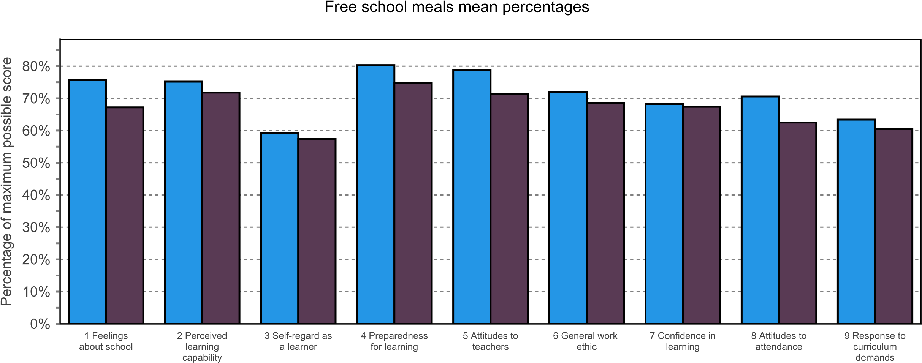
 | PASS Factor
 | 1 | 2 | 3 | 4 | 5 | 6 | 7 | 8 | 9
No | 75.7% | 75.2% | 59.3% | 80.3% | 78.8% | 72.0% | 68.3% | 70.6% | 63.4%
Yes | 67.2% | 71.8% | 57.4% | 74.8% | 71.4% | 68.6% | 67.4% | 62.5% | 60.4%

 |  |  |  | Free school meals percentiles
 | 1 | 2 | 3 | 4 | 5 | 6 | 7 | 8 | 9
 | Feelings about school | Perceived learning capability | Self-regard as a learner | Preparedness for learning | Attitudes to teachers | General work ethic | Confidence in learning | Attitudes to attendance | Response to curriculum demands
KS34 No | 55.2 | 51.5 | 33.6 | 60.5 | 73.7 | 36.3 | 66.4 | 50.3 | 45.2
KS34 Yes | 33.7 | 41.2 | 33.6 | 41.2 | 36.2 | 36.3 | 66.4 | 36.3 | 29.2

Survey date: 14/12/2020 | Level: PASS 3 | No. of students: 107

Level 2: Special Education

PASS factors analysed by special education
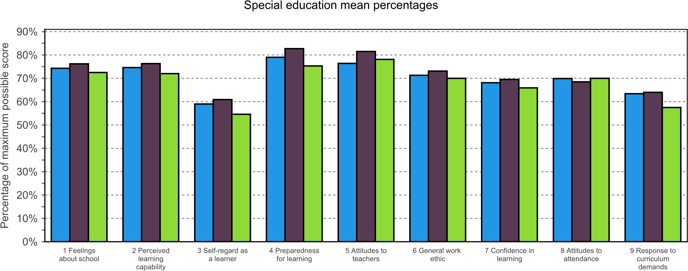
 | PASS Factor
 | 1 | 2 | 3 | 4 | 5 | 6 | 7 | 8 | 9
Not known | 74.3% | 74.6% | 59.0% | 79.0% | 76.4% | 71.3% | 68.1% | 69.9% | 63.4%
No Special Educational Need | 76.2% | 76.3% | 60.9% | 82.7% | 81.5% | 73.1% | 69.5% | 68.5% | 64.0%
SEN Support | 72.5% | 72.0% | 54.6% | 75.3% | 78.1% | 70.0% | 65.9% | 70.0% | 57.5%

 |  |  |  | Special education percentiles
 | 1 | 2 | 3 | 4 | 5 | 6 | 7 | 8 | 9
 | Feelings about school | Perceived learning capability | Self-regard as a learner | Preparedness for learning | Attitudes to teachers | General work ethic | Confidence in learning | Attitudes to attendance | Response to curriculum demands
KS34 Not known | 55.2 | 51.5 | 33.6 | 51.3 | 57.4 | 36.3 | 66.4 | 50.3 | 45.2
KS34 No Special Educational Need | 55.2 | 61.2 | 47.3 | 69.1 | 73.7 | 60.1 | 66.4 | 50.3 | 45.2
KS34 SEN Support | 43.3 | 41.2 | 22.6 | 41.2 | 73.7 | 36.3 | 57.9 | 50.3 | 29.2

Survey date: 14/12/2020 | Level: PASS 3 | No. of students: 107

Level 2: EAL

PASS factors analysed by EAL
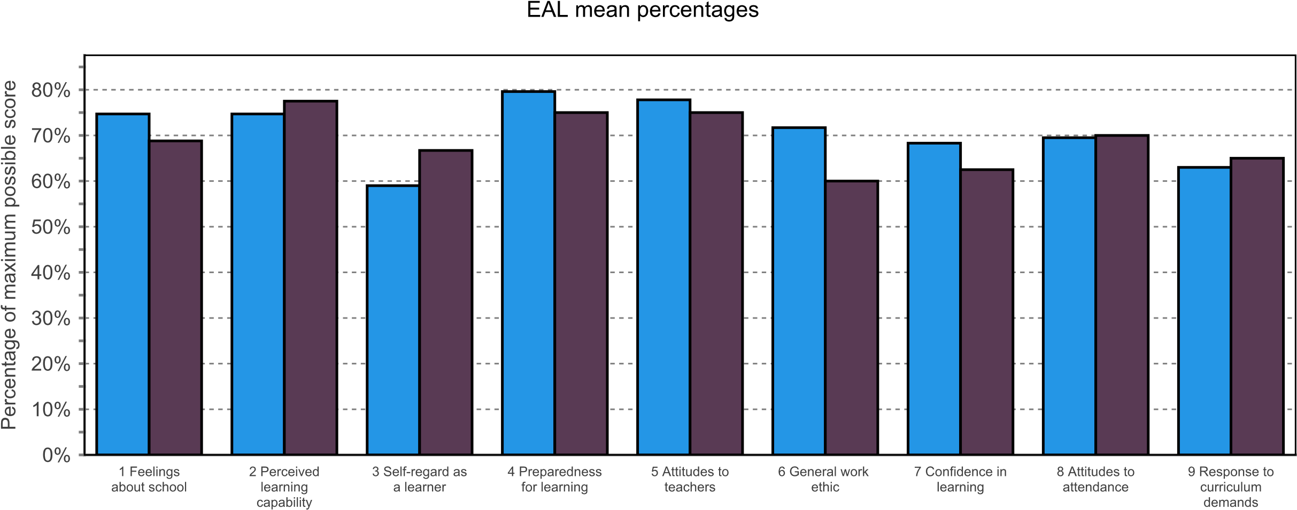
 | PASS Factor
 | 1 | 2 | 3 | 4 | 5 | 6 | 7 | 8 | 9
Not known | 74.7% | 74.7% | 59.0% | 79.6% | 77.8% | 71.7% | 68.3% | 69.5% | 63.0%
No | 68.8% | 77.5% | 66.7% | 75.0% | 75.0% | 60.0% | 62.5% | 70.0% | 65.0%

 |  |  |  |  | EAL percentiles
 | 1 | 2 | 3 | 4 | 5 | 6 | 7 | 8 | 9
 | Feelings about school | Perceived learning capability | Self-regard as a learner | Preparedness for learning | Attitudes to teachers | General work ethic | Confidence in learning | Attitudes to attendance | Response to curriculum demands
KS34 Not known | 55.2 | 51.5 | 33.6 | 60.5 | 57.4 | 36.3 | 66.4 | 50.3 | 45.2
KS34 No | 33.7 | 61.2 | 61.7 | 41.2 | 57.4 | 6.8 | 49.0 | 50.3 | 45.2

Survey date: 14/12/2020 | Level: PASS 3 | No. of students: 107

Level 2: Custom 1

PASS factors analysed by Custom 1
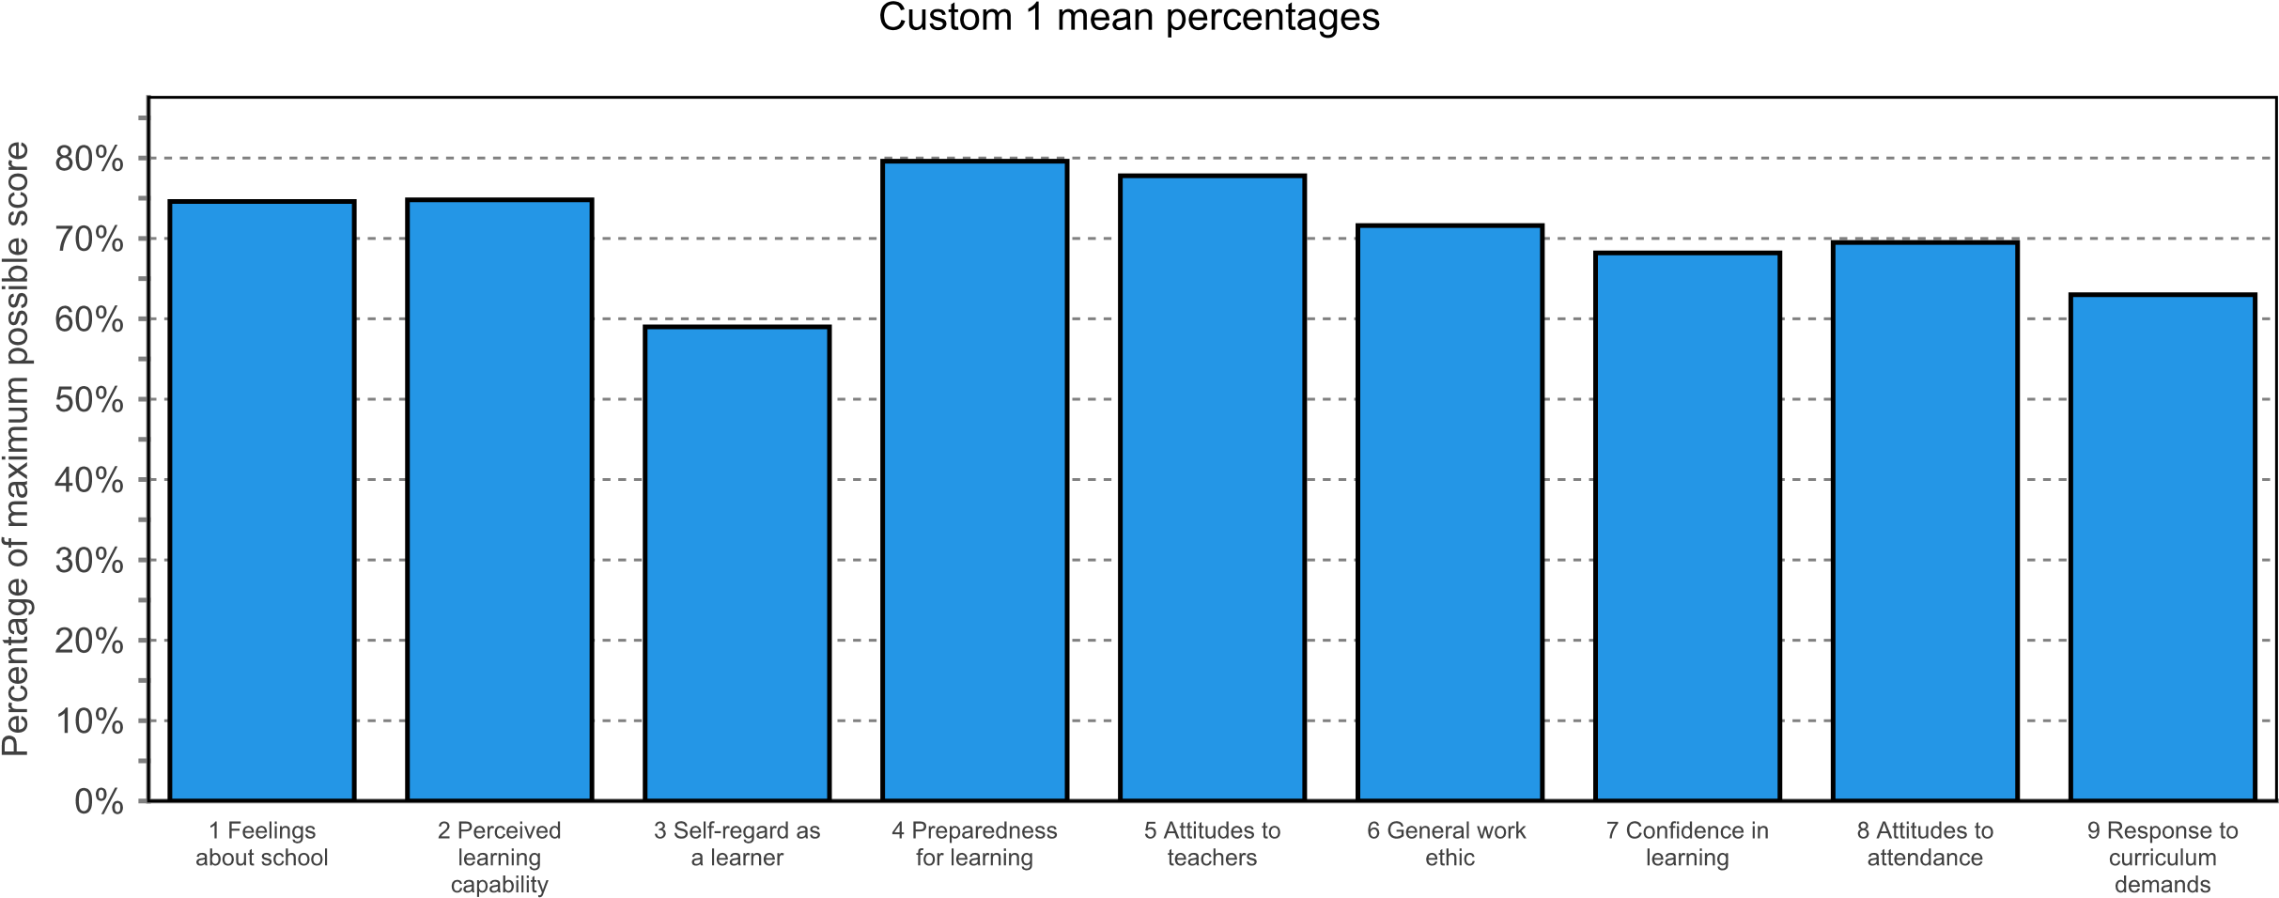
 | PASS Factor
 | 1 |  | 2 |  | 3 |  | 4 |  | 5 |  | 6 |  | 7 |  | 8 |  | 9
Not known | 74.6% |  | 74.8% |  | 59.0% |  | 79.6% |  | 77.8% |  | 71.6% |  | 68.2% |  | 69.5% |  | 63.0%
 |  |  |  |  |  |  |  | Custom 1 mean percentiles
 |  | 1 |  | 2 |  | 3 |  | 4 |  | 5 |  | 6 |  | 7 |  | 8 |  | 9
 |  | Feelings about school |  | Perceived learning capability |  | Self-regard as a learner |  | Preparedness for learning |  | Attitudes to teachers |  | General work ethic |  | Confidence in learning |  | Attitudes to attendance |  | Response to curriculum demands
KS34 Not known |  | 55.2 |  | 51.5 |  | 33.6 |  | 60.5 |  | 57.4 |  | 36.3 |  | 66.4 |  | 50.3 |  | 45.2

Survey date: 14/12/2020 | Level: PASS 3 | No. of students: 107

Level 2: Custom 2

PASS factors analysed by Custom 2
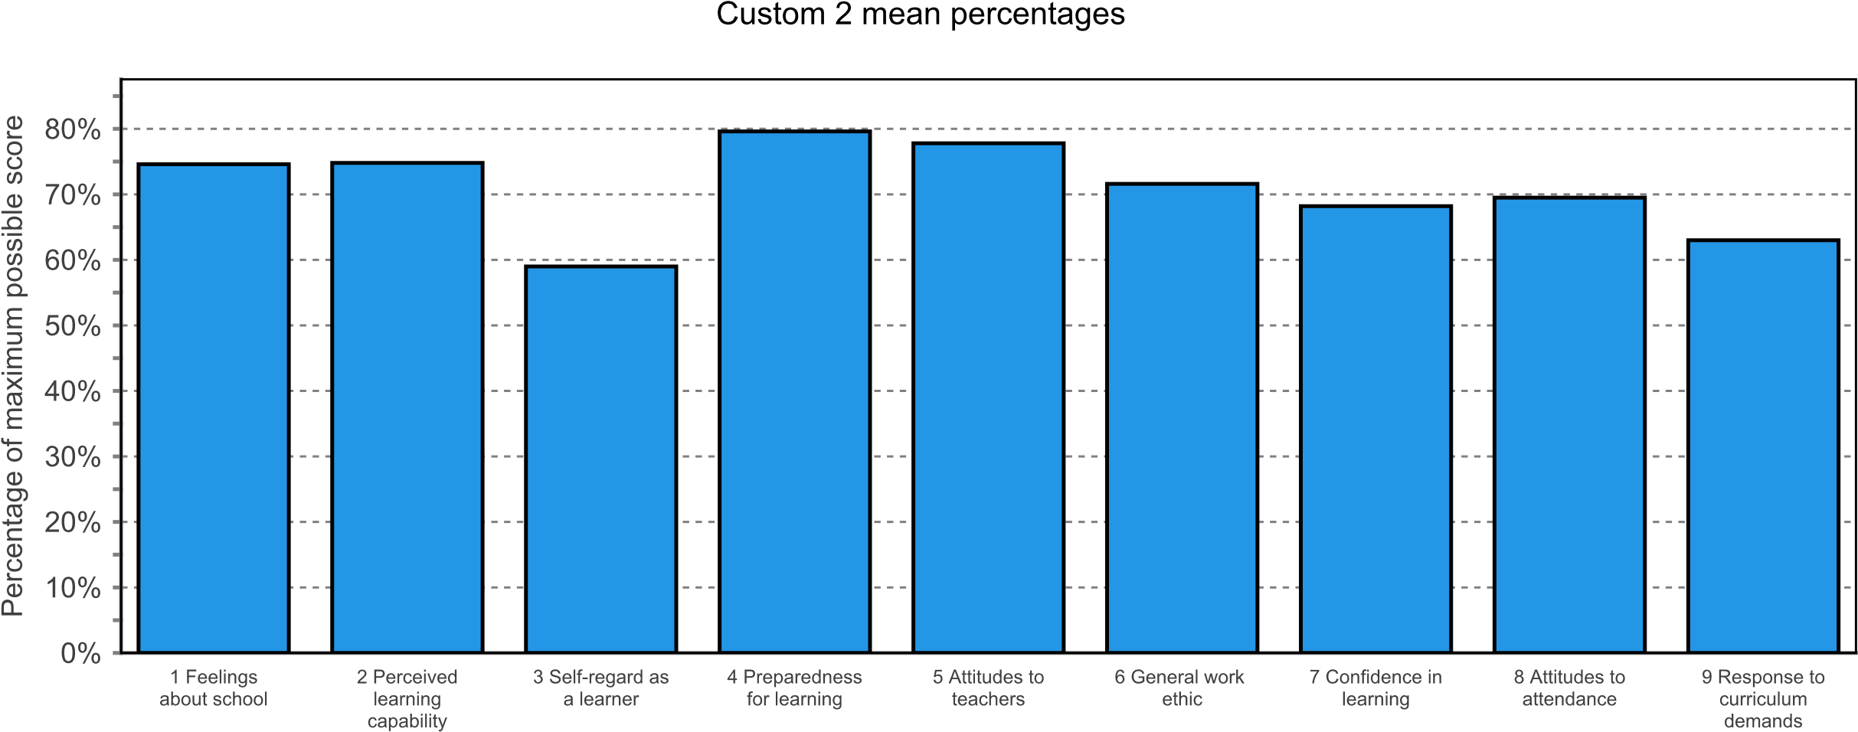
 |  | PASS Factor
 |  | 1 |  |  | 2 |  | 3 |  | 4 |  | 5 |  |  | 6 |  | 7 |  | 8 |  | 9
Not known |  | 74.6% |  |  | 74.8% |  | 59.0% |  | 79.6% |  | 77.8% |  |  | 71.6% |  | 68.2% |  | 69.5% |  | 63.0%
 |  |  |  |  |  |  |  |  |  | Custom 2 mean percentiles
 |  |  | 1 |  |  | 2 |  | 3 |  | 4 |  | 5 |  |  | 6 |  | 7 |  | 8 |  | 9
 |  |  | Feelings about school |  |  | Perceived learning capability |  | Self-regard as a learner |  | Preparedness for learning |  | Attitudes to teachers |  |  | General work ethic |  | Confidence in learning |  | Attitudes to attendance |  | Response to curriculum demands
KS34 Not known |  |  | 55.2 |  |  | 51.5 |  | 33.6 |  | 60.5 |  | 57.4 |  |  | 36.3 |  | 66.4 |  | 50.3 |  | 45.2
 | Survey date: 14/12/2020 |  |  | Level: PASS 3 |  |  |  |  |  |  |  |  | No. of students: 107

Level 2: Year and gender

PASS factors analysed by year and gender
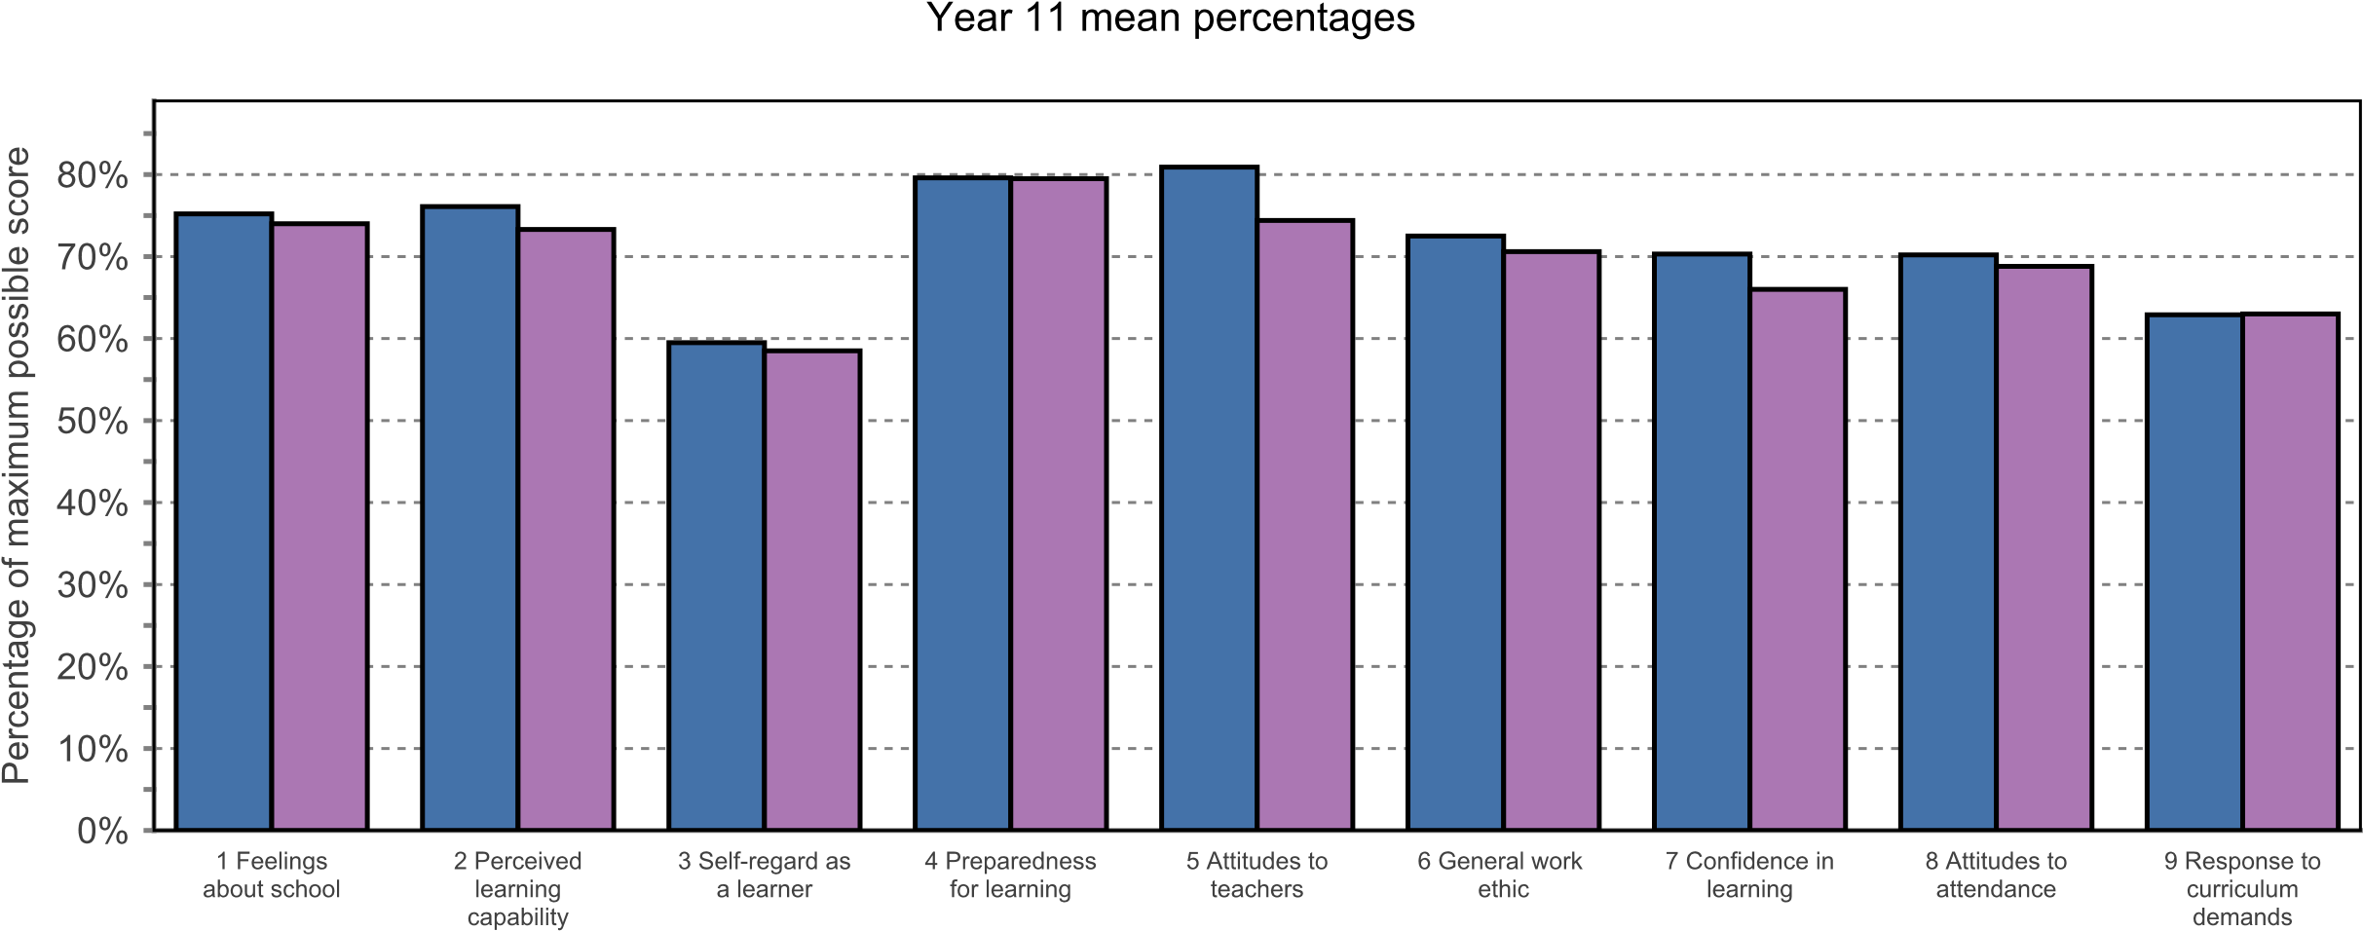
 | PASS Factor
 | 1 | 2 | 3 | 4 | 5 | 6 | 7 | 8 | 9
Boys | 75.2% | 76.1% | 59.5% | 79.6% | 80.9% | 72.5% | 70.3% | 70.2% | 62.9%
Girls | 74.0% | 73.3% | 58.5% | 79.5% | 74.4% | 70.6% | 66.0% | 68.8% | 63.0%

 |  |  |  | Year and gender percentiles
 | 1 | 2 | 3 | 4 | 5 | 6 | 7 | 8 | 9
 | Feelings about school | Perceived learning capability | Self-regard as a learner | Preparedness for learning | Attitudes to teachers | General work ethic | Confidence in learning | Attitudes to attendance | Response to curriculum demands
Year 11 Boys | 65.1 | 50.9 | 31.4 | 70.7 | 81.6 | 67.7 | 65.0 | 56.2 | 47.7
Year 11 Girls | 62.9 | 45.3 | 37.5 | 66.5 | 67.2 | 46.4 | 63.8 | 52.8 | 48.1

Survey date: 14/12/2020 | Level: PASS 3 | No. of students: 107

Level 2: Ethnic group and gender

PASS factors analysed by ethnic group and gender
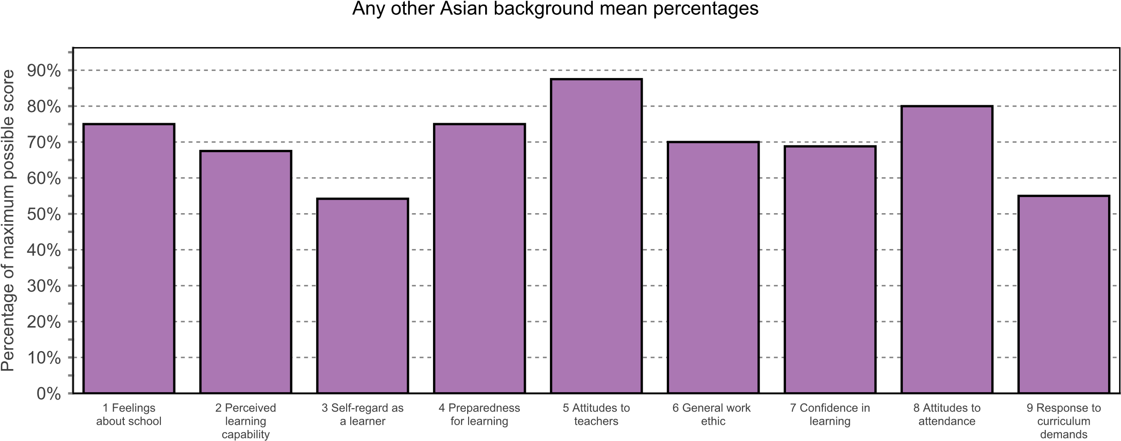
 | PASS Factor
 | 1 | 2 | 3 | 4 | 5 | 6 | 7 | 8 | 9
Girls | 75.0% | 67.5% | 54.2% | 75.0% | 87.5% | 70.0% | 68.8% | 80.0% | 55.0%
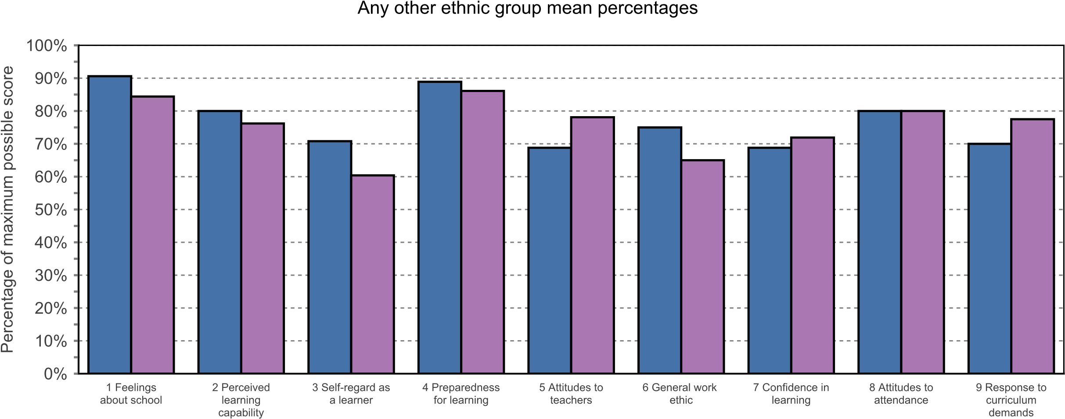
 | PASS Factor
 | 1 | 2 | 3 | 4 | 5 | 6 | 7 | 8 | 9
Boys | 90.6% | 80.0% | 70.8% | 88.9% | 68.8% | 75.0% | 68.8% | 80.0% | 70.0%
Girls | 84.4% | 76.2% | 60.4% | 86.1% | 78.1% | 65.0% | 71.9% | 80.0% | 77.5%

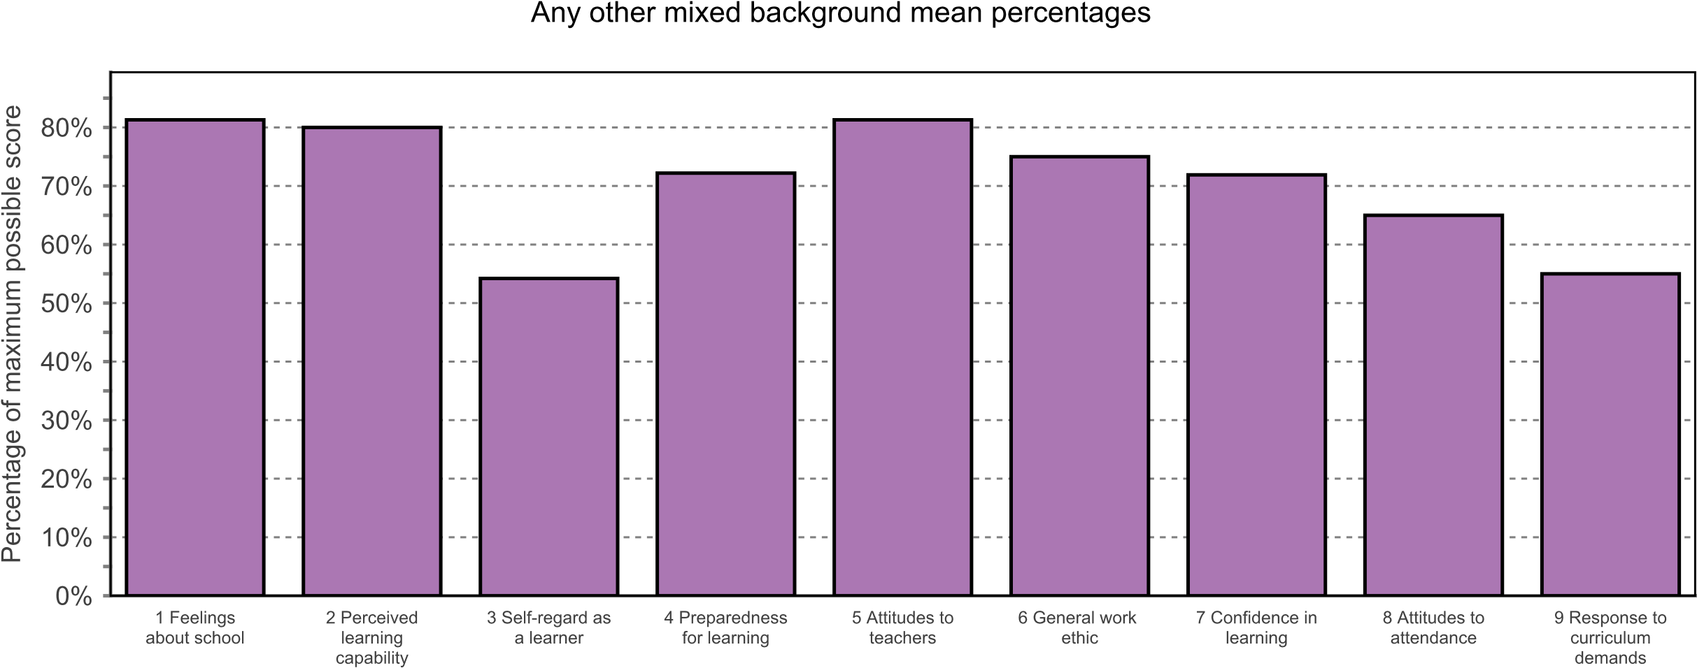
 | PASS Factor
 | 1 | 2 | 3 | 4 | 5 | 6 | 7 | 8 | 9
Girls | 81.3% | 80.0% | 54.2% | 72.2% | 81.3% | 75.0% | 71.9% | 65.0% | 55.0%
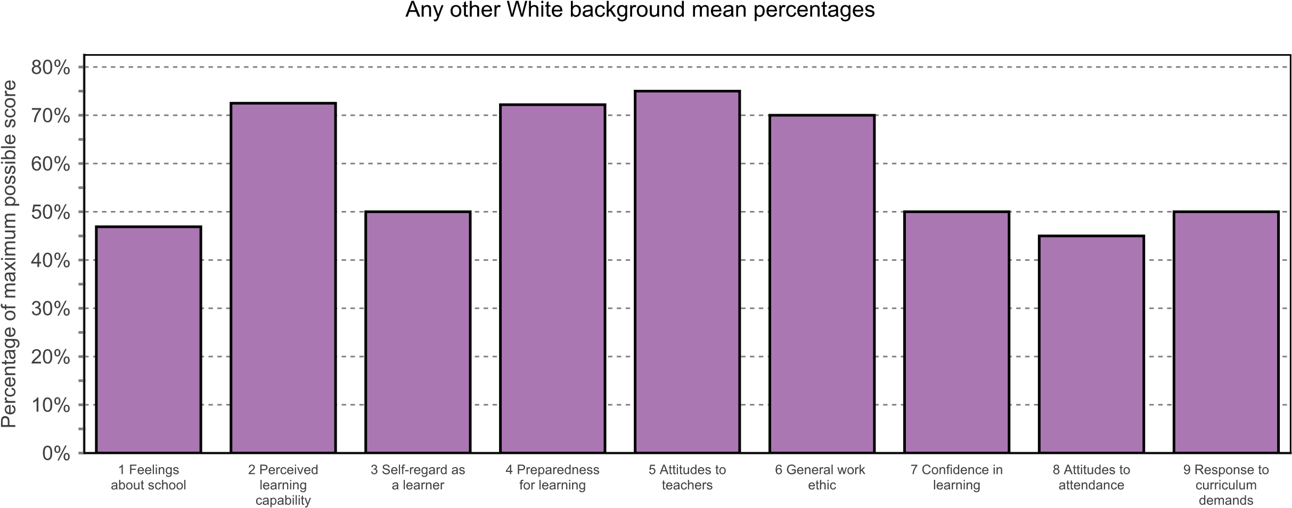
 | PASS Factor
 | 1 | 2 | 3 | 4 | 5 | 6 | 7 | 8 | 9
Girls | 46.9% | 72.5% | 50.0% | 72.2% | 75.0% | 70.0% | 50.0% | 45.0% | 50.0%
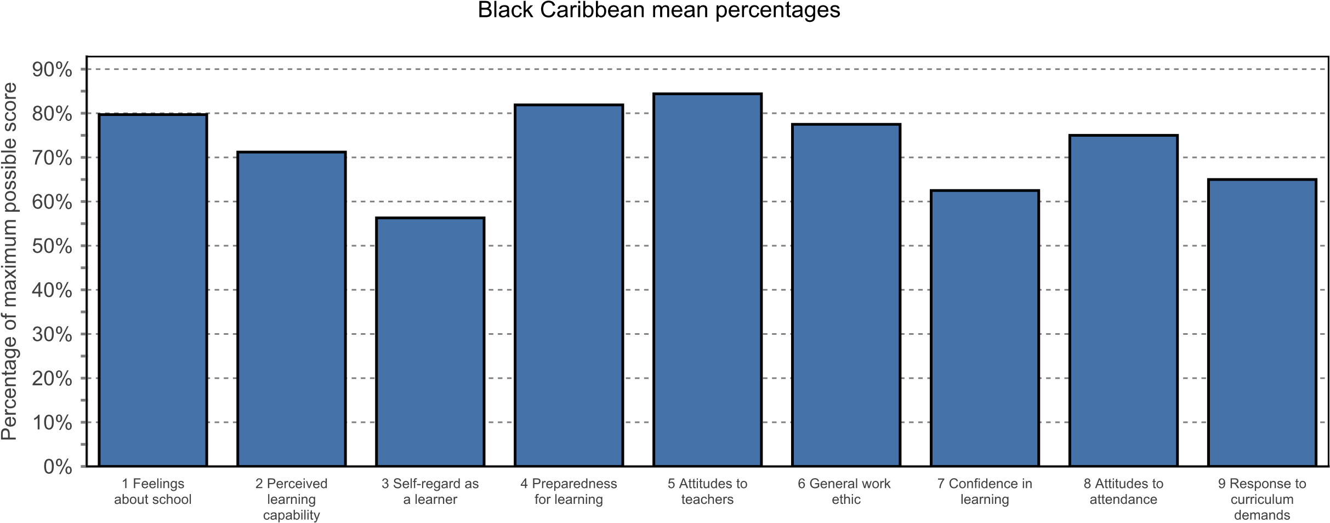
 | PASS Factor
 | 1 | 2 | 3 | 4 | 5 | 6 | 7 | 8 | 9
Boys | 79.7% | 71.2% | 56.3% | 81.9% | 84.4% | 77.5% | 62.5% | 75.0% | 65.0%
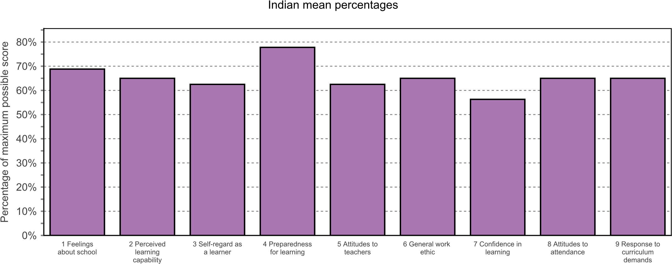
 | PASS Factor
 | 1 | 2 | 3 | 4 | 5 | 6 | 7 | 8 | 9
Girls | 68.8% | 65.0% | 62.5% | 77.8% | 62.5% | 65.0% | 56.3% | 65.0% | 65.0%
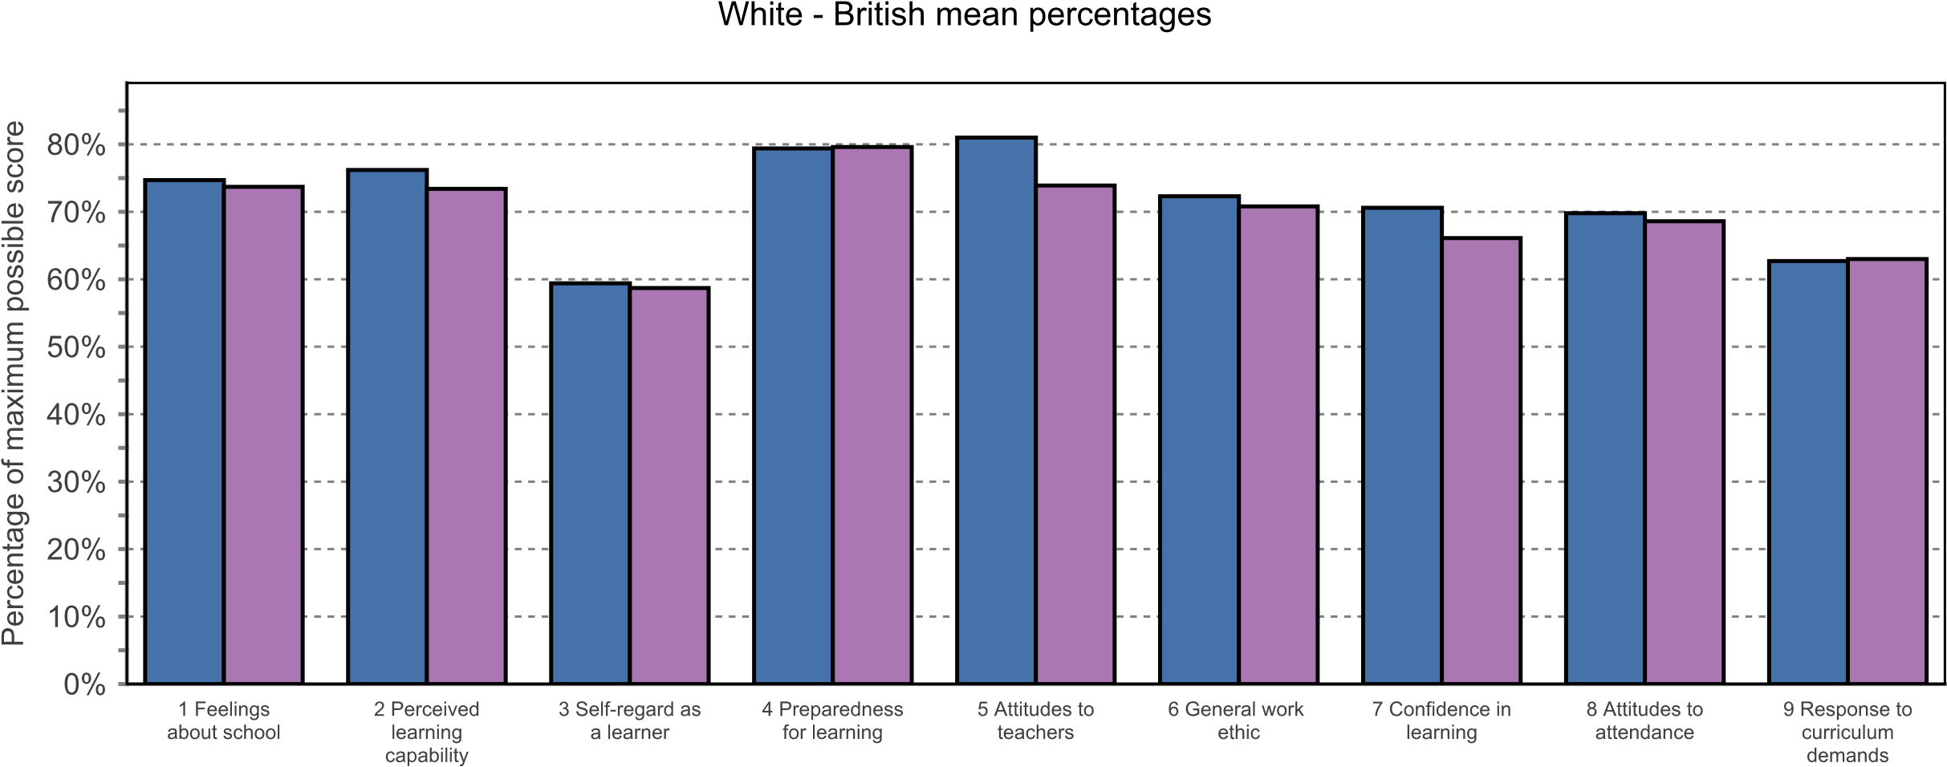
 | PASS Factor
 | 1 | 2 | 3 | 4 | 5 | 6 | 7 | 8 | 9
Boys | 74.7% | 76.2% | 59.4% | 79.4% | 81.0% | 72.3% | 70.6% | 69.8% | 62.7%
Girls | 73.7% | 73.4% | 58.7% | 79.6% | 73.9% | 70.8% | 66.1% | 68.6% | 63.0%
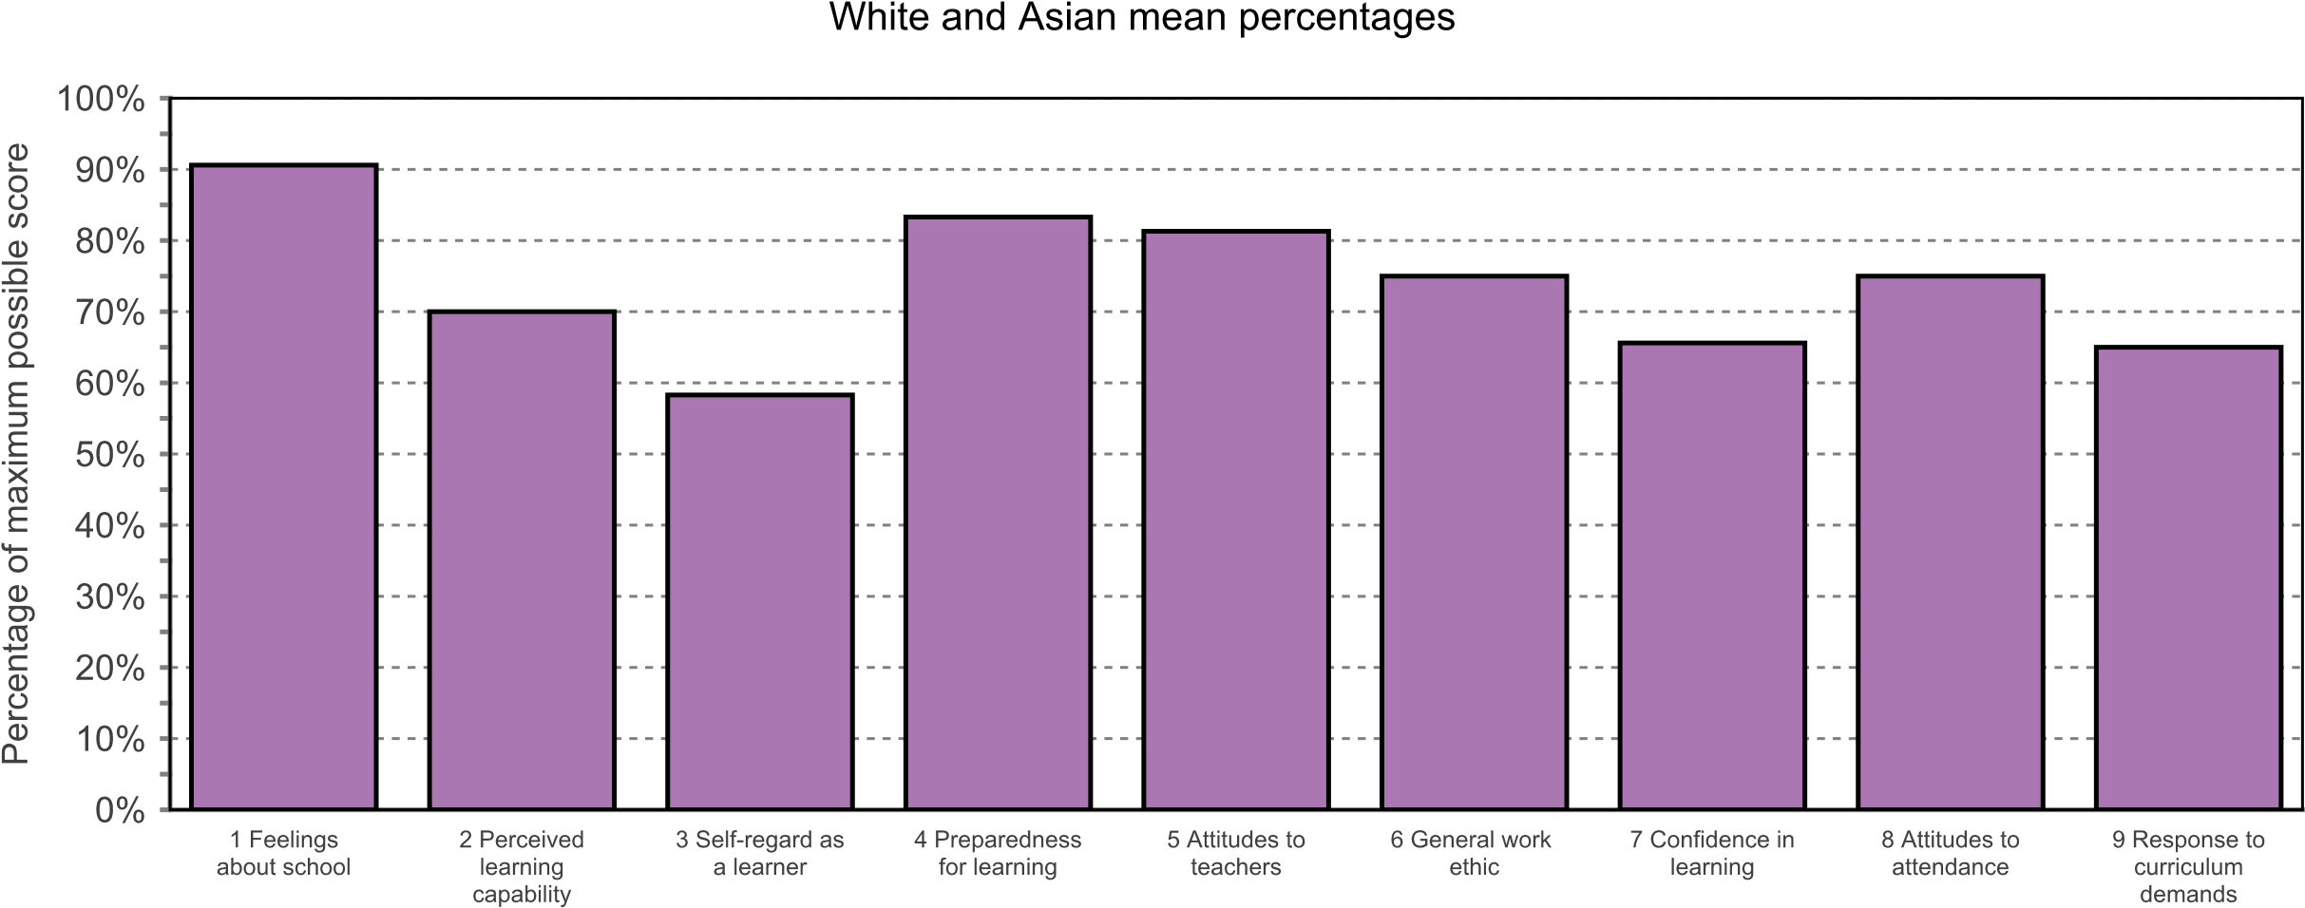
 | PASS Factor
 | 1 | 2 | 3 | 4 | 5 | 6 | 7 | 8 | 9
Girls | 90.6% | 70.0% | 58.3% | 83.3% | 81.3% | 75.0% | 65.6% | 75.0% | 65.0%

 | Ethnic group and gender percentiles
 | 1 | 2 | 3 | 4 | 5 | 6 | 7 | 8 | 9
 | Feelings about school | Perceived learning capability | Self-regard as a learner | Preparedness for learning | Attitudes to teachers | General work ethic | Confidence in learning | Attitudes to attendance | Response to curriculum demands
KS34 White - British Boys | 55.2 | 51.5 | 33.6 | 60.5 | 73.7 | 36.3 | 74.5 | 50.3 | 45.2
KS34 White - British Girls | 55.2 | 41.2 | 33.6 | 60.5 | 57.4 | 36.3 | 57.9 | 50.3 | 45.2
KS34 Any other ethnic group Girls | 78.5 | 61.2 | 47.3 | 77.1 | 73.7 | 17.4 | 74.5 | 78.7 | 89.3
KS34 Black Caribbean Boys | 71.9 | 41.2 | 33.6 | 69.1 | 85.2 | 81.0 | 49.0 | 65.9 | 45.2
KS34 Any other Asian background Girls | 55.2 | 24.0 | 22.6 | 41.2 | 85.2 | 36.3 | 66.4 | 78.7 | 17.5
KS34 Any other White background Girls | 5.3 | 41.2 | 14.5 | 30.6 | 57.4 | 36.3 | 16.3 | 7.3 | 9.6
KS34 Any other ethnic group Boys | 89.1 | 69.8 | 74.1 | 84.4 | 36.2 | 60.1 | 66.4 | 78.7 | 63.7
KS34 Any other mixed background Girls | 71.9 | 69.8 | 22.6 | 30.6 | 73.7 | 60.1 | 74.5 | 36.3 | 17.5
KS34 Indian Girls | 33.7 | 17.9 | 47.3 | 51.3 | 23.0 | 17.4 | 30.7 | 36.3 | 45.2
KS34 White and Asian Girls | 89.1 | 31.8 | 33.6 | 69.1 | 73.7 | 60.1 | 57.9 | 65.9 | 45.2

