Walton-le-Dale Duke of Edinburgh 2018
The practice expedition is taking place at Guys Farm Activity Centre, Lancaster, LA2 9DF.
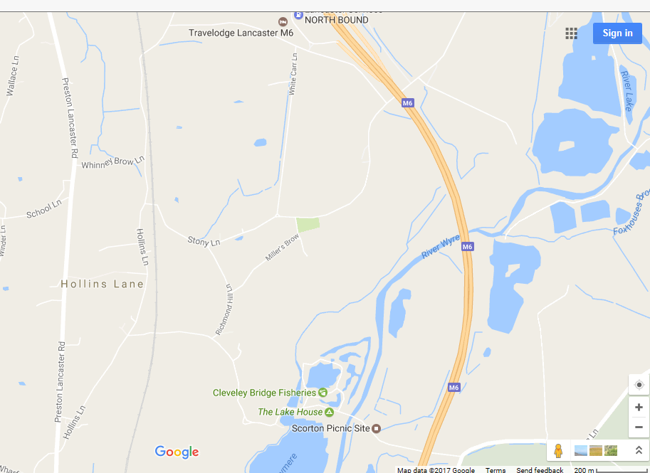
GUYS FARM

If travelling from the South on the A6, approximately 2¾ miles North of Garstang, turn right into Hollins Lane, continue under the Railway Bridge and turn first right, continue to the T junction at the end and turn left over the motorway, turn Immediately right and Guy’s Farm is at the end of the lane.
CAUTION, there may be large vehicles from the adjacent property manoeuvring in the lane.
Alternatively, you can take the M6 northbound, and leave at Forton services. On the left hand side of the car park there is a Police entrance, now not manned. Guys have given permission for people to use this if they want to. It may make your journey time shorter. To get home from here, you either need to go back onto the Motorway via the services, travel north to Lancaster and turn around, or use the A6. From experience there isn’t too much difference in time between the methods of getting home. (Map on reverse)

Pupils to be dropped off at 9:30am on the Saturday morning. Please make sure they are there promptly as we need to make sure all are present and with the correct equipment before they begin the walk.
Pupils are to be collected from the site at 4pm on the Sunday.

All pupils will need to have the 3b medical form completed for each expedition. Please fill this in and return it to school ASAP.
If you have any further questions after tonight’s meeting, please get in touch
d.cairns@waltonledale.lancs.sch.uk

NOTES
____________________________________________________________________________________________________________________________________________________________________________________________________________________________________________________________________________________________________
____________________________________________________________________________________________________________________________________________________________________________________________________________________________________________________________________________________________________
__________________________________________________________________________________________________________________________________________________

