TOPIC: Population

Books available to loan through our school library

Title | Author | Medium | Where | Description | Image | Dewey/Classification
Pollution: The Population Explosion | Jones, C | Book | School Library | Discusses the psychological and physical effects of continued population growth and presents some of the proposed solutions to this problem. | 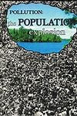 | 301.32
Settlement and Population | Webber, P | Book | School Library | this text covers such topics as cycles of wealth and poverty, racism, and population trends in the developed and developing world. | 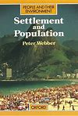 | 301.32
Population Explosion, The | Becklake, J | Book | School Library | Discusses our continually increasing population, its causes and consequences, and efforts by governments and individuals to control its growth | 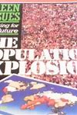 | 301.32
Population Explosion, The | Becklake, J | Online Book | https://archive.org/details/populationexplos00john | Discusses our continually increasing population, its causes and consequences, and efforts by governments and individuals to control its growth |  | 301.32
Population Growth | Bellamy, Rufus | Book | School Library | Looks at the ways people are working together to sustain our envrionment for future generations | 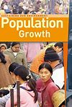 | 301.32
Population Growth | McGraw, E | Book | School Library | This book investigates the historical and contemporary factors behind the 'population explosion', looks at retrospective policies being adopted in response by the developed and developing countries of the world | 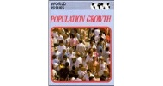 | 301.32
Revise GCSE - Geography | Lines, Cliff | Book | School Library | See section 2 on Population. | 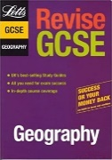 | 371.3
GCSE Geography | Parsons, Richard | Book | Library | See Section 8 – Population This book is full of clear revision notes, detailed diagrams and practice exam questions for GCSE Geography students | 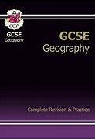 | 371.3
Population and Food | Thomas, J | Book | Library |  |  | 338

Other web sources:

Royal Society of Geography

https://www.rgs.org/schools/teaching-resources/

