Pupil Premium 2016-17 (September 2017)

Background

The pupil premium is a government initiative designed to target resources on those students deemed to be from a disadvantaged background. This is measured as those students who have been on Free School Meals (FSM) at any point over the last six years (Ever6) or those pupils who have been looked after continuously for at least 6 months (CLA), or those where one or more parents are in the armed forces. The current financial rate of the pupil premium is £935 per eligible student. The school is free to spend this money as it wishes but the money should be used to promote strategies which improve outcomes for disadvantaged students.
Our school is smaller than the average-sized secondary school. The proportion of students supported by the Pupil Premium is above average. We also have a higher than average proportion of students with additional needs and on entry to the school the KS2 scores are below average.

In 2014 Ofsted noted:

‘In 2013 the attainment of students known to be eligible for free school meals was approximately one GCSE grade lower than their classmates in English and mathematics. However, this wide gap was largely the result of a very high proportion of students known to be eligible for free school meals having special educational needs and/or joining the school late with low levels of prior attainment. School data and inspection evidence show that, currently, the gap in attainment between students supported by the pupil premium and other students is closing rapidly and securely.’

Since 2013 the attainment gap between pupil premium students and others have narrowed significantly and is much lower than the gap nationally.

Pupil Premium Cohort
Approximately one third of our students are on the Pupil Premium register. Of these 8 students are Looked After students (CLA), 2 of which are in Y7, 5 in Y8 and 1 in year 9. The table below illustrates the percentage of Pupil Premium students by year group and gender in 2016-17.
Percentages | All | Boys | Girls
All | 32% | 29% | 36%
Yr 7 | 28% | 27% | 29%
Yr 8 | 38% | 30% | 48%
Yr 9 | 28% | 19% | 36%
Yr 10 | 32% | 37% | 27%
Yr 11 | 33% | 31% | 35%
Averages | 32% | 29% | 35%

Clearly there are differences across year groups with Y8 having the highest percentage of disadvantaged students and Y7 and Y9 the lowest.
There are also significant differences between boys and girls. Overall the school has a higher percentage of female disadvantaged students than boys. This difference is also more significant within different year groups, with an 18% difference in Y8 and a 17% difference in Y9. However in Y10 the gap is reversed with 10% more PP boys than girls.

Prior Attainment
- There is variation in ability across year groups. In general terms younger students, on entry, are more able than older students, although Y11 students are by far weaker with a higher percentage of ‘lower prior attainment students’ than other year groups. The percentage of higher attaining students on entry is also lower. Most able year group on entry appears to be current year 7 students.
 | Percentage with higher prior attainment | Percentage with average prior attainment | Percentage with lower prior attainment
YR 8 | 37% | 52% | 10%
YR 9 | 34% | 49% | 13%
YR 10 | 25% | 54% | 12%
YR 11 | 25% | 57% | 16%
YR 11 leavers (2015-2016) | 18% | 57% | 25%

- 10 students with no KS2 data (year 10)
- Current year 11 suggests a much higher percentage of students with higher prior attainment than the previous year 11 cohort (2015-2016).
- Year 7 data has been split into quartiles based on KS2 scores.
ENGLISH | PP | PP Males | PP Females | Non PP | Non PP Females | Non PP Males | TOTAL
Lower | 10 | 5 | 5 | 22 | 9 | 13 | 32
2nd Quartile | 14 | 8 | 6 | 33 | 19 | 14 | 47
3rd Quartile | 10 | 4 | 6 | 31 | 16 | 15 | 41
Upper | 5 | 1 | 4 | 13 | 8 | 5 | 18
No Data | 3 | 2 | 1 | 5 | 1 | 4 | 8
TOTAL | 42 | 20 | 22 | 104 | 53 | 51 | 146
MATHS | PP | PP Males | PP Females | Non PP | Non PP Females | Non PP Males | TOTAL
Lower | 16 | 9 | 7 | 20 | 12 | 8 | 36
2nd Quartile | 10 | 6 | 4 | 32 | 18 | 14 | 42
3rd Quartile | 9 | 1 | 8 | 33 | 14 | 19 | 42
Upper | 5 | 3 | 2 | 14 | 8 | 6 | 19
No Data | 2 | 1 | 1 | 5 | 2 | 3 | 7
TOTAL | 42 | 20 | 22 | 104 | 54 | 50 | 146

- This suggests that there are approximately 22% in the lower quartile for English, 25% for Maths.
- There are approximately 32% in the 2nd quartile for English, with 29% for Maths.
- There are approximately 28% in the 3rd quartile for English and 29% for Maths.
- In the upper quartile there are approximately 12% for English and 13% for Maths.
- This suggests that there is a higher percentage of lower attainers than in previous years.
 | Number of students in year group | Percentage of PP students | Percentage of Non PP students
YR 7 | 149 | 29% | 71%
YR 8 | 163 | 38% | 62%
YR 9 | 146 | 27% | 73%
YR 10 | 113 | 33% | 67%
YR 11 | 128 | 34% | 66%

- There are only 144 students on SISRA for year 9.
- The year group with the biggest percentage of PP students is year 8 followed by year 11.
- The lowest percentage of PP students is in years 7 and 9.
- The following data is from internal tracking: The gap in attainment between Non PP students and those who are PP students is minimal at both key stages. The smallest gap is in year 10 being 0.08.
- Students in year 8 are making approximately the required numbers of sub levels progress 3.71 and 3.99 (Non PP to PP students).
- Progress of students in year 9 is more difficult to calculate as core subjects, English and Maths are working on grades rather than levels. Non-core subjects are averaging 4.47 and 4.93 sub levels of progress and English and maths 1.09 to 0.95 levels of progress. (PP students are performing better than Non PP students in non-core subjects).
- The disadvantage gap in prior attainment on entry to high school is highest in year 9 (2.26) and lowest in year 10 (0.83) based on average KS2 points score. Unable to comment on year 7 due to the changes in the reporting system for KS2 tests.

 | NON PP | PP | Gap | MALE NON PP | MALE PP | GAP | FEMALE NON PP | FEMALE PP | GAP
YR 8 | 29.14 | 27.27 | 1.87 | 29.07 | 26.32 | 2.75 | 29.26 | 28.05 | 1.21
YR 9 | 29.07 | 26.81 | 2.26 | 29.3 | 25.21 | 4.09 | 28.82 | 27.55 | 1.27
YR10 | 27.84 | 27.01 | 0.83 | 27.46 | 26.55 | 0.91 | 28.23 | 27.72 | 0.51
YR11 | 28.02 | 26.33 | 1.69 | 28.41 | 24.94 | 3.47 | 27.59 | 27.59 | 0

- Looking at student KS2 points scores we can see that the largest gap is in year 9 with a gap of 4.09 between Non PP and PP male students while the smallest gap is between year 11 females with a gap of 0.
Special Educational Needs
- Looking at students who have been grouped as K and S we can see that the year group with the highest percentage of SEN students is year 7 (20%) and the lowest is year 10 with 7%.
- The year groups with the highest percentage of SEN students that are also PP students are years 7, 8 and 9.
- Year 11 have more than half of the SEN students who are also PP students.
 | Number of students in year group | Percentage PP students | Percentage of SEN students | Percentage of both PP and SEN students
YR 7 | 149 | 29% | 20% | 9%
YR 8 | 163 | 38% | 18% | 8.5%
YR 9 | 146 | 27% | 15% | 6%
YR 10 | 113 | 32% | 7% | 3%
YR 11 | 128 | 33% | 14% | 8.7%

- Students who have previously been on the SEN register grouped as N on SIMS:
- Year 7: (21/149) = 14%, Year 8: (24/163) = 15%, Year 9: (37/146) = 25%, Year 10 (31/113) = 27% and year 11 (27/128) = 21%.
- For students on school support 13% of PP students are on the register for social, emotional and mental health problems ( 30/224) stated as having Social, emotional and mental health issues and 5% of those not on the PP register (23/472) are on there for the same reason. All of the BESD students are NON PP students. (3 students).
Spending plan
- The school is allocated just over £200,000 to implement strategies which will improve outcomes for disadvantaged students. Our action plan outlines the use of this funding. Whilst most of the intended outcomes of this plan are related to academic outcomes, and are thus discussed below, it is worth noting that some money is allocated to supporting disadvantages students in a material way – The Pupil Premium Support Fund. It is believed this is an effective way of using money as it ensures, for example, that parents can afford to send students to school, purchase uniform and enable their children to attend trips.
 | Number of students | Percentage of cohort
UNIFORM | 24 | 10%
TRIPS | 19 | 8%
LUNCHES | 65 | 27%
BUS PASS | 67 | 28%
NO REPLY | 65 | 27%

- Fewer parents chose to spend their monies on trips this year. (8%) against 13.4% last academic year.
- More parents are choosing to use the money for bus fares (28%) against 3% last academic year (not including Blackburn students)
- Lunches (27%) against 20% last academic year.
- 10% of parents have chosen to spend their funding on uniform against 14% last year.
- 27% of parents have yet to decide, 49% failed to decide last academic year so this is an improvement.
- Average attendance for those that purchased a bus pass is 92.03%, this included two students with attendance less than 65%. Average attendance for PP students is 92.11%, includes one student with an attendance of 16.5%.
- It is worth noting that only Blackburn and those living in the Ribbleton area of Preston benefit from the bus pass which will be less than half the entire disadvantaged cohort.

OUTCOMES FOR PUPIL PREMIUM STUDENTS
The FFT analysis for students in school shows the following trends, when considering value-added alone (i.e. only considering each student’s prior attainment at KS2)
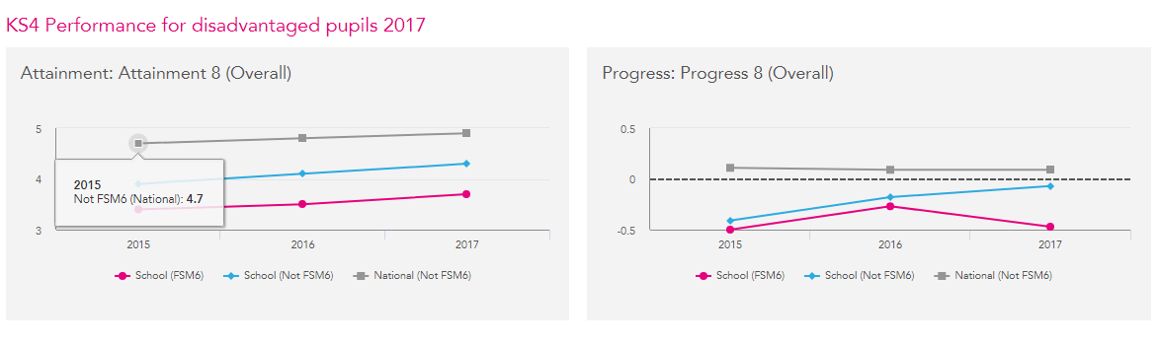
When considering the contextual value-added the performance trends are
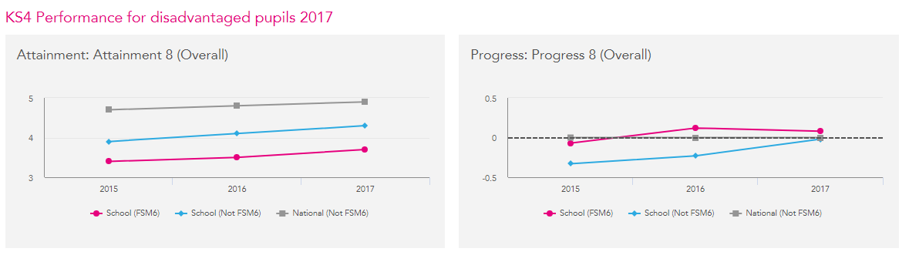

- The general picture is a positive one which shows a significant improvement in key measures for disadvantaged students and an equally significant reduction in the gap between these students and others. For example the proportion of disadvantaged students achieving 5 A*-C (EM) has been above national averages for similar students for the last 2 years. The attainment gap between disadvantaged and non-disadvantaged students for 5A*-C(EM) was 6.7% in 2016 compared to a national gap of 27%.
- Current high attaining students based on high KS2 prior data have been supported with a series of intervention strategies targeted to support their development and progress within a particular subject area. This has resulted in our more able PP students (who were an underperforming group in 2015/16) performing well in 2016/17 (in both VA and CVA analyses):

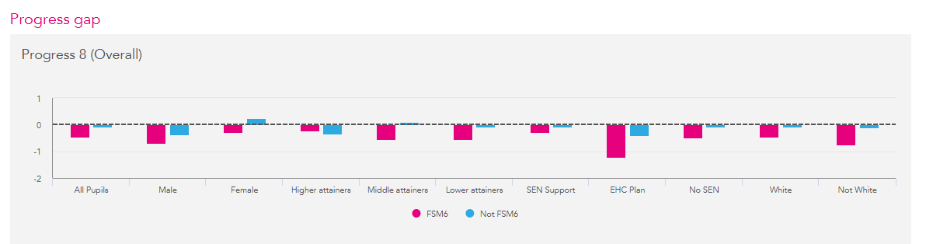

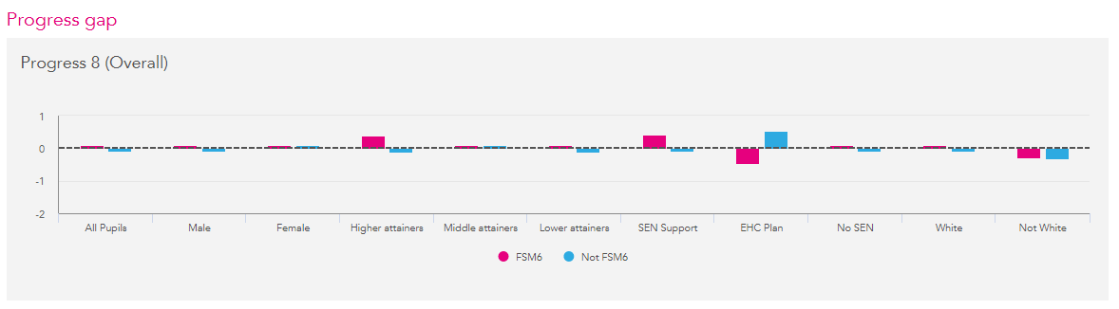

Outcomes from specific intervention strategies
Borwick Hall – this 2-day intervention session was highly effective and resulted in improve outcomes for those who attended, compared with those who did not attend (as shown by FFT analysis of the cohort);
“Blitz” – these sessions (where students were taken off timetable to focus on specific topics in Maths, English and Science) were successful in Maths (as shown by FFT analysis of the cohort), but less so in English and Science. The way in which they are being organised in English and Science is being reviewed for 2017-18, based on the experience in Maths.

Attendance 2016-17
Up to end of May 2017 | SEN code S | SEN Code K | SEN code N | PP attendance | Non PP attendance
YEAR 7 | 92.47% | 96.31% | 93.58% | 94.13% | 95.73%
YEAR 8 | 83.23% | 93.85% | 94.61% | 91.22% | 95.61%
YEAR 9 | 93.84% | 95.45% | 90.76% | 92.30% | 93.17%
YEAR 10 | 94.71% | 94.39% | 90.76% | 88.20% | 93.42%
YEAR 11 | 92.73% | 94.70% | 92.06% | 95.02% | 94.29%

- Attendance of Pupil premium students, at just over 92%, was 2% lower than that of other students. (92.174% and 94.444% respectfully). Previous data suggests that attendance for PP students was just over 93% and was 3% lower than the attendance for other students.

J Withers/J Harris (November 2017)

