RLO
Updated 1/10/20
BLENDED LEARNING policy october 2020

Rationale
In the event of a school closure, Walton le Dale High School is committed to providing continuity of education to its students and will do so through a process of remote (online) learning. Walton le Dale staff are committed to fostering the school’s mission ‘Learning for Life’, whatever challenges life may bring. Extensive remote learning would apply particularly in a situation in which the school is closed for an extended period of time, but a high proportion of students and teachers are healthy, and able to work as normal from home.
This policy does not normally apply in the event of short-term school closures (e.g. as a result of inclement weather) or a short-term student absence. Remote learning may also be appropriate in situations when students, in agreement with the school, have a period of absence but are able to work at home, at least to some extent. This may apply in cases such as exclusion from school, or longer term illness, assuming students are able to complete school work at home. Another relevant instance would be if, following an infectious disease outbreak, students are self-isolating at home but are not suffering with relevant symptoms. There is no obligation for the school to provide continuity of education to students who absent themselves from school, with or without parental permission, in contravention to school or government guidance.

Remote learning for individual students
Assuming an absence has been agreed with the school, and the student in question is healthy enough to work from home, the school will provide work for students who are unable to attend in person. This will be in line with the blended learning protocols outlined in the ‘Teaching and Learning Policy 2020-21'. If there are questions from an individual student or their parents regarding work, communication with the parent will be coordinated by the admin team under the direction of the Head of Section, keeping the form tutor informed. The student’s subject teachers will use Office 365 email and Microsoft Teams to make work available to the student in line with blended learning protocols (at the end of this policy document). If there are any issues with the compilation of work, tutors should liaise the relevant Head of Section or Head of Department (particularly if a classroom teacher is unavailable). Though every case will have its own specifics, a rough guideline for the frequency of communication between school (admin support or Head of Section, although they may seek guidance from the form tutor or mentor) and parent would be once per week. Work will be available immediately on the first day of absence.

Remote learning in the event of extended school closure

In the event of an extended school closure, the school will provide continuity of education in the following ways:
- Weekly emails to students from each subject teacher outlining the work for the week.and advising them of where to look for it (i.e. in Teams);
- For those with little or no electronic access, paper versions will be posted home, but this is only if the work cannot be accessed at all online via for example phone, tablet or gaming device;
- The work set will be completed electronically, where possible, and returned to the teacher.
- Weekly homework will be set using Classcharts and completion will be monitored – using Classcharts - by the class teacher;
- Where students submit work to teachers, some form of acknowledgement will be returned.
- Positive Classcharts will be awarded for work completed.

The primary platforms the school will use to deliver continuity of education are:
Office 365: Outlook email will be the primary means of initial communication with students, signposting them to work and resources.
Microsoft Teams - This is accessed via the relevant app or desktop application, or via the following URL: https://teams.microsoft.com.
School website - This will contain ‘how to access’ guides for both Classcharts and Teams. It also provides the gateway to Office 365.
The school reserves the right to vary the range of methods used to provide remote learning tasks, feedback and interaction, based on the particular circumstances of any closure and based on our experience.

Live sessions
N.B. Teams is the only platform that should be used for ‘live’ lessons (i.e. not Google or Zoom etc.).
Personal devices should NOT be used to participate in or deliver live lessons.
Academic subject areas may also arrange for teaching teachers to deliver content in a ‘live’ manner (either by text or audio and/or visual means). There is no expectation of teachers to carry out live sessions. Microsoft Teams allows for resources to be shared, teachers to provide exposition, and students to ask questions in ‘real-time’.
Students will be provided with details of session in the weekly email at the start of the week and will be expected to participate in them if they are asked and able to. Live sessions can be particularly helpful as they can facilitate contemporaneous communication, with students able to respond to teachers’ questions (and ask them) via the conversation functionality in Teams.
In a live session, there is no need for teachers or students to broadcast audio or video, as the text (conversation) function is adequate.
Teachers who wish to use the audio/video functions must follow the following protocols and inform PHO in advance of setting up sessions (see also Appendix below).

Assessment
Providing timely and helpful feedback is a cornerstone of good teaching and learning, and whilst this may be more challenging with remote learning, teachers will endeavour to provide regular feedback to students on pieces of work that they are required to submit. Under normal circumstances, not all pieces of work are formally assessed by teachers and this would continue to be the case should the school employ remote learning. Feedback can be a workload issue and teachers and departments should agree an appropriate and effective approach that is manageable by individual teachers.
Possible methods may include:
- Providing whole class feedback rather than feedback on individual pieces of work
- Using the “Comments” function on online documents through Teams
- Sending a direct email to students with specific feedback / targets
- Feedback via another website / piece of software (e.g. OneNote, SenecaLearning, MyMaths, Doddle)
- Additional functionality is available in Teams, if teachers want to create assignments for students to complete. These might include, for example, the creation of a tailor-made quiz (containing either multiple choice or extended answers) and teachers are able to use assignments to give feedback within Teams.

Expectations of students
Assuming that a student is healthy and well enough to work, students will be expected to participate as fully as possible in the remote learning process, attending relevant live sessions, completing independent work, and submitting assessed tasks promptly and to the best of their ability. Students will also be expected to read and respond to communication from the school (e.g. if they are set extension work, MAD time or an additional challenge) as regularly as they are able without putting themselves under unnecessary additional stress.
In the event of an extended school closure, teachers will continue to deliver content in line with existing schemes of work once the school is reopened; if any student misses significant parts of the content, they will be able to view material posted online and the school will give consideration to the practicalities of helping students to catch up once the school reopens.
Teachers must work on the assumption that students will not necessarily have the full range of books and equipment that they would usually have in school. However, if advance notice is possible, teachers will instruct students to take relevant equipment home.

Expectations of teachers (and subject areas)
Teachers should ensure they have effective internet and a phone connectivity at home. If this is not available for any reason, teachers should discuss this with the School Business Manager. If there are IT related issues while remote working, teachers can contact the IT Manager via email.
The setting and assessment of remote learning tasks will take place in accordance with school and subject area policies. Under normal circumstances, subject areas take different approaches to the setting and assessment of students’ work – for example, the frequency of substantive task set, and the regularity of written assessment provided – and subject area policies will be applied in the event of remote learning.
In order that we are providing a consistent approach, Heads of Faculty and Heads of Department are responsible for overseeing the nature of tasks set and assessed within their subject areas. Therefore, all Heads of Department should ensure that they have access to every teacher’s classes in Teams. All teachers should pay due care to the nature of tasks set, so that students have a range of activities to complete at home and are not exclusively working on a screen. Heads of department and will monitor this and should be included in the tasks set in Teams.
On a best-endeavour basis, teachers are responsible for providing constructive feedback to their students in a timely manner.
In the event a teacher is unwell during a period of remote learning, it becomes the responsibility of the Head of Department to ensure work is set to her/his classes. In the event that the Head of Department falls ill, it would be up to the second in department (where there is one) or a mutually agreed other member of the department.
Subject areas are expected to:
- Plan and deliver learning (‘live’ or otherwise) in consultation with Heads of Department
- Respond to reasonable amounts of communication from students, parents and teachers
- Plan and set tasks for their students using the blended learning protocols (see end of this document) by dropping work into the class Team (organised into weekly folders) in advance of the lesson.
- Be able to respond to work submitted within a reasonable timeframe.
- Teachers should be available to contact parents if needed, by email or phone (when phoning from personal devices, dialling 141 before the number will ensure the teacher’s own number is kept anonymous). If contact is deemed excessive the line manager will be able to support and, if necessary, escalate to SLT. If parents ask for additional work beyond that set as part of the requirements above, subject areas should refer students to the Oak National Academy lessons.

The following protocols are for use in case of school closure of prolonged absence of the teacher from school. They are in intended to safeguard all concerned.
Delivering Lessons Remotely (i.e. NOT in school)

If Teachers Are Using Teams for Live Video Lessons

Click here for a useful Microsoft tutorial to aid setting up lessons and to ensure safeguarding for staff and students.

Teachers should:
- Sit against a neutral background
- Avoid recording in their bedroom
- Dress, where possible, like they would for school (see Code of Conduct in the Staff Guide)
- Double check that any other tabs they have open in their browser would be appropriate for a child to see, if they're sharing their screen
- Use professional language
Teachers should also:
Script: At the start of a ‘live’ lesson, teachers should say the following words to their students (in the case of lessons delivered from school, the teacher may wish to paste this script into the chat at the start).

Please make sure that you are working in in a shared space and not in your bedroom. Make sure that your camera is switched off. I am going to begin this lesson by placing you all on mute. If you would like to ask a question, please click on the ‘raise your hand’ icon and wait to be asked. Remember to click on the icon again, once the question has been answered, to lower your hand. Let anyone nearby know that you are in a live lesson.

If at any point, any of these conditions are not met, I will have to end your lesson immediately.
Teachers should:
- Make a recording so there's something to go back to later on if you need to, and keep a log of who is doing video calls and when.
- Have sought permission from parents which will include storage of video in line with GDPR regulations. This is not necessary for lessons delivered from school.
To record in Microsoft Teams:
- In the meeting, click 'More options' (the 3 dots) > 'Start recording'
- Wait for the recording to start (you'll get a notification saying 'Recording has started')
- When you finish, click 'More options' > 'Stop recording'
- Wait for the recording to be saved in Microsoft Stream (whoever started the recording will get an email notification when it's ready to watch)

If Teachers are Recording Videos to Share through YouTube

Teachers should:
- Sit against a neutral background
- Avoid recording in their bedroom
- Dress, where possible, like they would for school
- Double check that any other tabs they have open in their browser would be appropriate for a child to see, if they're sharing their screen
- Use professional language
If teachers have a personal account where they have created playlists, they should set up a separate work account.
Teachers should ensure that:
- They set their videos to 'Unlisted' so that only people who have the link (e.g. parents who you've emailed) will be able to see the video
- They set the audience as 'Made for kids', so that adverts won't appear at the start of the video, and comments will be disabled
When uploading videos to YouTube:
- Under 'Audience', click 'Yes, it’s made for kids'
- When they get to the 'Visibility' step, click 'Unlisted'
The following protocols are for use in case of school closure of prolonged absence of the teacher from school. They are in intended to safeguard all concerned.

If Teachers or Support Staff are Phoning Students

Teachers and support staff should:
- Do this through parents’ phones or Teams only (unless this itself poses a safeguarding risk) and in all cases make sure parents are aware and agree.
- In the case of regular phone contact with a student, ensure LHO has sought permission first.
- It is advised to record the meeting, when using Teams, so that you have a record of the meeting for future reference.
- Call in school hours as much as possible.
- Make sure someone else at school is aware, and keep a record of the date and time of each call (for live lessons, this will be logged on the register here).
- Have a parent/carer present with the child where possible and have the phone on speaker phone.
- Either use an app like 3CX that will route calls through your school's number rather than their own, or block your number so parents don't see it.

General Further Considerations
- No 1:1s - groups only
- Staff and children must wear suitable clothing, as should anyone else in the household.
- Any computers used should be in appropriate areas, for example, not in bedrooms; and where possible be against a neutral background.
- Live classes should be kept to a reasonable length of time, or the streaming may prevent the family ‘getting on’ with their day
- Language must be professional and appropriate at all times.
- There should be no other persons in the background for live streaming or recorded lessons.
- Data Controllers (SEC) need to reassure themselves that any teaching/learning software and/or platforms are suitable and raise no privacy issues; or use cases against the providers terms and conditions (for example, no business use of consumer products).
- Parents will need to give their consent for their child to participate in remote learning using these platforms. They will also need to sign an agreement to agree that their child (or they) will not share footage of recorded online lessons/meetings. This will be organised centrally by LHO and JHA.
- If teachers are creating live lessons or recorded lessons using ‘off the shelf’ resources, they need to ensure that these are not subject to broadcasting copyright policies.
- When possible, teachers should attempt to have another adult in the meeting/live lesson, although it is recognised that this is not always possible.
In producing this document, guidance from the NEU and NASUWT has been considered.

An Approach to Planning Remote Learning

WLD’s Teaching and Learning Policy outlines David Didau’s useful evidence-informed approach to planning learning sequences. This element of planning may still provide a useful focus across - for instance – a week of remote learning (this depends on the frequency of your lessons).

Learning Sequence – Adapted from ‘The Secret of Literacy’ by David Didau

Phase One – some form of ‘live input’ or prepared materials to explain and model
- Explain – set the context and introduce new language. Place the topic in the whole scheme. Link to prior learning. This is the ‘why’.
  - Use questioning to see whether your explanation has impact and clarity. Only use them to make the explanation clearer. After all, ‘if you can’t explain it simply, then you don’t understand it well enough.’ (Albert Einstein).
  - Don’t dumb down. Use academic language (see Teacher Planners for Tier 2 Academic Word List).
  - Allow students time to practice using this academic language.
  - Prepare concrete examples to show students and add in some close but non-examples too (i.e. an onomatopoeia is a sound effect word like boom or crash. ‘Explosion’ is not an onomatopoeia; it is a non-example).
  - Address misconceptions

- Model – model and deconstruct.
  - Use WAGOLLs to show the success criteria in action
  - Clearly define the success criteria

Phase 2 – independent work at home, making use of carefully thought-out resources

- Scaffold – should not be used to make the work easier, but is should make the work possible. In order for it to work well, scaffolding should get the student interested; should be simple enough to allow them to attempt it; should give specific ideas of how to attempt the task; and should deal with their frustrations at ‘not getting it.’

- Practice – independently
This element may need tweaking as it usually relies on oracy. You may offer an opportunity at some point in the week for students to go through their work in small groups with you, either via video call or via ‘chat’; you could then clarify, probe and recommend.

Research-Informed Approaches

https://educationendowmentfoundation.org.uk/public/files/Publications/Covid-19_Resources/Remote_learning_evidence_review/Rapid_Evidence_Assessment_summary.pdf

The acronym REMOTE has been coined to summarise the research emerging from the EEF’s Covid-19 studies PLUS Rosenshine’s Principles of Instruction (which underpin the school’s Teaching and Learning Policy):

R – retrieval and recap activities. Low-stakes. Quick feedback. Self-marking.
E – Engage students – stimulus (use the planning template from EEF), questions, ‘chat’, feedback etc.
M – motivate through peer interaction (peer marking, sharing WAGOLLs, prompt live discussion through ‘chat’ function of Teams)
O – Outcomes – make explicit using check lists, success criteria, weekly plan/big picture etc. INTENT.
T – Teaching quality – this is more important than how it is delivered. Think about how you assess what students have learnt.
E – Expectations – be realistic but aspirational.

One Page Summary

Process for Organising a ‘Live’ Lesson
The process will be reviewed regularly in the initial stages and adjusted as necessary to make it workable for all concerned.

Before the Event
- Identify the group to be taught ‘live’.
- Teacher to inform LHO of the group, time and date of the lesson and ask her to send the ‘live’ lesson protocol to this group.
- Teacher to send invitations through Teams to the members of the class plus one other member of staff where possible.
- LHO will email the teacher of students who have been granted permission in advance of the lesson.
- Teacher to check the permission register stored in WLD Teachers under general/live Lessons.

At the Start of the Event
- Teacher starts recording the lesson.
- Teacher ensures that all students are muted.
- Teacher reminds all students to immediately turn cameras off.
- Teacher reads the safeguarding script.
- Teacher then takes a register.
- Teacher checks that he/she recognises all students in the meeting.
- Teacher begins the lesson.

After the Lesson
- If any incidents arise, they should be reported to HoD and/SLT link immediately and documented in an email to them.

Safeguarding Script

Script: At the start of a ‘live’ lesson, teachers should say the following words to their students:
Please make sure that you are working in in a shared space and not in your bedroom. Make sure that your camera is switched off. I am going to begin this lesson by placing you all on mute. If you would like to ask a question, please click on the ‘raise your hand’ icon and wait to be asked. Remember to click on the icon again, once the question has been answered, to lower your hand. Let anyone nearby know that you are in a live lesson.

If at any point, any of these conditions are not met, I will have to end your lesson immediately.

Live Lesson Protocol

Over the course of the coming weeks, a number of staff will be trialling different approaches to remote learning with your child. These may be in the form of recorded lessons, live demonstrations or live teaching in the form of mini lessons. All meetings and live lessons are recorded by school for safeguarding purposes and are held in compliance with GDPR.

Your son/daughter ______________ will be invited to attend a lesson with ________________ on ___________________________ at ______________________.

The following protocols must be followed for this form of remote teaching to continue.

Your child must:
- Complete the live lesson in a shared space and NOT in a bedroom
- Should be dressed appropriately as he/she would for a non-uniform day
- Should make others in the house aware that this lesson is taking place and that they may be heard by others
- Not record (video or voice), screenshot or attempt to copy any part of the lesson
- Use appropriate language, used in school, when speaking within the lesson

If any of these conditions are NOT met then this may result in your child being sanctioned in line with the school’s behaviour policy.

We hope that you agree to allow your child attend these lessons as we feel that they will enhance and engage them in their learning over the coming weeks.
If you have any further questions, please do not hesitate to contact school.

Moving Forward – Blended Learning protocols (updated 15/09/2020)

To manage the workload of teachers and support staff in setting work for absent students (i.e. due to illness or isolation), the following blended approach should be adopted by all teachers and should be known by appropriate support staff.
Teachers should:
- Ensure that the lesson material/resources are available in the relevant folder in the class Team BEFORE the lesson begins. This will avoid interruptions during lesson time.
- Ensure that there is enough work in line with timetable allocation each week (i.e. if they have 3 hours of English then the work set should take roughly three hours).
- Where possible, signpost Oak National Academy videos or other suitable video resources for students to access.

Students should:
- Access the work in each of their class Teams for the current week of absence in the event of being absent (including being isolated) from the lesson.
- Consolidate their learning from previous weeks by accessing previous lesson resource folders in their class Teams.
- Submit work completed to the teacher as directed (i.e. via Assignments, Classcharts upload, email etc).

Partial School Closure – T&L Protocol

In case of partial school closure, class teachers should follow this guide.
- Go to timetabled classroom even if the class is absent.
- LOG IN - Log into Teams and open class Team for this absent class.
- CHAT - Open the ‘chat’ function of the class Team and make contact with the class. It is located in the ‘General’ menu for the class Team.
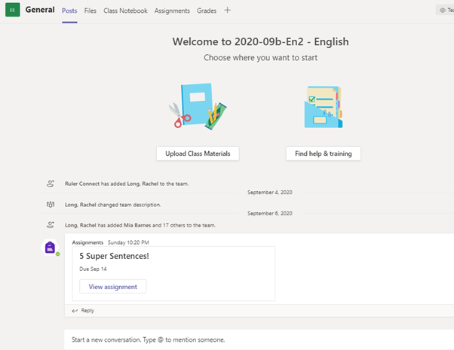
- CHECK IN - Ask students to message you so that you know who is ‘online’ at that point. Direct them towards the lesson resources for the lesson. You can do this by messaging them and copying in the link to the lesson materials folder for the appropriate week.
- EMAIL - Once you have communicated with those online in your lesson, then email work (including links to the weekly lesson folder in Teams) to the class email using Outlook for those accessing the work asynchronously.
- INTERACT - Remain in communication with students for the duration of the timetabled lesson.
- CLOSE - At the end of the lesson, let the class know that you are ending the lesson in the ‘chat function’.

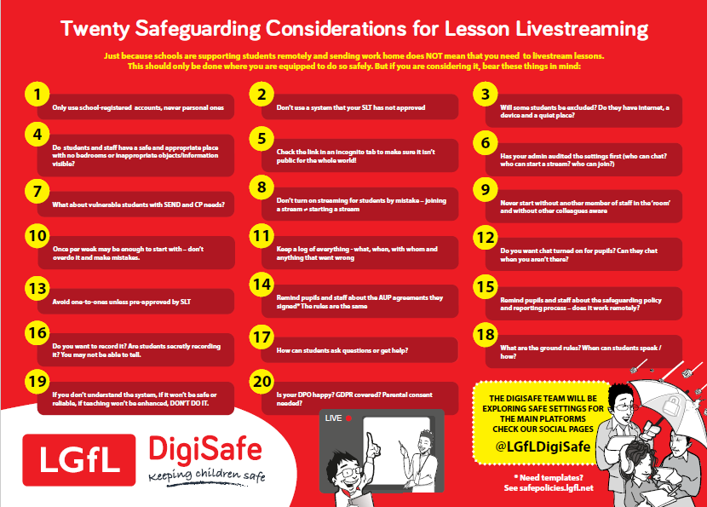
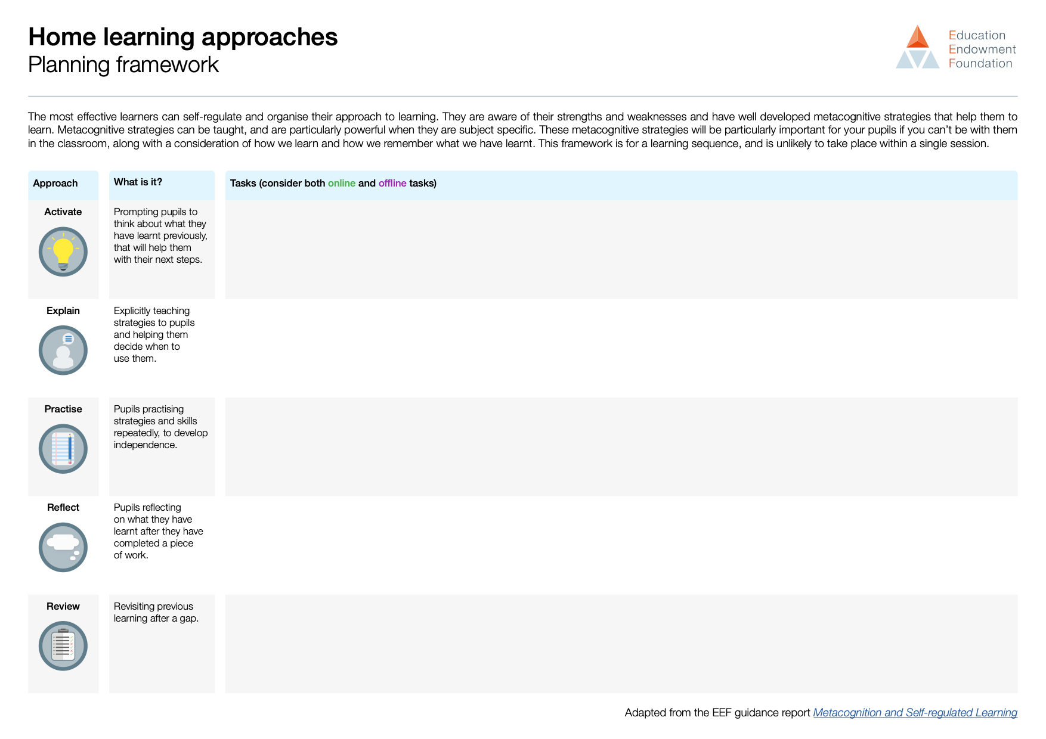

Please note that in this sense, ‘remote learning’ refers to any learning completed outside of school. The school’s approach to ‘blended learning’ is outlined in the ‘Teaching and Learning Policy 2020-21'

