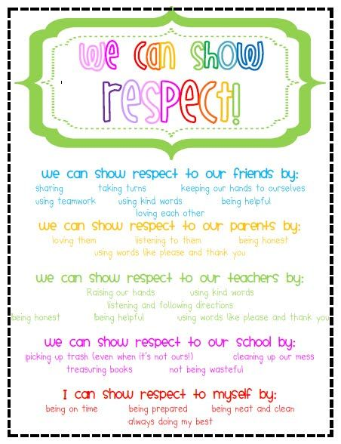

**Thought for the Week 12th November**

**RESPECT**

What else could be added to this very basic list? Create a Form list!