TOPIC: Rivers

Books available for loan through our school library

Title | Author | Medium | Where? | Description | Image | Classification
GCSE Geography | Parsons, Richard | Book | Library | See section 3 – Rivers. This book is full of clear revision notes, detailed diagrams and practice exam questions for GCSE Geography students | 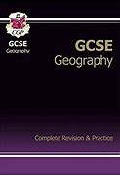 | 371.3
River Nile, The | Throp, Claire | Book | Library | This title teaches readers about the first brave, but sometimes ill-informed, explorers who ventured onto the banks of the Nile. Read all about the region, the river, and some of the most bizarre takes of its exploration. | 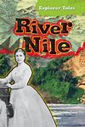 | 916.2
World Book Encyclopedia of People and Places I - L | Various | Book | Library | Page 626 has info on The River Ganges… see the other encylopedias for more rivers. | 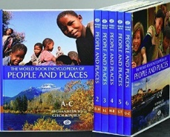 | 913
Ganges, The | Manning, Paul | Book | School Library | River Adventures takes intrepid young explorers on fascinating journeys of discovery along some of the world`s major rivers, from source to mouth. Along the way, readers find out about geography, settlement and trade, history, buildings and culture | 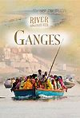 | 915.41
Water Cycle, The: Evaporation, Condensation and Erosion | Harman, Rebecca | Book | Library | Using an enquiry approach, this series explores earth science topics enabling students to learn about the natural processes and cycles that make the earth the way it is today. Various geological, hydrological, chemical and meteorological processes are explained | 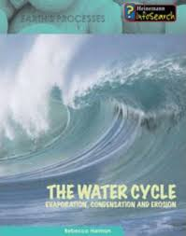 | 551.48  17344
The River | Bellamy, D | Book | Library | Beuatiful illustrations. This is part of a set of four books addressing the main conservation and ecology issues by the famous conservationist. The illustrations reveal the complex and ever-changing world of wildlife in different environments | 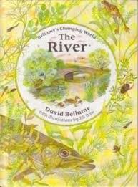 | 551.48  Barcode  2973
Water on the Land | Bain, I | Book | Library | Explores the origins and effects of water on the landscape including the formation of streams and rivers and the impact of erosion. |  | 551.4  Barcode  3020
Rivers and Lakes | Rowland-Entwistle, T | Book | Library | Describes the characteristics of different kinds of rivers and lakes and their importance to the surrounding plant, animal, and human life. | 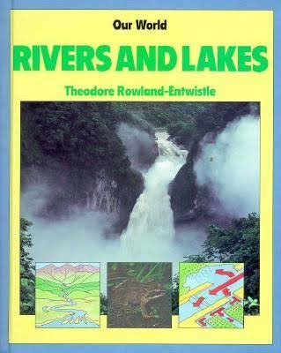 | 551.48  Barcode  2917
Great Rivers of Britain | Pollard, M | Book | Library | Looking at the Thames, Severn, Trent, Clyde, Mersey and Tees, this book examines their formation and physical features; their history; the human settlements along their banks; the role of the rivers today and how they may develop in the future. | 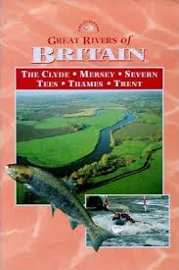 | 551.4  Barcode  7186
Lake and River Peoples | Jennings, T | Book | Library | Examines cultures that live near rivers and lakes, from the industrialized societies along the Rhine and Volga Rivers to the Uru of Lake Titicaca who follow ancient ways of life. Also discusses ways in which commercialization and pollution threaten our fresh water resources. | 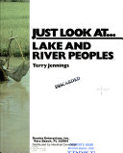 | 551.48  Barcode  2916
Flood! | Ganeri, Anita | Book | Library | Flood! describes how and why floods happen. | 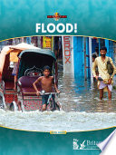 | 551.48  Barcode  14297
Raging Rivers | Ganeri, Anita | Book | Library | Wave goodbye to boring geography lessons. This book takes us on a turbulent river tour from ice cap to ocean, read the secret diary of a brave river explorer and get to know your watery wildlife with the spotter's guide. | 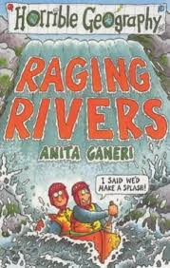 | 551.48  Barcode  14297

