Websites
https://www.roundersengland.co.uk/
News
https://www.roundersengland.co.uk/latest-from-rounders-england/
https://www.roundersengland.co.uk/rounders-england-guidance-next-steps-07-01-2020/
Squads
https://www.roundersengland.co.uk/englandsquads/
Equipment
https://www.roundersengland.co.uk/product-category/rounders-equipment/
Under 14s
https://www.roundersengland.co.uk/englandsquads/trials/
Under 16s
https://www.roundersengland.co.uk/englandsquads/trials/

You Tube
Rounders England Senior Squad International Against Wales 22nd July 2012
https://www.youtube.com/watch?v=veMacwRU9ms
How to play Rounders
https://www.youtube.com/watch?v=8M_SjjvSk3Y
Play Simple Rounders
https://www.youtube.com/watch?v=ApZK7eH40fs
Rounders Rules Video
https://www.youtube.com/watch?v=f5Lxiy9_L9Q

Pinterest
https://pin.it/63qVaO0
https://pin.it/yTC9FZ0
https://pin.it/16VopdI
https://pin.it/1hlJeKo
https://pin.it/2jlMYkD

Books available from our school library
Title | Author | Media | Info | Image | Barcode | Class
Rounders | Published by East Ardsley | Paperback |  | 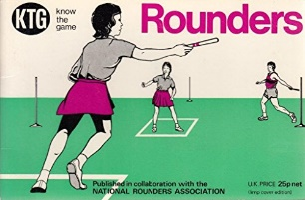 | 7395 | 796 Ref

