Rugby Podcasts
https://www.bbc.co.uk/programmes/p04q5p2n/episodes/downloads

Websites
Rugby Union
https://www.bbc.co.uk/sport/rugby-union

Rugby League
https://www.bbc.co.uk/sport/rugby-league
Quizzes
https://www.bbc.co.uk/sport/rugby-union/52412222
https://www.bbc.co.uk/sport/rugby-league/52084550
Biographies
https://www.biogs.com/biogsdirectory/rugby.html

News Comments
https://www.bbc.co.uk/newsround/35704577

Sport Podcast
https://www.bbc.co.uk/sounds/category/sport?sort=popular

Title | Author | Media | Where | Info | Book Image | Dewey No./Class | Barcode
Jonny Wilkinson Story, The | Spragg Iain & Clarke Adrian | Hardback | Library | Takes the reader on a journey through the extraordinary life and career of England’s latest sporting hero. | 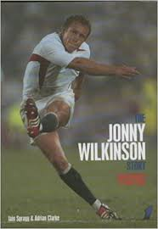 | 920 | 13733
Jonny Wilkinson Story, The | Spragg Iain & Clarke Adrian | Hardback | Library | Takes the reader on a journey through the extraordinary life and career of England’s latest sporting hero. |  | 920 | 11074
Rugby | O`Rorke, T | Hardback | Library | Focus on skills, rules and tactics. | 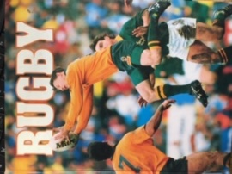 | 796.333 | 7119
Rugby Academy: Combat Zone | Palmer, Tom | Paperback | Library | "First title in a rugby trilogy. Borderlands is no ordinary school - all of the students boarding there have parents in the armed forces, and the UK is drawing perilously close to war in the Middle East. New boy Woody is desperate to escape the school and find his way to his dad's military base, but his dad has been mobilised | 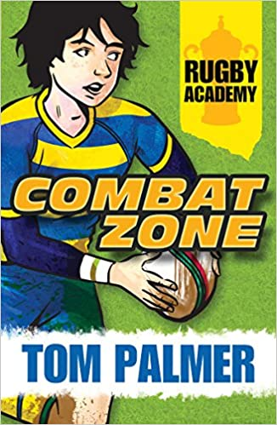 | 823.92 | 19601
Rugby Academy: Combat Zone | Palmer, Tom | Paperback | Library | "First title in a rugby trilogy. Borderlands is no ordinary school - all of the students boarding there have parents in the armed forces, and the UK is drawing perilously close to war in the Middle East. New boy Woody is desperate to escape the school and find his way to his dad's military base, but his dad has been mobilised |  | 823.92 | 19148
Rugby Academy: Deadlocked | Palmer, Tom | Paperback | Library | A sporting story set against the backdrop of war and the effect of conflict on the families of those serving overseas | 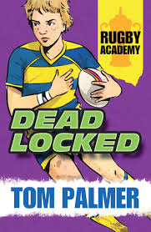 | Fiction | 19587
Rugby Academy: Surface to Air | Palmer, Tom | Paperback | Library | The Borderlands boarding school rugby team have made it into the European Rugby Championship Tournament. They're enjoying their time in France, but Rory and the rest of the team can't help thinking about each of their parents, serving overseas |  | Fiction | 19588
Rugby World - Annual 2000 |  | Hardback | Library | Hot shots, World Cup, Five Nations, Euro Giants, Women, Giants, schools… facts and quizzes | 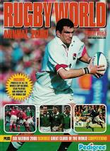 | 796.333 | 11127
World-class Rugby Union Star, A | Langley, Andrew | Paperback | Library | This series looks at how people succeed and reach the top of their chosen sport. | 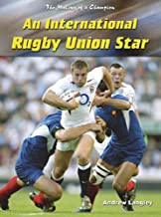 | 796.333 | 14071
Rugby Flyer | Gerard Siggins  Read by Patrick Harvey | eAudiobook | Blackburn with Darwen Libraries  https://fe.bolindadigital.com/wldcs_bol_fo/b2i/productDetail.html?productId=BOL_676599&fromPage=1&b2bSite=5614 | It’s shaping up to be an exciting summer for Eoin Madden. He’s been chosen for a special rugby summer camp where he makes new friends – and an enemy. But will he make the cut for the squad that’s headed to London? | 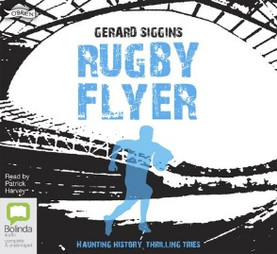 | Fiction
Rugby Rebel | Gerard Siggins  Read by Patrick Harvey | eAudiobook | Blackburn with Darwen Libraries  https://fe.bolindadigital.com/wldcs_bol_fo/b2i/productDetail.html?productId=BOL_654950&fromPage=1&b2bSite=5614 | Young rugby fans will enjoy the adventures of Dublin schoolboy Eoin Madden as he tries to help his school win a cup and, at the same time, solve a ghostly mystery …' — Rugby World |  | Fiction
Rugby Warrior | Gerard Siggins  Read by Patrick Harvey | eAudiobook | Blackburn with Darwen Libraries  https://fe.bolindadigital.com/wldcs_bol_fo/b2i/productDetail.html?productId=BOL_632655&fromPage=1&b2bSite=5614 | ... beautifully crafted by Siggins, this is a book that will thrill any rugby-mad youngster while delighting sports fans (of any age) with an interest in entertaining storytelling.' — Irish Daily Mail | 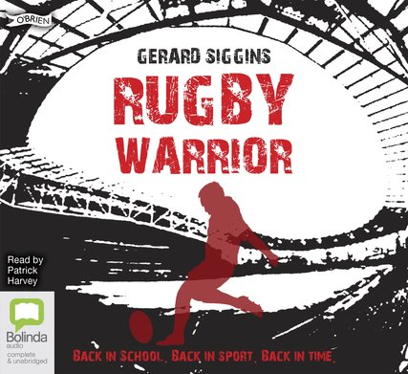 | Fiction
Rugby Spirit | Gerard Siggins  Read by Patrick Harvey | eAudiobook | Blackburn with Darwen Libraries  https://fe.bolindadigital.com/wldcs_bol_fo/b2i/productDetail.html?productId=BOL_620452&fromPage=1&b2bSite=5614 | A brilliant story for rugby-mad youngsters ... its simple approach ensures it can be enjoyed just as much by those new to the game.' — The Sunday Independent |  | Fiction
Rugby Runner | Gerard Siggins  Read by Patrick Harvey | eAudiobook | Blackburn with Darwen Libraries  https://fe.bolindadigital.com/wldcs_bol_fo/b2i/productDetail.html?productId=BOL_723682&fromPage=1&b2bSite=5614 | - Books, crooks and rucks - it’s all to play for this term! 'Engrossing mix of schoolboy rugby tactics and match action with skulduggery and crime to a very satisfying finishing line.' — Mail on Sunday |  | Fiction
Rugby Runner | Gerard Siggins | eBook | Blackburn with Darwen Libraries  https://fe.bolindadigital.com/wldcs_bol_fo/b2i/productDetail.html?productId=FFP_384632&fromPage=1&b2bSite=5614 | - Books, crooks and rucks - it’s all to play for this term! 'Engrossing mix of schoolboy rugby tactics and match action with skulduggery and crime to a very satisfying finishing line.' — Mail on Sunday | 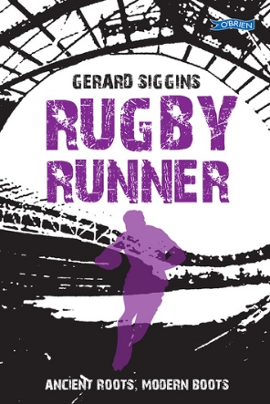 | Fiction
Rugby Heroes | Gerard Siggins | eBook | Blackburn with Darwen Libraries  https://fe.bolindadigital.com/wldcs_bol_fo/b2i/productDetail.html?productId=LSB_671091&fromPage=1&b2bSite=5614 | It looks like Eoin Madden's busiest term ever! He's Castlerock College’s star player and he's been called up for Ireland in the Under 16 Four Nations - how will he juggle sport and school work? | 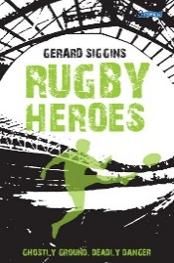 | Fiction
A Little Bit of Rugby Wit  Quips and Quotes for the Rugby Obsessed | Tom Hay | eBook | Blackburn with Darwen Libraries  https://fe.bolindadigital.com/wldcs_bol_fo/b2i/productDetail.html?productId=EPD_483334&fromPage=1&b2bSite=5614 | Scrum-down and get stuck into this mini-collection of rugby humour – the very best quips and quotes for lovers of the odd-shaped ball. | 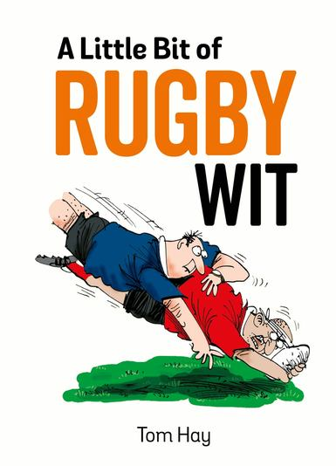
Phil Bennett The Autobiography | Phil Bennett | eBook | Blackburn with Darwen Libraries  https://fe.bolindadigital.com/wldcs_bol_fo/b2i/productDetail.html?productId=HCU_161178&fromPage=1&b2bSite=5614 | The former Wales and Lions rugby captain has travelled the world watching rugby and talking about the game since his retirement in 1978. There is no more authoritative voice in rugby union today and Bennett’s book will tackle a host of issues dominating the sport in the modern era. | 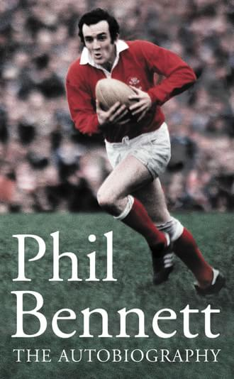
My Life and Rugby  The Autobiography | Eddie Jones | eBook | Lancashire Libraries  https://fe.bolindadigital.com/wldcs_bol_fo/b2i/productDetail.html?productId=MCU_701797&fromPage=1&b2bSite=5070 | Jones has a winning mentality - he is constantly asking for more. England were 18 games unbeaten and I saw his quote saying we are nowhere near ready to win a World Cup. He recognised what the end looks like and what that environment needs to look like. — Gareth Southgate | 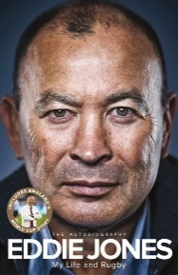
My Life and Rugby  The Autobiography | Eddie Jones  Read by Sam Haft | eAudiobook | Lancashire Libraries  https://fe.bolindadigital.com/wldcs_bol_fo/b2i/productDetail.html?productId=MDA_711892&fromPage=1&b2bSite=5070 | Brilliant, honest, combative – Eddie Jones is a gigantic yet enigmatic figure in world rugby and a true legend of the game. In My Life in Rugby he tells his story for the first time | 
My Life and Rugby: The Autobiography | Jones, Eddie author | eBook | Lancashire Libraries  https://capitadiscovery.co.uk/lancashire/items/borrowbox/MCU_701797?query=rugby&resultsUri=items%3Fquery%3Drugby%26facet%255B0%255D%3Dcollection%253A%2522eBook%2Band%2BeAudio%2522&facet%5B0%5D=collection%3A%22eBook+and+eAudio%22 | Brilliant, honest, combative – Eddie Jones is a gigantic yet enigmatic figure in world rugby and a true legend of the game. In My Life in Rugby he tells his story for the first time, including the full inside story of England’s 2019 World Cup campaign | No image
My Name'5 Doddie: The Autobiography | Weir, Doddie author; Weir, Stewart author | eBook | Lancashire Libraries  https://capitadiscovery.co.uk/lancashire/items/borrowbox/LSB_549642?query=rugby&resultsUri=items%3Fquery%3Drugby%26facet%255B0%255D%3Dcollection%253A%2522eBook%2Band%2BeAudio%2522&facet%5B0%5D=collection%3A%22eBook+and+eAudio%22 | There has never been anyone quite like Doddie Weir. A giant of the game and a rugby icon, his story is unique, inspirational and charged with a passion for living life to the full. | 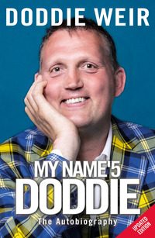
Gordons Game | Howard, Paul author; D'Arcy, Gordon | eBook | Lancashire Libraries  https://capitadiscovery.co.uk/lancashire/items/borrowbox/PRU_730326?query=rugby&resultsUri=items%3Fquery%3Drugby%26facet%255B0%255D%3Dcollection%253A%2522eBook%2Band%2BeAudio%2522&facet%5B0%5D=collection%3A%22eBook+and+eAudio%22 | Gordon D'Arcy is an ordinary boy, but he's not so ordinary once he gets a rugby ball in his hands. He's the star player for Wexford Wanderers and dreams of one day wearing the Ireland jersey. | 
Ordianry Joe |  | eAudiobook | Lancashire Libraries  https://capitadiscovery.co.uk/lancashire/items/borrowbox/PRH_755963?query=rugby&resultsUri=items%3Fquery%3Drugby%26facet%255B0%255D%3Dcollection%253A%2522eBook%2Band%2BeAudio%2522&facet%5B0%5D=collection%3A%22eBook+and+eAudio%22 | In Ordinary Joe, Schmidt tells the story of his life and influences: the experiences and management ideas that made him the coach, and the man, that he is today. And his diaries of the 2018 Grand Slam and the 2019 Rugby World Cup provide a brilliantly intimate insight into the stresses and joys of coaching a national team in victory and defeat | 