School Improvement Plan (SIP) 2020 – 2022 Summary and Priorities

The SIP has been constructed by the following process:
- Update of 2018-20 SIP with current position
- School Improvement Conference input from staff, governors and students
- External data – in particular from IDSR, FFT
The structure of the SIP remains the same as in 2018-20 – with a plan for each element of this diagram:
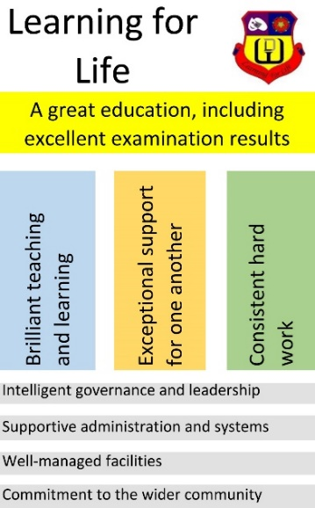
Our distinctive ethos is at the heart of all that we do. This is summarised in the ethos statement on the website and in the key phrases:
- “Learning for Life”.
- “We are aspirational for ourselves and for others”.
Our key priorities are to
- Improve pupil outcomes – especially for those identified as disadvantaged and those with SEND
- Improve health, wellbeing, workload and environment for staff and students
The most important ways of doing this will be through
- Further improving the quality of teaching, learning, assessment and curriculum
- Continually working to improve the attitude to learning of our students
- Developing a culture of professional trust and autonomy based on continuing professional development and open professional dialogue.
Success will be measured by
- Examination results at the end of Year 11
- Attendance data
- Internal and external surveys of staff, students and parent/carers.

