Many 'children taking risks online'
Thought for the Week
w/c 4th February 2019
- 10 February 2015
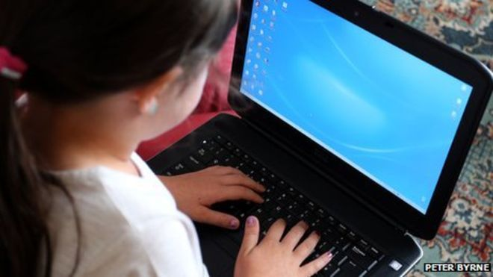ely to use the internet for socialising than boys
More than half of children in the UK (57%) have done something "risky" or anti-social online, a poll of 2,000 11- to 16-year-olds suggests.
Almost two-thirds (62%) told the BBC Learning poll they felt under pressure from others to act in this way.
Activities included sharing unsuitable videos or pictures of themselves or saying nasty things about others and looking at unsuitable websites.
Some 20% said they had put pressure on someone else to act negatively online.
The research was commissioned as part of a new online safety campaign - Be Smart - timed to coincide with Internet Safety Day on 10 February.

Online bullying
Nearly half, some 47%, said they had looked at something online that they thought their parents would not like them to see.
While 14% admitted to sending pictures of themselves, or others, that their parents would not like them to share.
And nearly one in 10 had signed up to websites or services not meant for their age group.
Among 14- to 16-year-olds, almost three-quarters (72%) said they had experienced or witnessed online bullying.

What is inappropriate? BBC talks to 11-16 year olds about their online activity
Andrew Tomlinson, the BBC's executive producer responsible for digital and media literacy, said: "Internet safety is becoming increasingly important as more families get online and children start to use tablets, computers and smartphones earlier in their lives.
"For the third year in succession, BBC Learning is supporting the aims of Safer Internet Day with a campaign of its own.
"Be Smart is giving young people the chance to speak for themselves about the pressures they face on social networking sites."
Meanwhile, a mobile app is to be launched later this year in the UK which will give parents remote access to everything their children get up to on their phones.
It will allow parents to track their child's movements, monitor text messages and vet the websites visited.
Do you think this mobile app seems like a good idea?
Think about it from the perspective of the parent/carer and the child.

