Topic: Slave Trade

Books

Title | Author | Description | Cover | Dewey Ref
Slavery: From Africa to the Americas | Hatt, Christine | Charts the history of 24 million people taken from their homes in West Africa by force | 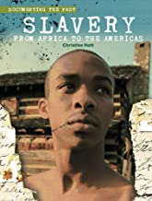 | 326
Slavery and Civil Rights | Steele Phillip | History through exploration of a wealth of primary source material. A factual presentation of each topic is given alongside personal accounts and documents | 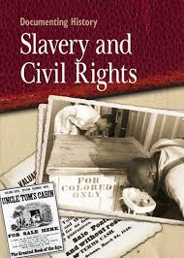 | 323
Transatlantic Slave Trade | Killingray David |  |  | 326  On loan
Black History: Resistance and Abolition | Lyndon, Dan | "Black History is brought to life in this exciting and engaging series, bringing together events from early civilisations in Africa right up to modern-day life for black communities across the world." | 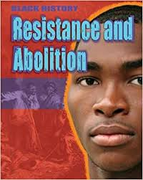 | 909.0496
Black History: Africa and the Slave Trade | Lyndon, Dan | "Black History is brought to life in this exciting and engaging series | 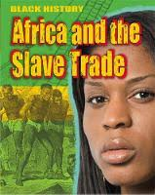 | 326
Story of Slavery, The | Courtauld, Sarah | A compelling account of the story of slavery from ancient times, through the sugar plantations of the Caribbean and America | 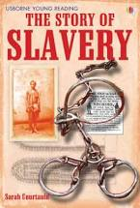 | 428.6
Slave Trade, The | Monaghan, Tom | It looks at the driving forces and vested interests behind the slave trade and assesses the legacy slavery has had on working practices around the world. | 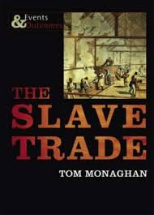 | 326
Uncle Tom`s Cabin | Stowe, H Beecher | Published in 1851, A didactic and sentimental drama set among the slaves of the American South |  | FICTION section
Uncle Tom`s Cabin | Stowe, H Beecher | "Uncle Tom's Cabin is the most powerful and enduring work of art ever written about American slavery." —Alfred Kazin | 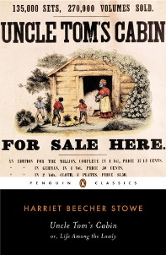 | https://fe.bolindadigital.com/wldcs_bol_fo/b2i/productDetail.html?productId=PGC_258216&fromPage=1&b2bSite=5070
Uncle Tom`s Cabin | Stowe, H Beecher | Published in 1852, it tells the story of Uncle Tom, a patient, forbearing slave and his misfortunes in a life of being sold from one master to the next. | 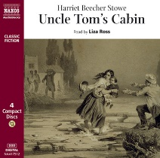 | https://fe.bolindadigital.com/wldcs_bol_fo/b2i/productDetail.html?productId=NXA_378422&fromPage=1&b2bSite=5070
Twelve Years A Slave | Solomon Northup | Autobiography. First published in 1853 | 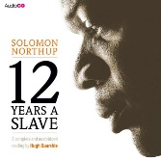 | https://fe.bolindadigital.com/wldcs_bol_fo/b2i/mainPage.html?b2bSite=5070

Books on Africa Lancashire Digital Library - https://fe.bolindadigital.com/wldcs_bol_fo/b2i/search.html?b2bSite=5070&searchBy=ALL&q=Africa

Web Sources
The Unsung Heroes of Abolition
http://www.bbc.co.uk/history/british/abolition/abolitionists_gallery.shtml

The Transatlantic Slave Trade
http://www.bbc.co.uk/history/british/abolition/launch_anim_slavery.shtml
The Post-Abolition World
http://www.bbc.co.uk/history/british/abolition/black_imagery_gallery.shtml
Your Abolition History
http://www.bbc.co.uk/history/british/abolition/local_trade_history_article_01.shtml
https://blackpresence.co.uk/category/black-history/slavery/
Africa and the Atlantic Slave Trade
https://www.nationalarchives.gov.uk/pathways/blackhistory/africa_caribbean/africa_trade.htm
The Caribbean and the Trade
https://www.nationalarchives.gov.uk/pathways/blackhistory/africa_caribbean/caribbean_trade.htm

Why did the Slave Trade develop?
https://www.bbc.com/bitesize/guides/zy7fr82/revision/1

What was life like for slaves?
https://www.youtube.com/watch?v=EhjBsJF4C20

Why did Britain abolish slavery?
https://www.bbc.com/bitesize/topics/z2qj6sg

References and Further Reading
Clarkson, T., History of the Rise, Progress and Accomplishment of the Abolition of the African Slave Trade by the British Parliament, London, 1808
Hair, P.E.H., Jones, A. and Law, R. (eds) Barbot on Guinea. The writings of Jean Barbot on West Africa 1678-1712, London, 1992
Shillington, K., History of Africa, London, 1989
Stepan, N., The Idea of Race in Science: Great Britain 1800-1960, London, 1982
Walvin, J., Black Ivory: Slavery in the British Empire (2nd edn), London, 2001

