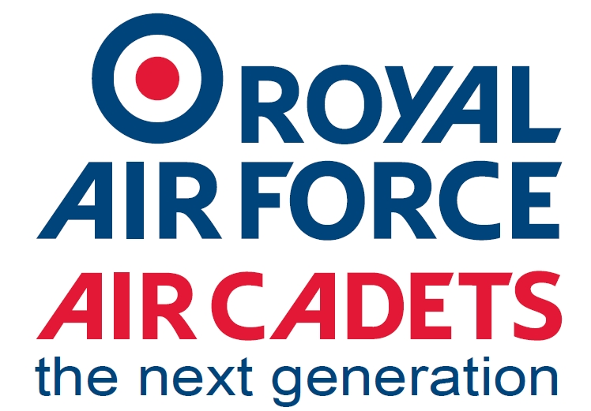

2376 (Bamber Bridge) Squadron Air Cadets.
Mounsey Road, Bamber Bridge, PR5 6LT
01772 491136 (PARADE NIGHTS ONLY)
oc.2376@rafac.mod.gov.uk
PARADE NIGHTS
MONDAY AND THURSDAY 1845-2130.
NEW RECRUIT OPEN NIGHT THURSDAY 23rd JUNE 2021.
We are pleased to announce that we are holding an open evening to welcome new recruits to the Squadron. This will take on Thursday 23rd June 2022 between 7pm and 9.30pm.
Any child who wishes to join or get more information should attend with parent(s). Children must be between 12 and 17 to join and in yr 8, however any yr 7 children are more than welcome to come along and they would be able to join us formally in September.
We are also looking for any adults (over 20yrs) who would like to help.
Activities include, Flying, Gliding, Shooting, First Aid, Flight Simulator, Camps, DofE, Sports, Swimming, Adventure Training, Leadership and many more.
The evening is also the Squadron Annual General Meeting (AGM), which will take place during the evening, everyone is welcome to join us.
There will also be our summer raffle on the night, tickets available at £1.00 per strip.
Prizes include, Hanging Basket, Gin Box, MoT Test Voucher, Luxury Hamper, a signed copy of The Battle of Bamber Bridge (publish date 24th June 2022), plus more

Flt Lt Gillian Fox (RAFAC)
OC 2376 (Bamber Bridge) Sqn ATC

