If there are no images, try opening in Internet Explorer (seems to work better)

**WLD Teaching and Learning Digest – w/c 10th December 2018**

|  |  |
| --- | --- |
| **COMMUNICATION FOCUSES**    Use the whole-school marking policy (codes in planners) to allow students to review the quality of their written work, one term in. What are their SPaG targets? | **INCLUSION FOR ALL**    Allow take-up time. Use pose-pause-pounce and bounce to consolidate and further understanding. |

[](http://www.google.co.uk/url?sa=i&rct=j&q=&esrc=s&source=images&cd=&cad=rja&uact=8&ved=2ahUKEwjJ2r2wuPfeAhWOx4UKHZZQBjoQjRx6BAgBEAU&url=http://clipart-library.com/christmas-cliparts.html&psig=AOvVaw1OqlJhYGQ3kVObYe2vlGQj&ust=1543506615071509)

***Don’t forget to click on our advent calendar!***

**This week:**

* The **thought for the week** this week is **‘Human Rights’.** A PPT explaining human rights has been emailed but also look at the link on the PPT as there are some useful news stories linked to the topic.
* ***NEW!* Picture News** – WL has sent an email about this. Use this new resource to stimulate discussion and to allow you to talk about Fundamental British Values with your students.
* **NQTs –** Friday break time! Cakes in B7 for Subject Mentors and NQTs to celebrate the end of your first term at WLD.
* **NQTs Reminder** – scheduled meetings with LG this week (LG’s office) are to complete the assessment forms.
* **10th December –** Walton le Dale Staff Christmas market @3.15.
* **19th December – *‘Pastries and Progress’* –** bring a marked exercise/process work (rather than a one-off assessment), sit with a colleague and discuss the student’s work, evidence of progress, presentation etc – and enjoy a pastry!

**Think about this…vocabulary matters!**

This approach comes from our advent calendar on Monday and is a useful and simple way to boost vocabulary:

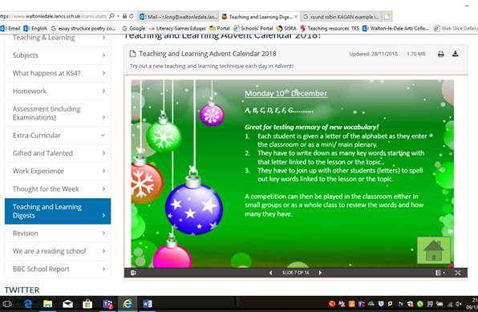

Talk-Talk! Structure of the Week: Round Robin

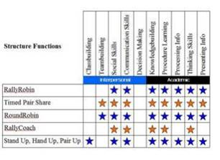

## ****The Round Robin****

The Round Robin strategy is a brainstorming strategy where students are situated around a table in an academic discussion. Like other brainstorming sessions, students generate ideas on a specific topic or question. However, with this strategy, there is equal participation among students as well as multiple discussions taking place.

* **Equal Participation** – The most effective thing about this strategy is that each student within the group has an equal opportunity to participate in the discussion. One student leads the discussion, then each student takes her turn voicing their opinion on the topic. In some cases, one student will be assigned the recorder where their job is to record everything that each student says. If the teacher finds that students are talking out of turn then sometimes they will use “Talking chips,” where students must turn in one chip each time they voice their opinion.
* **Group Discussions** – Tables are arranged around the classroom and positioned so that there are multiple brainstorming discussions taking place at one time. When the timer goes off or when the teachers says, each group moves to another table where the topic is different. Once groups have rotated to all tables, the Round Robin discussion strategy is over.

## *****How to Use it*****

Follow these steps to effectively use the Round Robin Discussion strategy in your classroom.

***Steps***:

1. The best way to implement this strategy into your classroom is to first think of the topic that you want students to discuss.
2. Next, decide on the amount of questions or topics you would like to be discussed so you know how many tables/groups you will need.
3. Arrange the desks or tables so that discussion flows nicely and students can move about easily. Also, consider the placement so that groups won’t be distracted by other groups.
4. Give each table one discussion sheet (preferably a different colour) along with a variety of different-colored pens (this will help distinguish groups from one another). Assign one person the leader of the group and another the recorder.
5. Set a timer for each group. Also, give groups tokens so when it’s each student’s turn to talk, they must turn in a token. This helps the groups move along.
6. Once each group has gone (and before they move to the next group), have the leader present their group’s ideas.

**Top Tips in Two this Term (HoDs please organise who will share and let me know)**

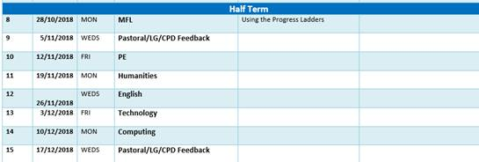

**CPD Cascade**

AY attended a ResearchEd workshop on revision strategies last week. Here are some of the top tips that she has shared:

‘The best strategies are (starting with most effective):

1. Distributed / spaced practice and interleaving

2. Practice testing

3. Flash cards

4. Self explanation

5. Mnemonics

6. Mental imagery / dual coding

The use of visualisers and digital inking were recommended for modelling critical thinking strategies, exam question analysis and modelling in general.

Low stakes quizzing was highlighted again with the emphasis on low stakes. They do it as a starter for most lessons. They also recommended knowledge organisers for all stages to revise from as homeworks for low stakes quizzing, as well as the use of challenge card homeworks (students produce flash cards, mind maps, etc for a topic to earn stamps for rewards). The use of the knowledge organisers and challenge cards means that the student ALWAYS has something they can do as homework, so parents that complain their child has no homework to do are easily pacified. ‘