Learning for Life
Long, Rachel
Walton le dale high school
2019-2020
Learning policy
Contents
TEACHING AND LEARNING POLICY 2
Overarching drivers behind our policy and approach 2
Vehicles for driving our vision – all of this is viewed as CPD: 2
Daily Practice 2
WLD Learning Policy 3
One Page Summary 3
Feedback 3
Expectations: 3
Plan 3
Expectations: 3
Teach 3
Expectations: 3
FEEDBACK – PLAN – TEACH 4
1. Teachers must have a secure overview of the starting points, progress and context of all. 4
2. Marking and/or feedback must be primarily formative, may be selective and include MAD time to allow students time to reflect and Make A Difference to their assessments. 4
3. Feedback must be regular 5
4. The whole-school marking policy must be actively used and discussed with students. 5
The Written Communication Policy 2019-20 (modified in June 2019) 5
Feedback – Plan – Teach 6
Brilliant Teaching and Learning Toolkit 7
Lesson Sequence – Adapted from ‘The Secret of Literacy’ by David Didau 9
Feedback – Plan - Teach 12
Reading 12
Oracy 13
Numeracy 14

TEACHING AND LEARNING POLICY

Overarching drivers behind our policy and approach
- Rosenshine’s Principles of Instruction
- EEF reports: literacy, PP
- Alex Quigley’s: ‘The Vocabulary Gap’
- ‘The Secret of Literacy’ by David Didau

Vehicles for driving our vision – all of this is viewed as CPD:
- Brilliant Teaching and Learning Toolkit
- T&L Digest – weekly
- Top Tips in Two Minutes – drip-feed CPD shared by colleagues, for colleagues
- Pastries and Progress – more practical hands-on CPD giving staff the opportunity to try an approach (i.e. cooperative learning, feedback showcase)
- Drop-ins and follow-up conversations
- Informal and formal work scrutiny
- Teaching How2s – online community allowing teachers to share CPD and approaches with one another through ‘nudges’
- SLT Link meetings – half-termly joint activities
- SIG – Middle Leader forum
- Whole school CPD
- Study Groups – curriculum focus for 2019-20

Daily Practice
- Teacher planners – designed to allow teachers space to think about their craft in terms of school priorities and literacy elements
- Brilliant Teaching and Learning Toolkit
- Inclusion Toolkit
- Dialogue about lessons

WLD Learning Policy

One Page Summary

Feedback
Feedback is fundamental in formative assessment, which is the key to enabling students to progress. It has two key purposes: to allow students to make progress over time; and to inform future planning and teaching.

Expectations:
- Teachers must have a secure overview of the starting points, progress and context of all.
- Marking and/or feedback must be primarily formative, may be selective and include MAD time to allow students time to reflect and Make A Difference to their assessments.
- Feedback must be regular.
- The whole-school marking policy must be actively used and discussed with students.

Plan
Formulating a coherent, cohesive and well-structured learning sequence is a process, as opposed to the plan, which is the product. The planning stage has two functions: to enable high quality learning which meets the needs of all students.

Expectations:
- Be clear and precise about the knowledge and skills that you want students to learn, not what you want them to do. Break the skills and knowledge down.
- Ask ‘why’ when planning learning. Do not include activities to keep students busy. Learning must be central to every element of the plan.
- There must be evidence of long-term planning from schemes of work and short-term planning in teacher planners (or evidenced elsewhere).
- Differentiation should be planned over time to ensure a Quality First approach which meets the needs of all in the room and optimises the use of any additional adult in the room.
- Every class must have a seating plan on ClassCharts that accounts for their profile.
- In line with Basics@WLD, there should be no dead time. This includes a flying start, with students purposeful from the beginning.

Teach

Fulfilling the role of teacher is fundamental to allowing successful learning and progress to take place.

Expectations:
- We are all teachers of literacy (communication) and numeracy. The quality of both students’ and teachers’ language, such as in concise instructions and questioning, are determinants of progress. Making the implicit, explicit.
- Teachers must be explicit about the learning outcomes (or big question) and key vocabulary.
- Be flexible and adapt: the flow or great learning is more important than sticking rigidly to the plan.
- All students must be working harder than the teacher, over time.
- Retrieval activities and interleaving will be inbuilt elements of the learning sequence. Students should know more and be able to do more.

FEEDBACK – PLAN – TEACH

Feedback… has two key purposes: to allow students to make progress over time; and to inform future planning and teaching.

Teachers must have a secure overview of the starting points, progress and context of all.

A secure overview means that:
- The information in the ‘progress ladder’ is understood. This includes:
  - Prior attainment data from primary school
  - Reading age data
  - Cohort and progression path on progress ladders
  - GL assessment data
  - How the student is doing in your subject compared to others
  - How the student has done in your subject, prior to you teaching them.
- Teachers should understand the student’s overall strengths and weaknesses, in examined courses it is advisable to have a checklist linked to progress ladders.
- Teachers should be aware of the context of each class because:
  - Of the relationships formed with them, in line with the Behaviour for Learning policy
  - You make a mental note of any announcements about student welfare, for example in briefings, on ClassCharts or by email
  - You liaise with Progress Coordinator or Form Tutor where necessary
It is important that a student’s context rarely means that you should adjust your aspirations of what they can achieve. At WLD, we believe in being ‘aspirational for ourselves and others’.

Without a secure overview, it is impossible for a teacher to form the first wave of intervention by delivering ‘Quality First’ teaching. Feedback provides a marker to teachers as to whether students have learnt what has been taught.

Marking and/or feedback must be primarily formative, may be selective and include MAD time to allow students time to reflect and Make A Difference to their assessments.

‘Primarily formative’ – means that the focus of your marking must show students how to improve. A summative mark/band/grade often means that the students spent their time comparing their performance with that of their peers on not on improving their mark. The use of MAD time is designed to engage students within the improvement process and will be completed in a different colour pen (usually red pen).
Summative assessments will be marked in more detail and their frequency should be proportionate to the amount of curriculum time, although they must also have formative comments. These assessment will form the minority of marked work in any subject or year group.

‘Selective marking’ – allows a more precise focus on key areas for development and to ensure progress within them. Subject-specific spelling errors (Tier1 vocabulary) will be corrected and students will be asked to copy the correction five times.

Feedback must be regular

Marking frequency should be in line with the published policies online. If the time taken to mark a class set of books is out of proportion with the amount of time that the class collectively spends on responding to the feedback then something has gone wrong. If students do not engage with the feedback then there is no impact.
- Class Feedback templates available in lots of formats online.

The whole-school marking policy must be actively used and discussed with students.

The laminated Written Communication Policy should be displayed in every classroom on A3 in buff coloured paper. When used by everyone, it saves time and explanation. The students must feel that they work is marked in the same way across the school. Abbreviations from the policy should be written in the margin in green pen. When teachers deliver feedback to students and refer to the policy, students must be prompted to look at the policy within their planners (or in their exercise books, if appropriate).
Where teachers notice a common error, intervention in-class will be planned and delivered.

The Written Communication Policy 2019-20 (modified in June 2019)
These codes will be used by teachers and students to correct the basic accuracy of written work in all subjects.
SYMBOL | WHAT DOES IT MEAN?
U | Underline headings
C | Add the missing or amend the misplaced capital letter
P | Add the missing or amend the misplaced punctuation mark
SP | Correct the spelling error

Expectations:
- Do you make your expectations clear before a task? (i.e. when writing a letter or a persuasive article?)
- Do you actively reinforce the importance of accurate written or spoken word? For example, emphasising the need for correct sentence punctuation in one-sentence answers or correcting ‘we was’ in pupils’ speech?
- Do you point out spelling, grammar or punctuation issues as you walk around the class?

Feedback – Plan – Teach

Formulating a coherent, cohesive and well-structured learning sequence is a process, as opposed to the written, which is the product. The planning stage has two functions: to enable high quality learning which meets the needs of all students.
- Be clear and precise about the knowledge and skills that you want students to learn, not what you want them to do. Break the skills and knowledge down.

‘Give me six hours to chop down a tree and I will spend the first four sharpening the axe.’
Abraham Lincoln

Planning is about hard thinking, not filling in forms. It is a thinking process. As obvious as it sounds, a teacher’s planning must consider what you want students to learn first, and spend some time on it, before you give any consideration to what you want them to do. High quality planning requires a broader strategy than this. All too often, planning begins with the final question:

- Where are the students starting from? (secure overview)
- Where do you want them to get to?
- How will you know when they are there?
- How can you best help them to get there?

Scenarios to avoid:
- Formulation of activities
- Coverage-based lessons
- Over-planned lessons

Instead, aim for:
- Excessive clarity and precision when articulating what you want your students to learn and what you would like them to do so that they learn it.
- Phrase explanations in a way that students quickly understand what they are aiming for.
- Breaking down what you would like students to learn to reveal the skills and knowledge that they need to acquire and which need, therefore, to be taught.
Clear and precise command words
Adapt  Speculate  Transfer  Infer  Predict  Discriminate | Negotiate  Summarise  Reconstruct  Examine  Compare  Evaluate | Extrapolate  Determine  Hypothesise  Determine  Evaluate  Model  demonstrate | Construct  Reorganise  Tabulate  Interrelate  Separate  modify

- Ask ‘why’ when planning learning. Do not include activities to keep students busy. Learning must be central to every element of the plan.
To improve students’ understanding of their own learning, it is useful to consider why and how we plan learning for our students. Over-planning can be very common. If a learning activity is not making a significant difference, then drop it.
Activities must be focused on learning, as opposed to control. This can be easier said than done, but in any circumstances, learning should be you long term goal. After planning a sequence, always check that the activities are supporting you to deliver the learning that you want to achieve and whether there was a more efficient and effective way of doing it. Ask yourself ‘so why’ after each planned activity and the length of time allocated to its completion.

Brilliant Teaching and Learning Toolkit

As part of the teacher’s planning, the ‘Brilliant Teaching and Learning Toolkit’ should be used. This organic document is updated, with input from colleagues, twice per year: February and July. It contains ideas and best practice to ensure that school priorities are addressed.
The ‘Brilliant Teaching and Learning Toolkit’ should be stored somewhere for use during planning stages (i.e. in the Teacher Planner) and an electronic version is also stored in the ‘WLD Teachers’ Team.

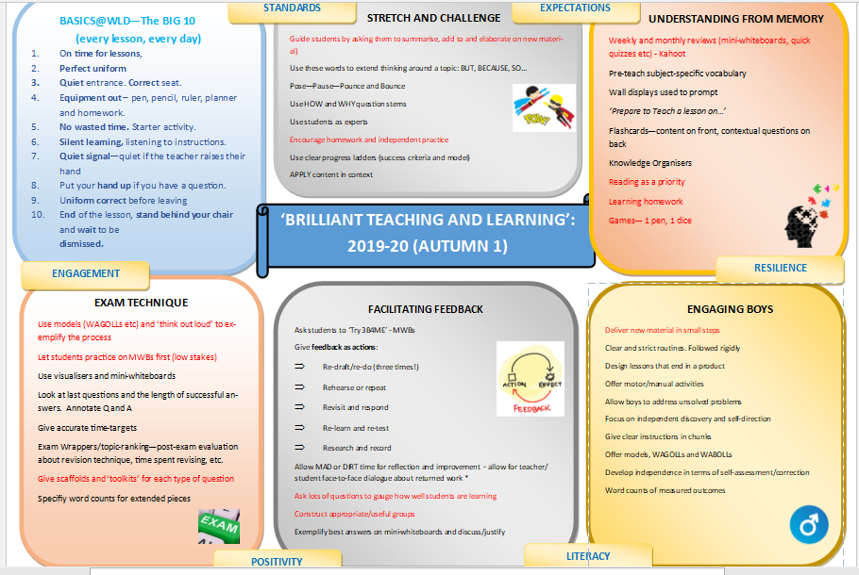

Learning Objectives or Big Questions
How often do you question your own learning objectives? The precision of your language really counts in making the learning relevant so that it sticks; this does NOT mean asking students to copy learning objectives. Ask yourselves again:
- Where are the students starting from? (secure overview)
- Where do you want them to get to?
- How will you know when they are there?
- How can you best help them to get there?

Lesson Sequence – Adapted from ‘The Secret of Literacy’ by David Didau
- Explain – set the context and introduce new language. Place the topic in the whole scheme. Link to prior learning. This is the ‘why’.
  - Use questioning to see whether your explanation has impact and clarity. Only use them to make the explanation clearer. Afterall, ‘if you can’t explain it simply, then you don’t understand it well enough.’ (Albert Einstein).
  - Don’t dumb down. Use academic language (see Teacher Planners for Tier 2 Academic Word List).
  - Allow students time to practice using this academic language.
  - Prepare concrete examples to show students and add in some close but non-examples too (i.e. an onomatopoeia is a sound effect word like boom or crash. ‘Explosion’ is not an onomatopoeia; it is a non-example).
  - Address misconceptions

- Model – model and deconstruct.
  - Use WAGOLLs to show the success criteria in action
  - Clearly define the success criteria

- Scaffold – should not be used to make the work easier, but is should make the work possible. In order for it to work well, scaffolding should get the student interested; should be simple enough to allow them to attempt it; should give specific ideas of how to attempt the task; and should deal with their frustrations at ‘not getting it.’

  - Pitch it at the top and then scaffold upwards
  - Offer general encouragement: ‘Now you have a go…’
  - Give specific instructions: ‘Do this first and then try…’
  - Directly demonstrate: show students what to do

- Practice – independently
This is where oracy is key. Teachers should aim to clarify, probe and recommend. Teachers talking is okay as long as they use quality language and high levels of vocabulary. Refuse to allow students ‘off the hook’ and do not allow the ‘I don’t know’ answer. Instead, ask another student and then return to them.

Strategies:
- Pose – pause – pounce – bounce
- Deeper questioning (see grid below)

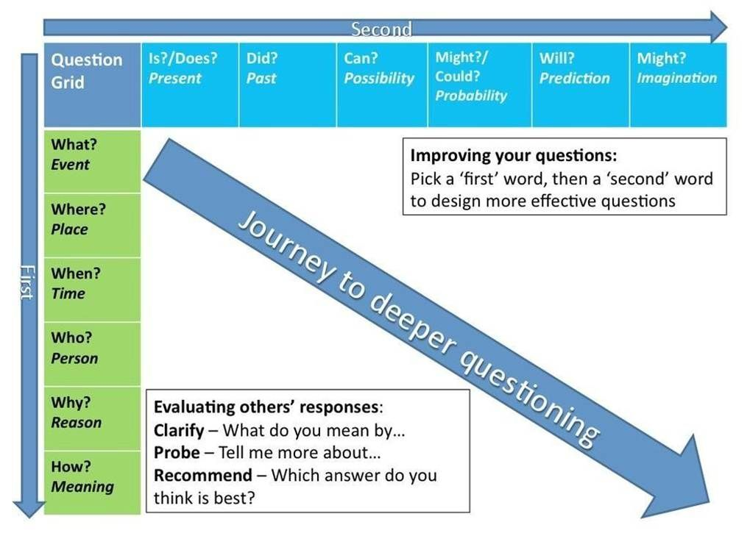

- There must be evidence of long-term planning from schemes of work and short-term planning in teacher planners (or evidenced elsewhere).
We do not expect teachers to produce individual lesson plans, but we do expect evidence of ‘planning over time’. Teachers’ plans must contain the difference between the scheme of work and the lesson you intend to deliver.
The WLD Teacher Planner contains common elements required for successful learning sequences. However, we also recognise that some members of staff plan electronically using PowerPoints or other programs. There must be evidence for each lesson that you teach, in an appropriate format:
- The WLD Teacher Planner
- Electronic equivalent
- Ring binder of planning sheets
- Ring binder of lined paper (must contain lesson number and date).

- Differentiation should be planned over time to ensure a Quality First approach which meets the needs of all in the room and optimises the use of any additional adult in the room.
What is Quality First?
High quality teaching, including appropriate differentiation, is the first wave of intervention.
Differentiation Techniques  Seating plan  From the top down  Variety  Resources online  Timings  Extension work  Sequencing of task | Questioning – progression, number and style  Assigning roles  By outcome  By support  Model answer (WAGOLLs) and visualiser

The second form of differentiation is feedback and planning. This continues to be a challenging aspect of classroom practice so adopting a ‘differentiation over time’ approach – rather than trying to meet the needs of individual students in one-off activities (worksheets etc) – is time consuming, unsustainable and an ineffective use of time (not to mention the impact on workload).
ADD IN SEND TOOLKIT FROM JMA

- Every class must have a seating plan on ClassCharts that accounts for their profile.
Expectations:
- The seating plan offers differentiation possibilities and wave one intervention for Quality First teaching.
- The seating plan is used to evidence that the teacher has processed data available for a class.
- The teacher should always decide on where students sit.
- Changing the seating plan at the start of a new term keeps the dynamics fresh.
- Use ClassCharts seating plan facility to monitor the position of vulnerable students (i.e. PP, SEN, AG&T etc)
- Consider having more than one seating plan per class so that you have groups and individual seating plans

- In line with Basics@WLD, there should be no dead time. This includes a flying start, with students purposeful from the beginning.
Expectations:
- This list of 10 basics must be displayed in every classroom.
BASICS@WLD
Every Lesson, Every Day – The Big 10!
- On time for lessons, respect for learning.
- Perfect uniform in every lesson.
- Come in quietly. Sit down in your correct seat.
- Equipment out – pen, pencil, ruler, planner and homework.
- Starter activity – no wasted time.
- Silent learning, listening to instructions.
- Quiet signal - quiet if the teacher raises their hand
- Put your hand up if you have a question.
- Uniform correct before leaving the lesson.
- End of the lesson, stand behind your chair and wait to be dismissed for an orderly exit.
We are WLD

Feedback – Plan - Teach

‘Teaching is a lifetime’s craft. “Every teacher needs to improve, not because they are not good enough, but because they can be even better.’ (Professor Dylan William)
- We are all teachers of literacy and numeracy. The quality of the teachers’ and students’ language, such as concise instructions and questioning, are significant in determining the progress made. This relies on making the implicit, explicit. At some point in every lesson, you will be required to model HOW to read, write, speak or listen.
 | READING | ORACY | WRITING
STUDENTS | - Years 7-9 bring a book with them each day | - Use of standard English in the classroom.  - Talk in purposeful ways. | - Writing should be proof-read against the marking policy.  - Use the word of the week, where possible.
TEACHERS | - Promote wider reading around the subject  - Promote reading for pleasure | - Oral rehearsal (talk to write)  - Targeted questioning  - Use cooperative structures to challenge all. | - Plan opportunities within lessons to use the word of the week.  - Use WAGOLLs where possible to exemplify good practice.  - Provide success criteria for written work.
DEPARTMENTS | - Key words on display and explored within lessons (Tier 2 and 3) and in knowledge organisers (where these have been created). | - Plan cooperative learning exchanges in lessons where appropriate. | - Embed the use of the marking policy.
FORMS | - Reading material through Form PPT each week. Discussion and exploration of the text. | - Promote discussion of ‘thought for the week’ and word of the week using oral rehearsal.

Reading
When reading longer more challenging texts, Reciprocal Teaching (Vygotsky) will be used to enable students to support one another to fully digest the text. It is an instructional activity in which students become the teacher in small group reading sessions, equipped with a straightforward set of reading comprehension prompts. Teachers model, then help the students to learn to guide group discussions using four strategies:
- Summarising
- Questioning
- Clarifying
- Predicting
Expectation:
All teachers will use this strategy when reading longer or challenging texts with students.
Prompts:

READING WARRIORS
PREDICT
Use the clues from the text or illustration to predict what might happen next

- I think…because…
- I predict…because…
- I suppose…because…
- I think that I will learn…because…

QUESTION
Ask questions as you read.
Ask some questions that have answers in the text.

Use the question words: Who? What? Where? When? Why? How? What if…?

CLARIFY
How can you figure out a difficult word or idea in a text?
- Try sounding it out
- Try breaking it down
- Think about what would make sense
- Re-read and read ahead to see if you can work it out
- Talk to a friend

SUMMARISE
Using your own words, sum up the main ideas from the text in order.

- This text is about…
- This part/section is about…
- First…next…in the last paragraph…

Oracy

Over the last two years, ‘purposeful interaction and talk’ has been a focus. Cooperative structures have been re-launched to maximise participation and challenge. The three main structures promoted are: think-pair-share, Round Robin and All Write Round Robin (also presented as a silent conversation).
Oral rehearsal in preparation for writing tasks is essential. Given the nature of our students, the opportunity to rehearse writing by discussing ideas with a partner or small group in standard English, not only improves their content, but their literacy.
Prompts:
ORACY – BASICS@WLD
- Be concise
- Be clear
- Be more explicit
- Use strategies regularly, not as a one off…
- Make your students work harder than you

Writing
‘I do; we do; you do’ or modelling is a key teaching strategy that, when coupled with high expectations, supports students to make maximum progress.
By using a metacognitive approach and explaining or demonstrating to students what is expected of them, students are better able to respond effectively to tasks.
It is particularly important that this strategy is used when expecting a student to complete any form of extended writing.
Prompts:
WRITING – BASICS@WLD
Step 1: Look at similar texts and annotate key features. This becomes your success criteria.
Step 2: I do – watch me write
Step 3: We do – let’s write a section together (use the visualiser here)
Step 4: You do – now it’s your turn
Step 5: Let’s share our writing and evaluate the success criteria and what went well (the visualiser is useful for this stage, too)

Use it!

All classrooms have desk top computers and visualisers so exemplifying successful writing is simple. This piece of hardware must be used when possible and it is useful for the teacher to talk through choices when writing.

Numeracy
We are all teachers of numeracy. Numeracy includes significant aspects of what is taught in mathematics but also include the ability to use numbers and solve problems in other subjects and in real life.

A strong mathematical grounding is beneficial for a wide range of subjects, including the STEM subjects (Science, Technology, Engineering and Mathematics) but also geography, computing, art, PE and so on.

When you are teaching something numeracy related, you should make it explicit that you are doing so, to enable students to see the relationship between subjects.

Numeracy includes:
Reasoning | Problem solving | Decision making | Use of space
Measures | Calculations | Data handling

…as well as anything else which is taught within the mathematics curriculum.

- Teachers must be explicit about the learning outcomes (or big question) and key vocabulary.
Students must know the knowledge and skills that you want them to learn and the language that they are expected to understand and use (tier 2 and tier 3 vocabulary).

Teachers must share the big question or learning outcomes (preferably written and verbally) with students and display key vocabulary for the lesson on the board/PowerPoint or presentation source. The key vocabulary should be referred to and made explicit throughout the lesson. Students must not copy down learning outcomes as a ‘control’ activity. On rare occasion, this may be deemed appropriate (i.e. if the classroom climate is not as it should be and needs to be corrected by providing a focus). Copying is definitely not a ‘flying start’ to lessons.

Instead, you may try:
- Asking for a reminder of the previous learning outcomes and key words; the class may then speculate as to what they may learn this lesson.
- Completing the first activity above and then asking the class to define the learning outcomes.
- Teach the lesson and then ask students to articulate the learning outcomes or big question.

Key words must be referred to throughout the lesson; otherwise mentioning them at all will be pointless. The high expectations of the teacher will be represented in the teacher’s language and the key words will not be commonly understood unless referred to throughout the lesson. There should be no more than two or three key words per lesson.

- Be flexible and adapt: the flow or great learning is more important than sticking rigidly to the plan.
‘Be flexible and adapt’ means that teachers have the freedom to teach and veer off from the formulated plan when necessary to ensure that learning takes place. This recognises and values teachers who are intuitively recognise whether students have learned what they have been taught and re-formulate learning accordingly. This still means that planning needs to be thorough and detailed (i.e. purposeful), otherwise there would be nothing to adapt. Unplanned lessons, though possible for experienced teachers, are not desirable and are certainly not professional.

Remember, the point of the lesson is to maximise learning, NOT to deliver the plan. Being ‘flexible and adapting’ ensures ‘flow’ in the delivery of teaching and learning.

- All students must be working harder than the teacher, over time.
As our motto says, ‘Learning for Life’, this is ultimately what we need to prepare them for. Our students must have the expectation that when they arrive to our lessons, they will think and work hard for sustained periods. This does not mean that whole-class teaching or direct instruction is discouraged; but over time, the students should work harder than you.
The planning of your lessons is pivotal to this and especially the structure. The start of your lesson can and should set the tone for the rest of the lesson. Your students come in and immediately start working unprompted while you meet and greet. When new to teaching or with a new class, you may feel that you are the person working the hardest by some distance. It should be your ambition to reverse this. This is a key part of student self-regulation. Teach the learning behaviours that you would like to see and be relentless in getting these right.
- Retrieval activities and interleaving will be inbuilt elements of the learning sequence. Students should know more and be able to do more.
If learning is planned for, teachers should be able to gauge if learning has taken place. However, it is not always that easy. Learning cannot always be seen. It is therefore vital that teachers can confidently and accurately use teaching techniques to gather a secure overview as to whether students have remembered certain information. All teachers should be confident in testing whether learning has stuck, using systematic and incisive techniques, frequently based on questioning.
Far too often, teachers make the assumption that teaching something means that is has been learned. This feedback is absolutely fundamental in ensuring that students make strong progress over time. Every teacher has had the experience of writing the same comment in every book or seeing the same mistake on every exam paper, because learning was not checked effectively.
Ensuring that learning sticks, starts with the planning and formulation. If you have planned an effective sequence of learning so that the main activities are as long as possible, this enables you to circulate to monitor progress. Mini-whiteboards and other interactive strategies also facilitate this feedback.

