Week 2 What is a Raga?
Can you create your own raga scale and send it to you teacher. Your teacher will email you all the resources you need.

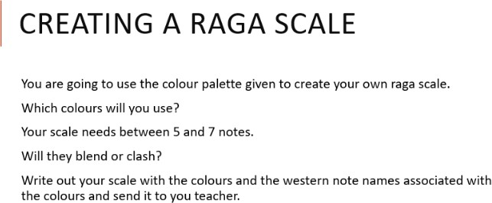

Answer:
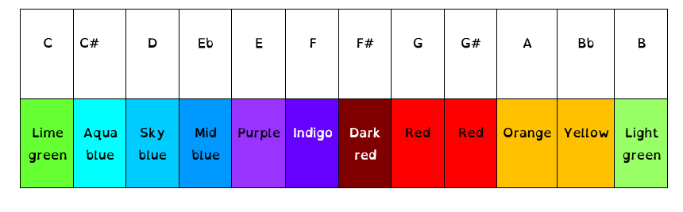
Here is my Raga Scale:

D | E | F | Bb | A | G | F#

Which colours will you use?
I have used the above colours because I think they blend together really well, I like the way they go from a cold gentle blue, right through orange4s and red to represent warmer colours and finally on to dark red so it looks really fiery and angry!
Will they blend or clash?
I think they should blend together OK, the only problem really is where it goes from indigo to yellow, maybe that is a bit too much of a jump but I think it would look OK

