The Final Sprint Leader Board
Revise to win an Amazon Fire 7 Tablet!
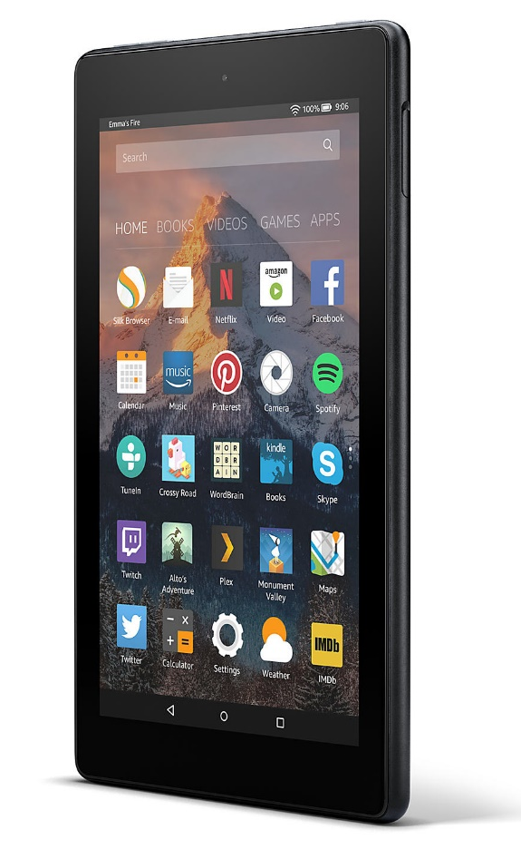
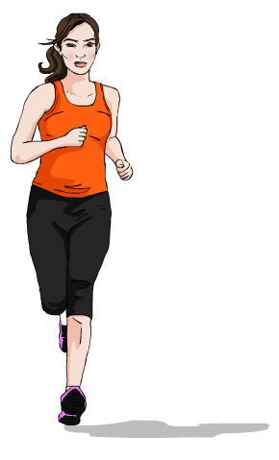
- To win, use Doddle to revise for your exams!
- The more resources you complete, the better your chances of winning
- Complete assignments set by your teachers and explore the Browse tab
- The Top 3 students nationwide using Doddle between 16 April-6 May will win an Amazon Fire 7 Tablet, with runner-up prizes for the Top 10

