Topic: Titanic

Books

Title | Author | Description | Images | Dewey Ref
Titanic Destination Disaster | Eaton, J P Haas, C A | Ninety years after the most famous sinking of all time, two of the world's foremost authorities on the Titanic present this popular account of the sea's best-known disaster. | 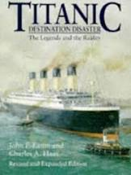 | 910.53  School library
Titanic, The | Malony Senan | Powerful and emotive book takes you back to turn of the century | 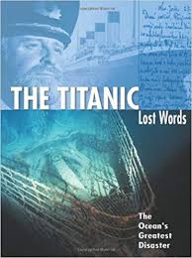 | 910.9  School library
Titanic Voices Memories from the Fateful Voyage | Hyslop, Donald Forsyth, Alastair Jemima, Sheila | Using many previously unpublished photographs, letters and oral histories, "Titanic Voices" is a recreation of the sinking of the great ship, reliving the events through the first-hand accounts of those who were actually there. | 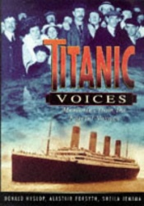 | 910.45  School library
True Disaster Stories | Deary,Terry | This is a collection of true stories of different people involved in many different kinds of disaster, and how they behaved in life or death situations. | 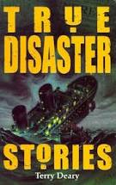 | 904  School library
Famous Shipwrecks | Spence, D & Spence, S | A look at the world’s most famous shipwrecks, from the mighty Spanish galleons, hoards of treasures to modern day disasters. | 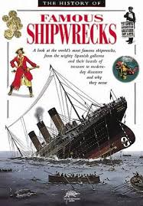 | 910.4  School library

Web Sources
National Archives
https://www.nationalarchives.gov.uk/titanic/
https://www.nationalarchives.gov.uk/titanic/list-index-society-flyer.pdf
Podcasts
https://media.nationalarchives.gov.uk/index.php/titanic-the-official-story/
Crewman on the Titanic
https://media.nationalarchives.gov.uk/index.php/frederick-woodford-a-crewman-on-titanic/

