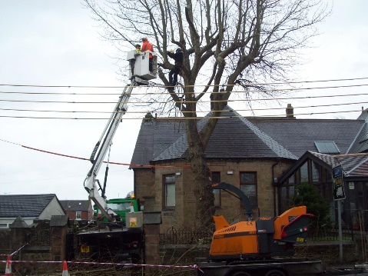
Job title: Tree Surgeon
Job title: Tree Surgeon  Tree climber, arborist | Tree surgeons carry out tree work including planting, felling, care and maintenance, and hazard assessments.
Entry requirements: | University:  You can study for a foundation degree, higher national diploma or degree.  Relevant courses include:  - forestry  - arboriculture  - countryside management  - forest management  - woodland ecology and conservation  You'll usually need:  - 1 or 2 A levels for a foundation degree or higher national diploma  - 2 to 3 A levels for a degree  College:  You could do a college course, which would teach you some of the skills and knowledge you need in this job. Relevant subjects include:  - Level 2 Certificate in Forestry and Arboriculture  - Level 3 Diploma in Forestry and Arboriculture  - Level 3 Diploma in Work-based Trees and Timber  You'll usually need:  - 2 or more GCSEs at grades 9 to 3 (A* to D) for a level 2 course  - 4 or 5 GCSEs at grades 9 to 4 (A* to C) for a level 3 course  Apprenticeship:  You can get into this job through an arborist intermediate apprenticeship.  You'll usually need:  - some GCSEs, usually including English and maths, for an intermediate apprenticeship  Work:  You may be able to start as a ground worker, supporting a qualified tree surgeon. You could then work your way up by completing further training in the use of chainsaws, ropes, ladders and harnesses.  Volunteering and Experience:  It can be useful to get some experience of tree work by volunteering with conservation organisations or horticultural groups. For example, you can contact the National Trust and the Woodland Trust about opportunities.
Skills required: | You'll need:  - physical skills like movement, coordination, dexterity and grace  - to be thorough and pay attention to detail  - the ability to work well with others  - leadership skills  - patience and the ability to remain calm in stressful situations  - sensitivity and understanding  - the ability to use, repair and maintain machines and tools  - ambition and a desire to succeed  - to be able to carry out basic tasks on a computer or hand-held device
What you'll do: | Your day-to-day tasks may include:  - assessing hazards posed by trees  - assessing tree health and treatment  - pruning or removing branches  - planting and felling trees
What you’ll earn: | £16,000 Starter to £30,000 Experienced
Working hours, patterns and environment: | - 41-43 hours per week  - You could work weekends at short notice  - You could work on the road, on rail tracks or in parks and gardens.  - Your working environment may be outdoors in all weathers, at height, dusty and physically demanding.  - You may need to wear safety clothing.
Career path and progression: | With qualifications and experience, you could progress to supervisor or manager. You could also start your own business.  You could move into recreational tree climbing, taking people into treetops as an outdoor activity.

