WLD Communications Survey

152 Responses online (no responses from the paper forms posted home)

13.9% of responses were from members of staff
86.1% of responses were from parents/carers

A specific focus was on parents who live at different addresses and both have PR:

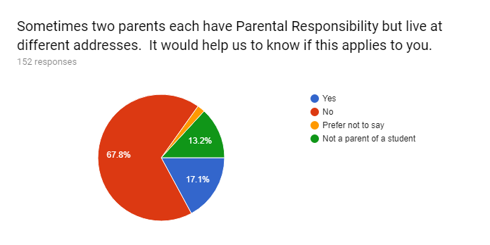

All respondents had access to the internet, could access email and could receive texts. Twitter was less used
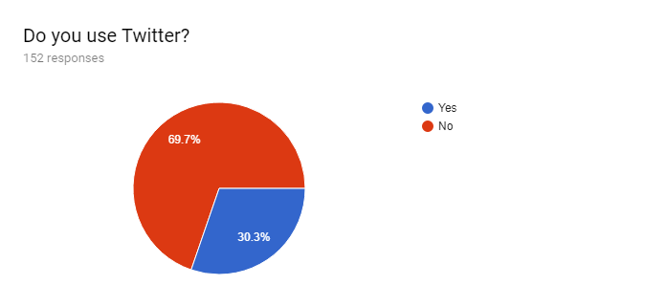

The respondents were asked about the usefulness of our communication methods. They rated them on the scale of 1 to 5. The following chart shows the average response values for the 3 groups - staff, parents at different addresses, other parents.

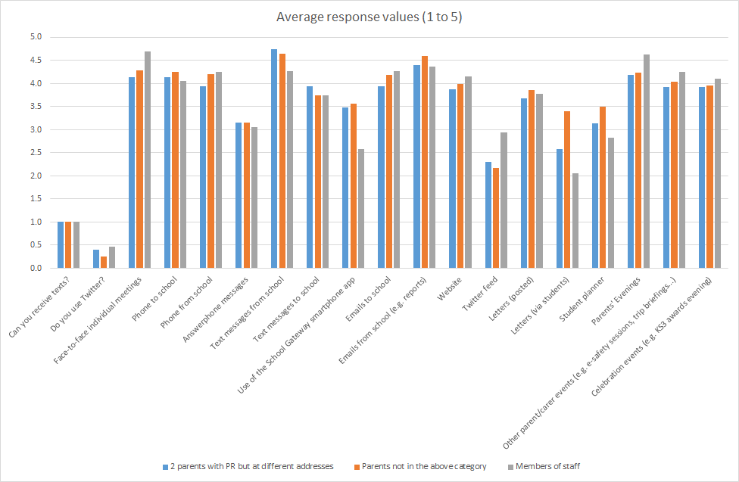

Looking at all respondents, the different forms of communication received the following ratings

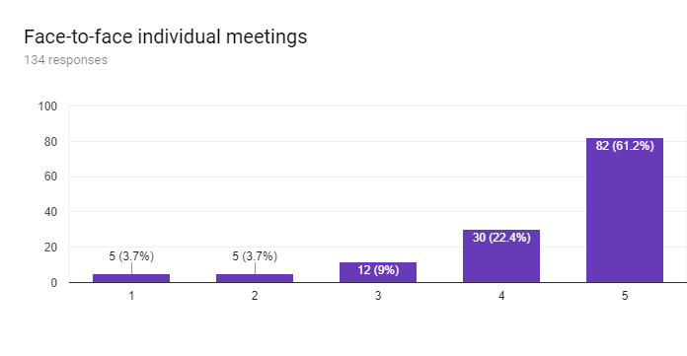
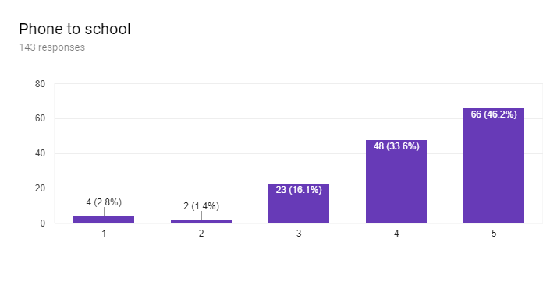

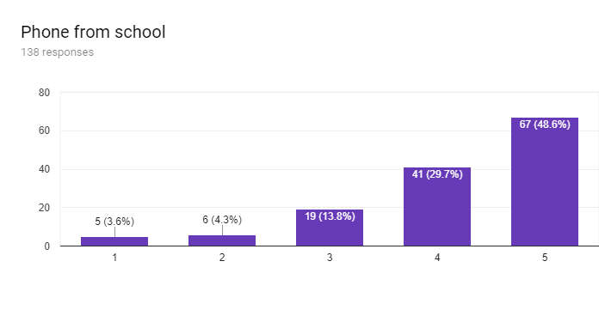
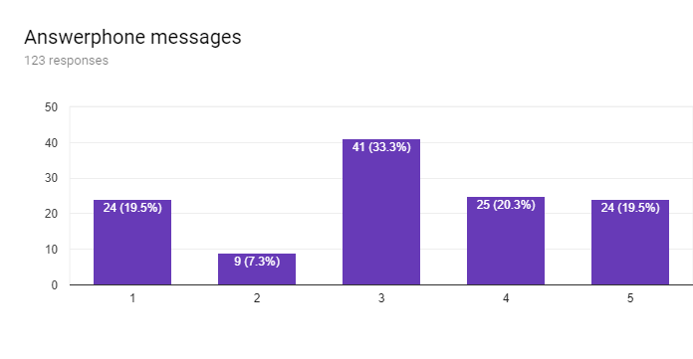

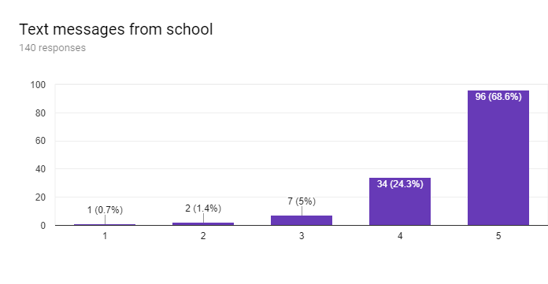
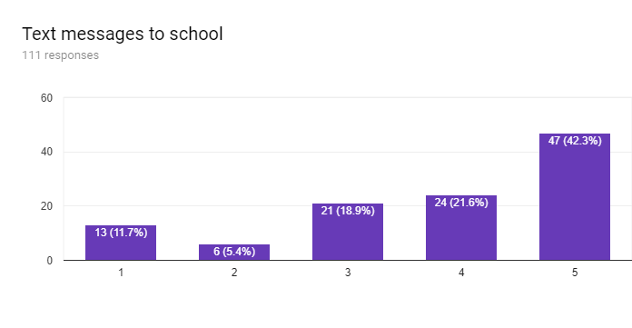

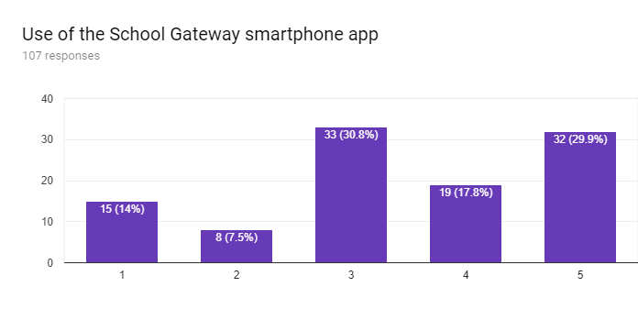
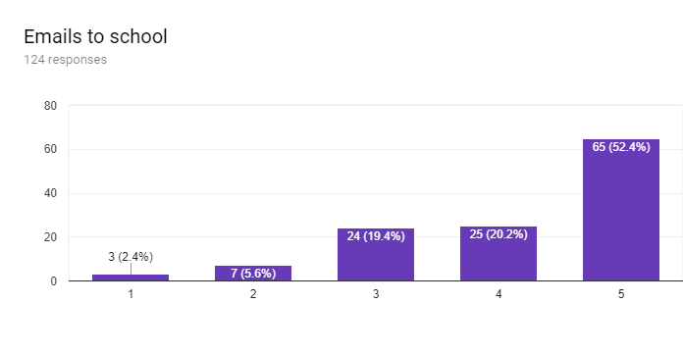

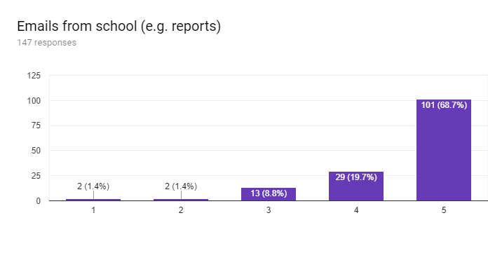

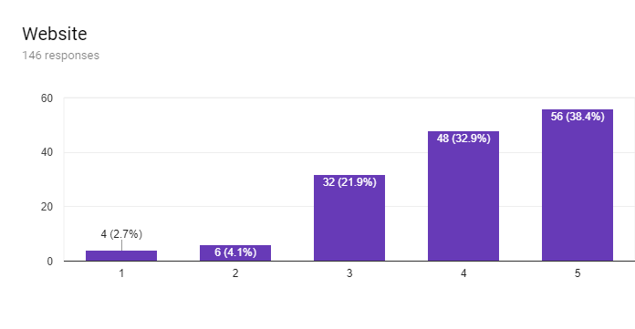

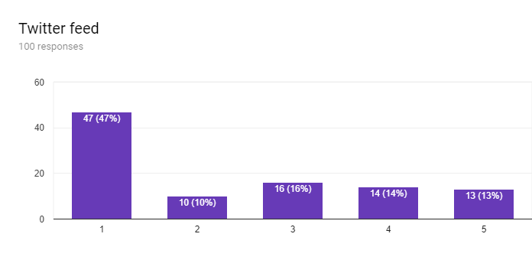
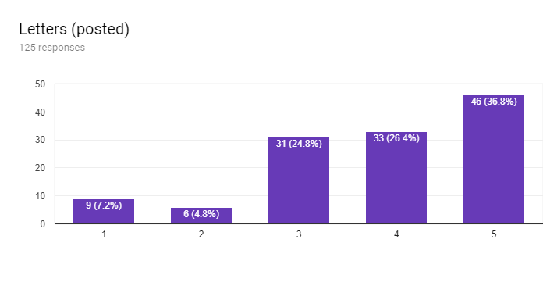

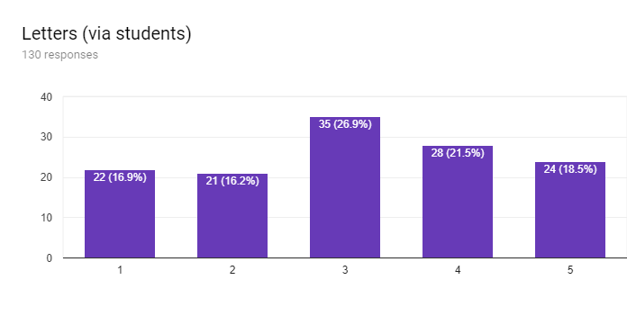
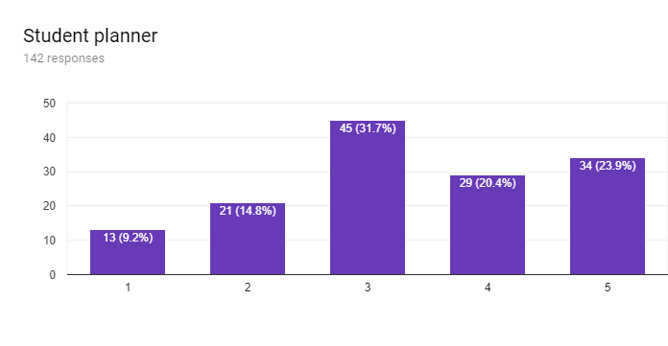

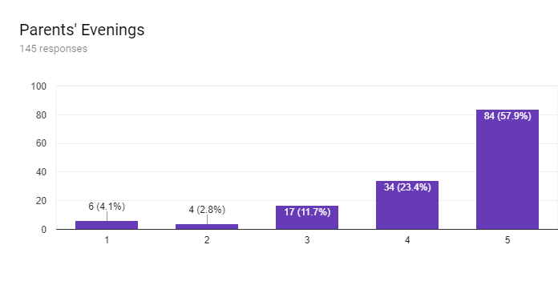

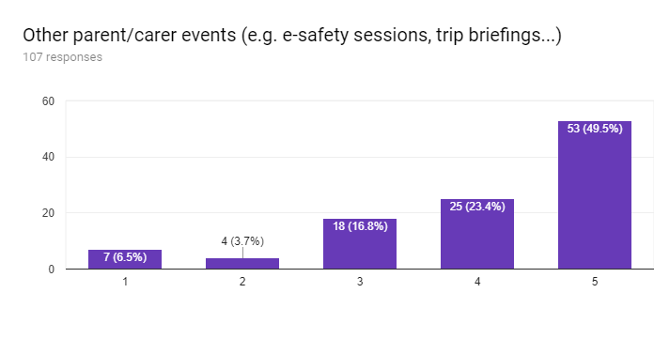

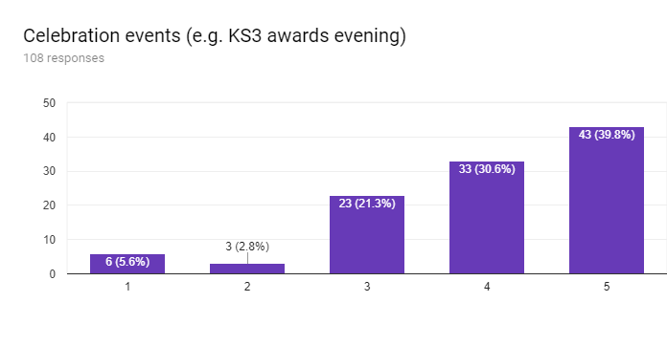
In addition there were a significant number of comments. These have been carefully studied by the senior leadership team to identify trends and individual issues. The comments from parents with shared PR living at different addresses were studied particularly closely.

Actions arising from senior leadership team analysis:

- The more that we can do face-to-face the better;
- Promote the School Gateway app;
- Investigate e-signatures to reduce paper letters further;
- Investigate ways in which attendance recording can be improved and reduce erroneous Groupcall messages;
- Review the website diary – perhaps go to “week commencing” format;
- Ensure that all letters appear on the website
- Ensure that extra-curricular activities are not cancelled on the day
- Develop a year group page on the website
- Consider a printed calendar for parents/carers
- Consider the use of text messages for detentions

