WLD Teaching and Learning Digest – w/c 19th February 2018
COMMUNICATION FOCUSES  - How are we promoting reading with our students?  - Are you checking understanding (and spelling) of key subject words? | DYSLEXIA-FRIENDLY STRATEGY  When writing a lot, avoid justifying the text as this makes it tricky to read.
This week:
- The thought for the week this week is Fair Trade Fortnight – please use the PPT emailed; it includes a short video about Fair Trade. There is also an article to read with forms in registers on Tuesday.
- Heads up! – next Wednesday, bring one revision strategy that you are using with Year 11; we will do a ‘speed swap’ to share good practice.
Teaching Approach of the Week – Try It!
‘Throwback Thursday’ – Following the popular internet trend, the English Department is using ‘throwback Thursday’ to encourage interleaved practice; students are encouraged to be ‘nostalgic’ on a Thursday by covering something that they have already learnt. See if it works for you!
PIE FACES: Encouraging Good Writing
Years 9 to 11 now have this checklist of good writing features to use in their own writing. We have created this checklist so that students know what to include in a GOOD piece of writing. Please refer to them in your subjects. I will have posters made if successful.
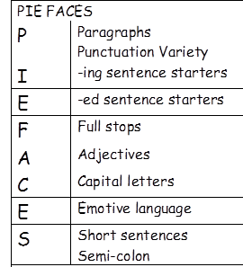

Recent Top Tips (abridged)… Keep using them if they worked!
- ‘Prepare to Teach’ and ‘Topic Ranking’
- ‘Just a Minute’ and ‘Exam Wrappers’
- Retrieval Practice – questions from last lesson, last week and last term
- Presentation as an indirect way of enhancing progress
- Unlocking key words – discussing possible meanings
- The ‘BIG Question’
- 3B4ME – promoting independence
- WAGOLLs (what a good one looks like – use of model work)
- Pose, Pause, Pounce and Bounce
- Reading for understanding – mini-whiteboards, quick quizzes, verbal questioning, think-pair-share etc.
Top Tips in Two this Half-Term
Scheduled in this half-term, we have:
- This week! Weds 21st Feb – C. Rowson
- Next week! Weds 28th Feb – All staff – Year 11 revision strategies swap
- Thursday 8th March – D. Turner
- Friday 16th March – S. Smith-Sergeant (mindfulness)
- Thurs 22nd March – R. Long
CPD
The Preston Schools Teaching Alliance is holding its annual Teaching and Learning Conference in April. Please submit your interest to me by the end of the week.

