WLD Teaching and Learning Digest – w/c 22nd January 2018

This week:
- Thought for the week this week is Safer Surfing – the PPT contains a comical but informative take on a ‘One Direction’ song and focuses on how to stay safe online. There is also an article from the BBC in registers and emailed.
- Please remember to ask students to get planners out at the starts of lessons.
Teaching Approach of the Week – Try It!
http://www.theconfidentteacher.com/2018/01/top-10-revision-strategies/
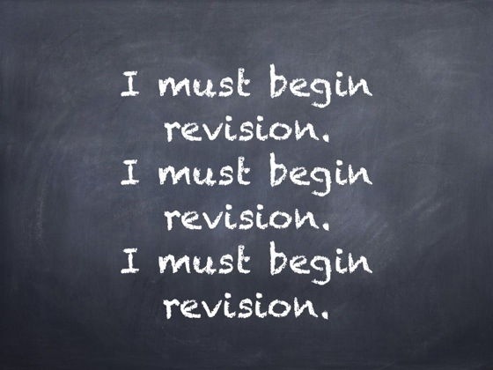 | Top 10 Revision Strategies  www.theconfidentteacher.com  Year after the year, the same pressures attend exam revision. Each year teachers try the old favourites, alongside a few new revision strategies to keep our students interested. Happily, we now have a wealth of evidence to support some revision strategies over others as we approach the revision stretch. We know that students are not the most reliable when it comes to judging their own learning, with regular self-testing proving the most effective antidote. We also know that some strategies, like re-reading and using highlighters, are largely ineffective, whereas as quizzing does the trick. We know that a little 'deliberate difficulty' may well prove a good thing for revision, and that 'cramming' is inferior to 'distributed practice' (or spreading revision out over time), when it comes to remembering. We should be careful not outsource an approach to revision to a company promoting the following strategies, or to puff up the confidence of our students. A successful approach to

We have now entered the ‘end game’ for our Year 11s. Every lesson counts. You can read the top ten revision strategies at the above link. Try these two and see if they work:
(Good to use following mock exams!) - Exam wrappers. Labelled ‘exam wrappers‘ because they wrap around information on how the student has revised, offers important information for the teacher to help diagnose how effective, or extensive (or not), revision has proven. Also, it can prove a good way to help puncture student over-confidence in their revision. (online examples and templates given in the above link).

‘Just a minute’. Students have to talk for a minute on the given term/topic – no pauses, no hesitations. Slips or repetitions or micro pauses lose a ‘life’ – three strikes and you’re out. No preparation; maximum gains in terms of consolidation and formative assessment (and no marking!).
Recent Top Tips… Keep using them if they worked!
- Retrieval Practice – questions from last lesson, last week and last term
- Presentation as an indirect way of enhancing progress
- Five ways to feedback
- Use presentation to aid progress
- BUG the question: box, underline, glance back
- Unlocking key words – discussing possible meanings
- The ‘BIG Question’
- Whole-school marking policy – please display the new pink poster in rooms (spares with LG)
- 3B4ME – promoting independence
- Feedback – using exemplar work so students can compare with their own. Allowing students time to ask you questions about their work (make use of MAD time).
- Pose, Pause, Pounce and Bounce
- Developing recall skills: short quizzes, mini-whiteboards, etc.
- Starter cards
- Reading for understanding – mini-whiteboards, quick quizzes, verbal questioning, think-pair-share etc.
Top Tips in Two this Term
Scheduled in this term, we have:
- Thurs 1st Feb – FD
- Weds 7th Feb – EH
HALF-TERM
- Weds 21st Feb - RW
- Thursday 1st March - TU
After half-term: I am currently taking bookings. Please let me know if you are happy to share an idea; simple ideas are the best.

CPD
Please let me have any course requests for this financial year asap.

