**WLD Teaching and Learning Digest – w/c 4th June 2018**

|  |  |
| --- | --- |
| **COMMUNICATION FOCUSES**    Please encourage Year 7 to complete their summer reading challenge (attached for info). If they complete, they win a prize! | **DYSLEXIA-FRIENDLY STRATEGY**    Cue in students using names |

**This week:**

* The **thought for the week** this week is **‘Reflections – 7 weeks to achieve your goals’ –** ask students whether they can remember their goals/resolutions from January? What measures do they need to put in place to achieve them? There is also an article in registers with the headline ‘Mind Over Matter’, encouraging students to push themselves in this final stage of the academic year.
* **Preston Teaching Schools’ Alliance**: Trainee Teachers – final assessment observations and meetings will take place this week. Good luck to all!
* **Year 7 Teachers** – please continue to enforce the protocols emailed two weeks ago to promote consistency and to facilitate progress for all. Thanks for your support.

**Teaching Approach of the Week – Try It!**

This approach links to our ***TOOLKIT: ‘Understanding from Memory’*** section. Try using the retrieval practice grid shared by Keira and Claire in our ‘Top Tip in Two’ two weeks ago. It is a good way to ask students to reflect on their learning, particularly at the start of a new half-term.

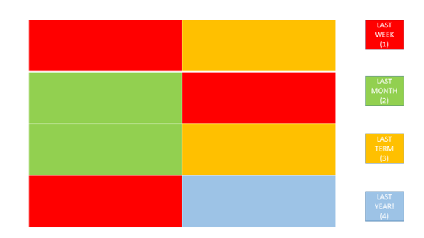

**Recent Top Tips (abridged)… Keep using them if they worked!**

* **Reading strategy – sum up a paragraph at a time**
* **Calm behaviour management – wait, cue in positive role models for behaviour**
* **Competition in lessons**
* **Black dot in a white square – focus on the positives**
* **We Are Reading! – offer lots of opportunities for students to read**
* **Show the and in stages…think out loud**
* **Verbal Feedback**
* **Because, but, so – extend sentences and thinking**
* **PIE FACES – Features of good writing**
* **‘Just a Minute’ and ‘Exam Wrappers’**
* **Retrieval Practice – questions from last lesson, last week and last term**
* **The ‘BIG Question’**
* **3B4ME – promoting independence**
* **WAGOLLs (what a good one looks like – use of model work)**
* **Pose, Pause, Pounce and Bounce**
* **Reading for understanding – mini-whiteboards, quick quizzes, verbal questioning, think-pair-share etc.**

**Top Tips in Two this Half-Term**

* ~~Monday 9~~~~th~~~~April –A. Christian – We Are Reading~~ – Many thanks!
* ~~Friday 13~~~~th~~~~April – D. Turner – Doddle Revision~~ - Postponed
* ~~Wednesday 18~~~~th~~~~April – G. Moore – revision strategy~~ Many thanks!
* ~~Friday 27~~~~th~~~~April – A. Halsall~~ Many thanks!
* ~~Friday 4~~~~th~~~~May – D. Turner – Read Write Gold~~ - Many thanks!
* ~~Friday 18~~~~th~~ ~~May – C. Rowson and K. McPartlan – knowledge retrieval~~ Many thanks!
* Wednesday 23rd May – J. Mayor – postponed TBC
* Monday 4th June – A. Sam
* Friday 15th June – A. Lyons
* Wednesday 20th June – E. Hand and S. Allen