**WLD Teaching and Learning Digest – w/c 5th February 2018**

|  |  |
| --- | --- |
| **COMMUNICATION FOCUSES**   * How are we promoting reading with our students? * Are you checking understanding (and spelling) of key subject words? | **DYSLEXIA-FRIENDLY STRATEGY**    Address students by name to ‘cue in’ attention |

**This week:**

* Thought for the week this week is **Manners –** Please use the PPT with your forms and encourage ‘professional’ behaviour around school.  You may wish to discuss language, gestures and general attitude around school.
* Well done to our Trainees who have ‘almost’ survived their first half-term.
* **Thank you**! – for encouraging students to have planners and equipment ready in lessons.  If we all do it, we support one another.

**Teaching Approach of the Week – Try It!**

Remember Elevate…?  The Year 11s are going to be having their second workshop soon.  The following approach to past papers is nothing new and one that we will all know well but perhaps is worth reinforcing with them over the coming weeks:

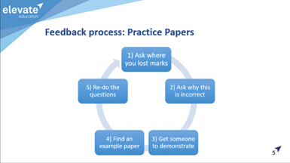

**Recent Top Tips (abridged)… Keep using them if they worked!**

* **‘Prepare to Teach’ and ‘Topic Ranking’**
* **‘Just a Minute’ and ‘Exam Wrappers’**
* **Retrieval Practice – questions from last lesson, last week and last term**
* **Presentation as an indirect way of enhancing progress**
* **Unlocking key words – discussing possible meanings**
* **The ‘BIG Question’**
* **3B4ME – promoting independence**
* **WAGOLLs (what a good one looks like – use of model work)**
* **Pose, Pause, Pounce and Bounce**
* **Reading for understanding – mini-whiteboards, quick quizzes, verbal questioning, think-pair-share etc.**

**Top Tips in Two this Term**

Scheduled in this term, we have:

* Weds 7th Feb – EH

**HALF-TERM**

* Weds 21st Feb – RW
* Thursday 1st March – TU

***After half-term:*** Please let me know if you are happy to share an idea; simple ideas are the best.

**CPD**

MY attended CPD last week on dealing with anxiety and stress.  She has kindly shared the following tips for dealing with students with anxiety issues:

* **DON'T EVER** tell someone to calm down
* **DO** try and help them to control their breathing so that they can think
* **Don't** tell someone they are being silly, as their feelings are real
* If someone has a meltdown the key is to get them to breathe slowly and in a rhythm as this helps to take the brain out of 'fight or flight' mode and think.