**WLD Teaching and Learning Digest – w/c 8th May 2018**

|  |  |
| --- | --- |
| **COMMUNICATION FOCUSES**    Year 7s should now all have reading books – refer to them if necessary. | **DYSLEXIA-FRIENDLY STRATEGY**    Avoid justifying large amounts of text – it makes it tricky to read |

**This week:**

* The **thought for the week** this week is **‘Deaf Awareness Week’ –** Please use the PPT and bear in mind that this issue affects several of our students.
* **Preston Teaching Schools’ Alliance**: Trainee Teachers – meeting LG at lunch on Tuesday (topic: literacy).

**Teaching Approach of the Week – Try It!**

This week, think about starts of lessons. This short video by Bill Rogers is nothing new (far from it!) but has some useful reminders and subtle ways of eliminating low-level off-task chat:

* Calm (at all times) but assertive manner
* Respectful directions to the class
* Cue in attention
* Compliments when students do as you ask

<https://www.youtube.com/watch?v=KTxGXiuLgb4>

|  |  |
| --- | --- |
| [https://www.bing.com/th?id=OVP.0bUwp8kYpJM3JRgWgGe6KgEsDh&pid=Api](https://www.youtube.com/watch?v=KTxGXiuLgb4) | [Bill Rogers on behaviour](https://www.youtube.com/watch?v=KTxGXiuLgb4)  [www.youtube.com](http://www.youtube.com)  Bill Rogers on behaviour |

Further reminders for tackling low-level disruption can be found in this link from TES (again, nothing new; just reminders).

<https://www.tes.com/news/eight-easy-ways-tackle-low-level-disruption>

|  |
| --- |
| [Eight easy ways to tackle low-level disruption | Tes News](https://www.tes.com/news/eight-easy-ways-tackle-low-level-disruption)  [www.tes.com](http://www.tes.com)  Students are losing up to eight weeks of teaching every year to low-level disruption, a recent Ofsted report suggests. In this week’s issue of TES, Greg Ashman, teacher at Ballarat Clarendon College in Victoria, Australia, says that while most schools have clear procedures for dealing with extreme ... |

***Year 11 – Top Tips***

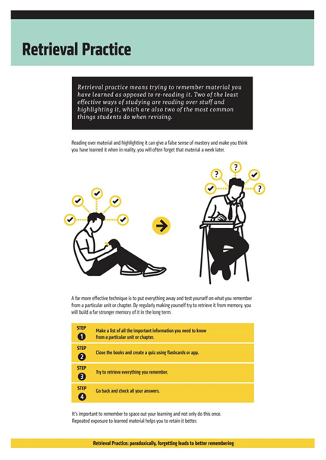

**Recent Top Tips (abridged)… Keep using them if they worked!**

* **Competition in lessons**
* **Black dot in a white square – focus on the positives**
* **We Are Reading! – offer lots of opportunities for students to read**
* **Show the and in stages…think out loud**
* **Verbal Feedback**
* **Because, but, so – extend sentences and thinking**
* **PIE FACES – Features of good writing**
* **‘Just a Minute’ and ‘Exam Wrappers’**
* **Retrieval Practice – questions from last lesson, last week and last term**
* **The ‘BIG Question’**
* **3B4ME – promoting independence**
* **WAGOLLs (what a good one looks like – use of model work)**
* **Pose, Pause, Pounce and Bounce**
* **Reading for understanding – mini-whiteboards, quick quizzes, verbal questioning, think-pair-share etc.**

**Top Tips in Two this Half-Term**

* ~~Monday 9~~~~th~~~~April –A. Christian – We Are Reading~~ – Many thanks!
* ~~Friday 13~~~~th~~~~April – D. Turner – Doddle Revision~~ - Postponed
* ~~Wednesday 18~~~~th~~~~April – G. Moore – revision strategy~~ Many thanks!
* ~~Friday 27~~~~th~~~~April – A. Halsall~~ Many thanks!
* ~~Friday 4~~~~th~~~~May – D. Turner – Read Write Gold~~ - Many thanks!
* Friday 14th May – C. Rowson and K. McPartlan – knowledge retrieval
* Wednesday 23rd May – J. Mayor