**WLD Teaching and Learning Digest – w/c 14th January 2019**

|  |  |  |  |  |  |  |  |  |  |  |  |  |  |  |  |  |  |  |  |
| --- | --- | --- | --- | --- | --- | --- | --- | --- | --- | --- | --- | --- | --- | --- | --- | --- | --- | --- | --- |
| **COMMUNICATION FOCUSES**  Use our policy when marking written work:   |  |  | | --- | --- | | **SYMBOL** | **WHAT DOES IT MEAN?** | | **U** | **Underline headings** | | **C** | **Add the missing or amend the misplaced capital letter** | | **P** | **Add the missing or amend the misplaced punctuation mark** | | **NP** | **New paragraph needed** | | **WW** | **The wrong word has been used and needs to be amended (e.g. ‘there’ instead of ‘their’)** | | **SP** | **Correct the spelling error** | | **EXP** | **Make this sentence clearer** | | **WO** | **Put the words in the correct order** | | **INCLUSION FOR ALL**    Where possible, use buff or pastel coloured backgrounds on whiteboards and on handouts |

**This week:**

* The **thought for the week** this week is **‘Adventure’.** The PPT contains a trailer for the film ‘Touching the Void’, based on a true story. Please also use the Picture News material emailed by Paula. Both provide useful talking points.
* **NQTs Reminder** – meetings with LG will commence again from **this week**
* **Preston Teaching Schools’ Alliance –** J. McQuade shadowed two students last week and will be in school on Monday, following his PE timetable.

***Coming Soon…***

**w/c 21st Jan: Open Door Week** – as mentioned before Christmas, we would like to hold an Open Door Week to allow all staff to have access to the privilege of ‘wandering the school’; during this week, staff are encouraged to wander and to ‘magpie’ ideas from colleagues.

**Weds 23rd Jan: ‘Pastries and Progress’** – this time will focus on WAGOLLs and teachers need to bring a WAGOLL (example of a high standard extended answer) and share how it is used within the classroom to enhance progress.

# Our T&L Targets:

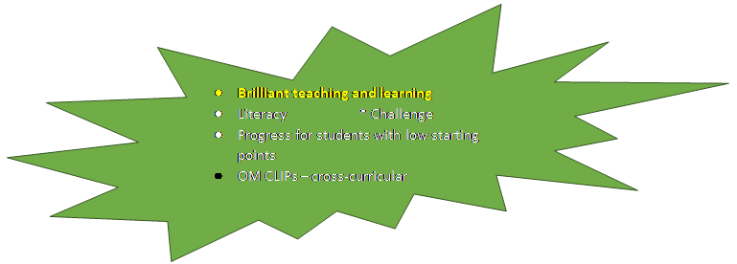

**Think About:**

Over the course of the last half term, Middle Leaders (having consulted with their departments), completed a ‘Brilliant Teaching and Learning – Toolkit’ for their subject area. This document is absolutely crucial in outlining a department’s identity and approach when it comes to our priorities (i.e. each box of the Toolkit).

These documents are on the agenda at the School Improvement Group meeting tomorrow evening and will also provide the focus for conversations between Middle Leaders and their SLT Links over the coming weeks. Teaching and Learning is, after all, our raison d’etre. It should be the topic that we are talking about…

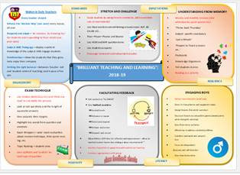

So, with this in mind and to give a clear focus over the next five weeks up until half-term, we would will focus on ONE aspect of the toolkit: UNDERSTANDING FROM MEMORY. As a department and as an individual teacher, you can support this focus by:

* All - Reading the T&L Digest each week which will contain a strategy to try out
* HoDs – Make this focus and agenda item at every department meeting
* All - Share ideas around this area in conversation or by other means
* HoDs – remind and recirculate your bespoke departmental Toolkit as the strategies that have been outlined in this box should be evident in lessons.

On informal walks, SLT will be discussing what they have seen in relation to this focus.

# Try This!

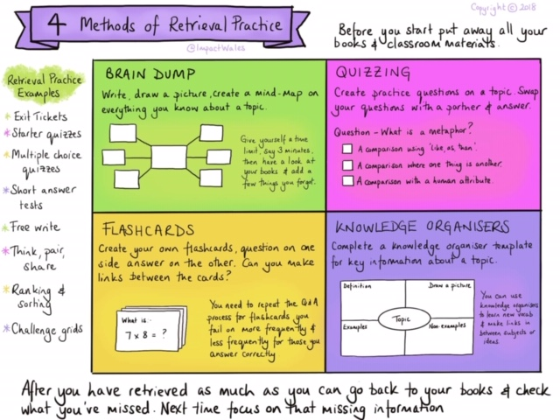

# Top Tips in Two this Half-Term

|  |  |  |  |
| --- | --- | --- | --- |
| **17** | **14/01/19** | **WEDS** | **MY** |
| **18** | **21/01/19** | WEDS | **TU** |
| **19** | **28/01/19** | MON | **HL and SZ** |
|  |  | FRI | **HD and TU** |
| **20** | **4/02/19** | WEDS | **HS and MY** |
|  |  | FRI | **CN and LY** |
| **21** | **11/02/19** | WEDS | **HC and MO** |

**CPD Cascade**

Several staff are attending CPD with the Preston Teaching School’s Alliance over the next few weeks. Please drop me a one-liner or idea that can be shared in this section.