**WLD Teaching and Learning Digest – w/c 14th May 2018**

|  |  |
| --- | --- |
| **COMMUNICATION FOCUSES**    Please encourage Year 7 to complete their summer reading challenge (attached for info). If they complete, they win a prize! | **DYSLEXIA-FRIENDLY STRATEGY**    Use pastel coloured backgrounds on your board. |

**This week:**

* The **thought for the week** this week is **‘Fake News’ –** A PPT has been circulated and there is an article in registers (abridged) with some tips of how to spot fake news.
* **Preston Teaching Schools’ Alliance**: Trainee Teachers – meeting YF and TU at lunch on Thursday (topic: ICT and numeracy across the curriculum).

**Teaching Approach of the Week – Try It!**

This approach links to our ***TOOLKIT: ‘exam technique’*** section and focuses on creating and communicating useful success criteria. This will be something you will have done with Year 11s in preparation for their GCSEs this week.

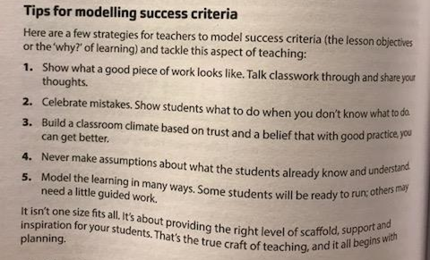

Taken from ***‘Mark. Plan. Teach.’ By Ross Morrison McGill*** (available to borrow from our CPD library in the staffroom – good one-stop shop for top tips).

The ‘celebration of mistakes’ is important because the mistakes are often to common pitfalls of several in the class. If we don’t highlight them, they will keep being made.

***Year 11 – Top Tips***

Obvious, but worth saying anyway:

* Positivity.
* Praise their strengths.
* Remind them of things to watch out for…
* Direct them towards specific things to revise to address THEIR gaps.

**Recent Top Tips (abridged)… Keep using them if they worked!**

* **Calm behaviour management – wait, cue in positive role models for behaviour**
* **Competition in lessons**
* **Black dot in a white square – focus on the positives**
* **We Are Reading! – offer lots of opportunities for students to read**
* **Show the and in stages…think out loud**
* **Verbal Feedback**
* **Because, but, so – extend sentences and thinking**
* **PIE FACES – Features of good writing**
* **‘Just a Minute’ and ‘Exam Wrappers’**
* **Retrieval Practice – questions from last lesson, last week and last term**
* **The ‘BIG Question’**
* **3B4ME – promoting independence**
* **WAGOLLs (what a good one looks like – use of model work)**
* **Pose, Pause, Pounce and Bounce**
* **Reading for understanding – mini-whiteboards, quick quizzes, verbal questioning, think-pair-share etc.**

**Top Tips in Two this Half-Term**

* ~~Monday 9~~~~th~~~~April –A. Christian – We Are Reading~~ – Many thanks!
* ~~Friday 13~~~~th~~~~April – D. Turner – Doddle Revision~~ - Postponed
* ~~Wednesday 18~~~~th~~~~April – G. Moore – revision strategy~~ Many thanks!
* ~~Friday 27~~~~th~~~~April – A. Halsall~~ Many thanks!
* ~~Friday 4~~~~th~~~~May – D. Turner – Read Write Gold~~ - Many thanks!
* Friday 18th May – C. Rowson and K. McPartlan – knowledge retrieval
* Wednesday 23rd May – J. Mayor
* Monday 4th June – A. Sam
* Friday 15th June – A. Lyons
* Wednesday 20th June – E. Hand and S. Allen

Thank you for finding time to read at this hectic and pressured time of year. Hopefully, you will ‘like’ something in this issue.