**WLD Teaching and Learning Digest – w/c 19th November 2018**

|  |  |
| --- | --- |
| **COMMUNICATION FOCUSES**    Vocab Building: Idea…make a note of any new words to be used in the following lesson. Ask the students to find the meanings for homework. As a starter to next lesson, ask them to use the words in sentences to a partner… | **INCLUSION FOR ALL**    Use the marking policy for written work (copy in all planners) so that students know where they have made errors |

**This week:**

* The **thought for the week** this week is **‘Inspirational People’.** Please use the materials circulated as usual with forms.
* **New staff and NQTs –** No CPD session this week due to parents’ evening.
* **NQTs** – scheduled meetings with LG this week (LG’s office) to discuss progress against standards.

**Think about this…vocabulary matters!**

Alex Quigley grapples with vocabulary in his book *‘Closing the Vocabulary Gap’* and he provides food for thought.

What is the percentage of words known in a text to ensure reading comprehension?

* 50%
* 60%
* 75%
* 90%
* 95%

The answer is a massive 95%. If your first answer was nearer to 75%, then consider the following example of a definition that could be encountered by a secondary school student with approximately 75% of the words blacked out to obstruct comprehension:

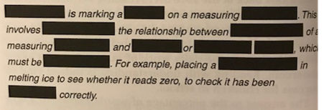

Can you identify the process that is being described? If not, how about trying just two words being omitted (thereby making it approximately 95% of the words known). Can you identify the missing words and complete the definition now?

Talk-Talk! Structure of the Week: Round Robin

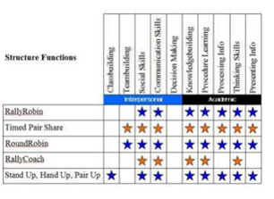

Over the last few weeks, I have suggested resurrecting ***think-pair-share*** and the ***rally robin*** *structures to focus group work*. This week, try another of the Kagan top five, by using round robin in trios to develop ideas further. Forgotten how it works? Here is a recap:

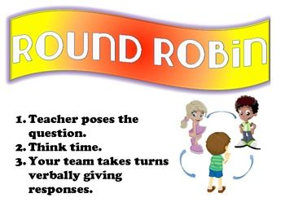

Remember that we have books on cooperative learning in our CPD library. Feel free to sign out and borrow.

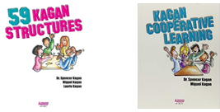

**Top Tips in Two this Term (HoDs please organise who will share and let me know)**

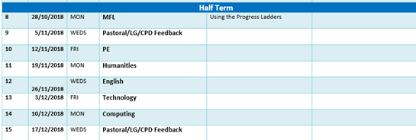

**CPD Opportunity**

T&L Think Tank is this evening 4-5pm at Balshaws. Please let me know if you intend to do. The focus is engagement strategies, particularly with underachieving boys.  You are asked to take an example to share and discuss of a strategy that has worked for you / in your school. As this is after school, you could use this as part of your study group time if you are in the boys group.

Other CPD opportunities were emailed out last week through the Preston Teaching School’s Alliance. Please let me know if you would like to attend any. I have had some interest in some of the meetings, which again, could count as part of your study group time allocation as they are twilight sessions.