**WLD Teaching and Learning Digest – w/c 1st October 2018**

|  |  |
| --- | --- |
| **COMMUNICATION FOCUSES**    Flick through your exercise books…what does the presentation say about standards and expectations in your lessons? | **INCLUSION FOR ALL**    Check that students have overlays if they need them when reading. Also, use pastel coloured paper for those who need it. |

**This week:**

* The **thought for the week** this week is **‘Cultural Diversity’ ahead of ‘Black History Month’.** I have put an extract from ‘I am Malala’ in registers. This may prove as a useful starting point.
* **New staff and NQTs –** CPD session on curriculum and assessment will run this Friday lunch time (everyone said that they preferred lunch times). Please let WL/WS know if you are not attending.
* **Top Tip this week –** the Maths department is leading this week.
* **Reminders:** 
  + **Attachment Theory voluntary INSET** – Monday evening.
  + **Study Groups – Whole-staff CPD session on Monday 8th October to launch this year’s Study Group research projects. See previous T&L Digest.**
  + **PP Review** – this Friday. Information has been emailed by HR so please read. Usual focus on high standards and consistency, as well as high level T&L needed please.

**Teaching Approach of the Week**

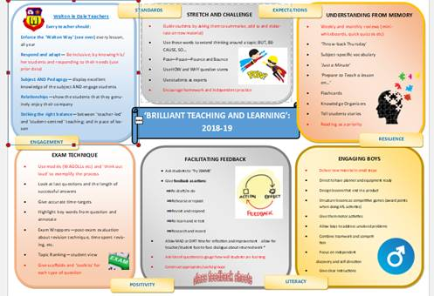

Over the last month, we have been working hard to ensure that our students are provided with consistent approaches within our classrooms. Often, there is the temptation to make a ‘silent starter’ into a ‘task’ rather than deep learning. As students enter our classrooms, we want them to feel enthralled by our subjects...  This clearly fits in with our focus on engaging boys (and indeed all students!).

I have pasted in a few ideas that you could try to prevent ‘silent’ from becoming (dare I say it) ‘dull’. They are nothing new but, as always in teaching, we often forget some of the best – and most engaging - ideas as we try many new things.

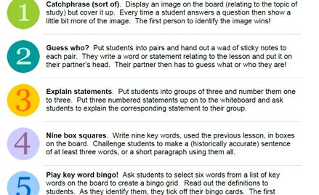

For more ideas, ask others within your areas and also have a look at the attached document (though it is aimed at historians, it is still relevant) and try something out this week.

**Top Tips in Two this Term (HoDs please organise who will share and let me know)**

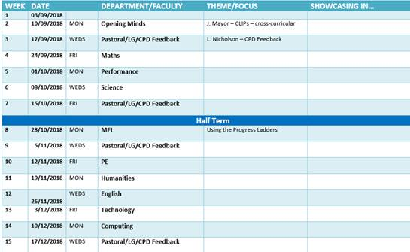

**CPD Cascade**

I know that a few members of staff have offered to lead voluntary CPD sessions on various things. If you have any pedagogy/skills that you would like to share, let me know and we can offer to everyone. Thanks to those who have already.