**WLD Teaching and Learning Digest – w/c 21st January 2019**

|  |  |  |  |  |  |  |  |  |  |  |  |  |  |  |  |  |  |  |  |
| --- | --- | --- | --- | --- | --- | --- | --- | --- | --- | --- | --- | --- | --- | --- | --- | --- | --- | --- | --- |
| **COMMUNICATION FOCUSES**  Test yourself…:   |  |  | | --- | --- | | **SYMBOL** | **WHAT DOES IT MEAN?** | | **U** |  | | **C** |  | | **P** |  | | **NP** |  | | **WW** |  | | **SP** |  | | **EXP** |  | | **WO** |  | | **INCLUSION FOR ALL**    Cue in by using names clearly |

**This week:**

* **Open Door Week** – Please spend some time wandering and sampling the brilliant teaching in classrooms around school; it is a the best CPD there is! Thanks for trying it out. You can share a ‘magpied’ idea with someone on Wednesday.
* **🍩 Wednesday – Progress and Pastries with a focus on WAGOLLs** – Please bring a WAGOLL (example of a high standard extended answer) and share how it is used within the classroom to enhance progress.
* **Friday INSET –** Teaching and Learning Conference. Your lanyards will contain the workshops that you have chosen (just in case you have forgotten). See HR’s email/board for timings for the day.
* The **thought for the week** this week is **‘Holocaust Memorial’.** The PPT contains a poignant film. Year 8s have just started this theme in OM. Please also use the ‘Railway Safety’ video and the Picture News materials emailed by Liz and Paula.
* **NQTs** – No meetings this week due to interviews and INSET day.

# Our T&L Targets:

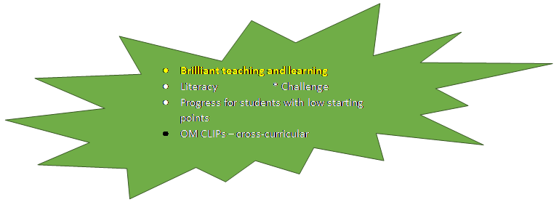

**Try This!**

We are focusing on UNDERSTANDING FROM MEMORY.

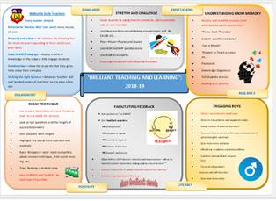

Dr. Anthony Metivier is an experienced memory expert, author, professor and memory improvement course creator. He has created something called the Magnetic Memory Method which relies on creating Memory Palaces in which to store any kind of information.

**What Is A Memory Palace?**

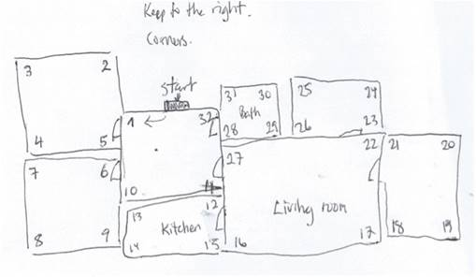

A Memory Palace is a mental construct used to store and retrieve information that you want to memorize. Although related to the world of mnemonics, Memory Palaces are much more powerful than any single mnemonic.

Why? Because all the other memory strategies that you could ever possibly hope to use can themselves be stored and used inside of Memory Palaces.

Typically Memory Palaces are based on real locations, such as your home, schools in which you have studied, places where you have worked, churches, movie theatres, etc.

There are countless options, and you can use literally any place with which you are familiar to memorise information. If you are interested, read more at the following link (it resonates with the Elevate methods shared a few years ago):

<https://www.magneticmemorymethod.com/about/>

|  |  |
| --- | --- |
| [https://www.magneticmemorymethod.com/wp-content/uploads/2013/08/pristinepoetrycartoonanthony01.png](https://www.magneticmemorymethod.com/about/) | [About the Magnetic Memory Method](https://www.magneticmemorymethod.com/about/)  [www.magneticmemorymethod.com](http://www.magneticmemorymethod.com)  A Memory Palace is a mental construct used to store and retrieve information that you want to memorize. Although related to the world of mnemonics, Memory Palaces are much more powerful than any single mnemonic. |

# Talk-Talk! Structure of the Week: Rally Robin

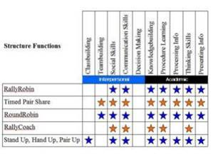

# ****The Round Robin****

The Round Robin strategy is a brainstorming strategy where students are situated around a table in an academic discussion. Like other brainstorming sessions, students generate ideas on a specific topic or question. However, with this strategy, there is equal participation among students as well as multiple discussions taking place.

# Top Tips in Two this Half-Term changes

|  |  |  |  |
| --- | --- | --- | --- |
| **17** | **14/01/19** | **WEDS** | **~~MY~~** |
| **18** | **21/01/19** | WEDS | **Pastries and Progress** |
| **19** | **28/01/19** | MON | **HL and SZ** |
|  | **30/01/19** | WEDS | **TU** |
|  |  | FRI | **HD and TU** |
| **20** | **4/02/19** | WEDS | **HS and MY** |
|  |  | FRI | **CN and LY** |
| **21** | **11/02/19** | WEDS | **HC and MO** |

**CPD Cascade**

Several staff are attending CPD with the Preston Teaching School’s Alliance over the next few weeks and also with Broughton High School. If you could share any ideas to be shared in this section, I would appreciate it.