**WLD Teaching and Learning Digest – w/c 24th September 2018**

|  |  |
| --- | --- |
| **COMMUNICATION FOCUSES**    Do students know what ‘sp’ and ‘p’ mean in your marking? How do you ask them to act on these errors? | **INCLUSION FOR ALL**    Keep minimal background noise. Allow everyone to focus on their learning. Silence is okay. |

**This week:**

* The **thought for the week** this week is **‘Languages’.** Materials have been sent in registers and by email. Please use them or your own (if using your own, feel free to share).
* **New staff and NQTs –** CPD session on curriculum and assessment will run next week instead of this week due to Sports Day and KS3 review evening.
* **Top Tip this week –** the Maths department is leading this week.  It will be on Wednesday rather than Friday to avoid Sports Day.
* **NQTs** – scheduled meetings with LG this week (LG’s office).
* **Reminders:** 
  + **Attachment Theory voluntary INSET** – Monday 1st October after school in D4.  Let SN know if you are attending.
  + **Study Groups** – Whole-staff CPD session on Monday 8th October to launch this year’s Study Group research projects. Remember that this will NOT count as one of the 5 hours. It will be an opportunity for you to think about how you, as a group, wish to organise your time and remember face-to-face meetings may be difficult to schedule and are not necessarily the best use of your time.
  + **PP Review** – this Thursday and next Friday.  Information has been emailed so please read.

**Teaching Approach of the Week**

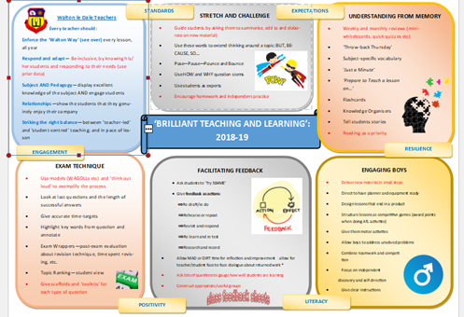

So over the last two weeks, we have been promoting and highlighting the impact that purposeful talk can have on learning.  If done successfully, this should aid all areas of the T&L Toolkit (above) which I hope is being used/adapted/edited to promote learning within your areas.   This week, consciously work on posing deeper questions by using the question stems grid below to help you to create your questions.

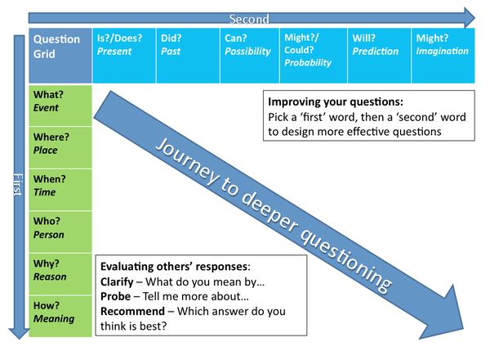

For further reading on the research around this area (there is lots out there) try David Didau and look the following blog.

<https://learningspy.co.uk/learning/developing-oracy-its-talkin-time-2-2/>

|  |  |
| --- | --- |
| [https://i1.wp.com/learningspy.co.uk/wp-content/uploads/2012/12/imgres.jpeg?fit=240%2C180&ssl=1](https://learningspy.co.uk/learning/developing-oracy-its-talkin-time-2-2/) | [Developing oracy: it's talkin' time! – David Didau](https://learningspy.co.uk/learning/developing-oracy-its-talkin-time-2-2/)  learningspy.co.uk  Talk is the sea upon which all else floats ~ James Britton, Language and Learning, 1970 Students spend a lot of talking, don’t they? Everyone can speak, so why would we want to waste valuable time teaching them to do it? |

**Top Tips in Two this Term (HoDs please organise who will share and let me know)**

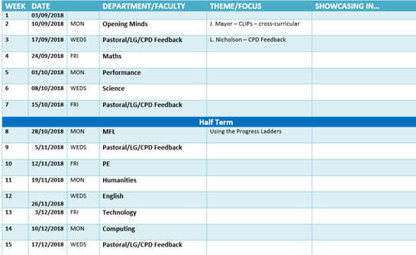

**CPD Cascade**

I know that a few members of staff have offered to lead voluntary CPD sessions on various things. If you have any pedagogy/skills that you would like to share, let me know and we can offer to everyone. Thanks to those who have already.

**Thanks for reading.**