WLD Teaching and Learning Digest – w/c 25th June 2018

COMMUNICATION FOCUSES  Deadline – Year 7 wider reading challenges due in today! | DYSLEXIA-FRIENDLY STRATEGY  Short, clear, concise instructions

This week:
- The thought for the week this week is ‘What is Beauty?’ (thanks to Miss Hand and her CREST-Awarders for preparing the materials) –– Please use the PPT and the article with forms as they have spent time preparing them for us.
- CPD Update – please read the email sent out last Thursday (21st June) as it contains information about the final CPD sessions of the year. It also explains the different sessions being offered on 16th July as you will need to sign up to these sessions over the course of the next week (staffroom noticeboard).
- NQT and Staff Induction – Many thanks to those of you who have led a CPD session for NQTs or new staff this year. I really appreciate it. I have issued a timetable for next year to those concerned; please could you respond either way by the end of today as I need to get the booklets printed up for staff coming in for Year 6 day this week.
Teaching Approach of the Week – Try It!
This approach links to our TOOLKIT: ‘Understanding from Memory’ section.
Thanks to Mr Lyons for delivering a ‘top tip in two’ on this last week. I have used both his PPT and the referenced blog to create this week’s T&L Digest. I know that we all use verbal ‘quizzing’ but the following research helps to justify why we should continue to ‘knowledge-check’ our students in every lesson.

‘Over the course of a year and a half, while the teacher continued teaching as normal, students were regularly quizzed on the material with no-stakes quizzes, meaning they wouldn’t count against their grades. These quizzes only covered about one-third of what was being taught. The teacher left the room for every quiz, so she had no knowledge of what was included in the quizzes.

On end-of-unit exams, students scored a full grade level higher on the material from the quizzes than on any of the other material. The other concepts had been taught and reviewed by the teacher as they normally would; the only difference was that some things also appeared on the no-stakes quizzes, and those were the concepts students retained more fully when tested on the exam.

The very act of being quizzed actually helped students learn better.’

This is nothing new. This week, try verbal quizzing to really check understanding. Read more at this link:
https://www.cultofpedagogy.com/retrieval-practice/
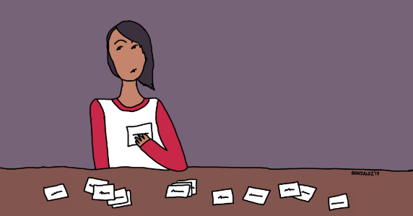 | Retrieval Practice: The Most Powerful Learning Strategy ...  www.cultofpedagogy.com  Retrieval Practice: The Most Powerful Learning Strategy You’re Not Using

Recent Top Tips (abridged)… Keep using them if they worked!
- Clever use of seating plans
- Behaviour strategies - reminders
- Reading strategy – sum up a paragraph at a time
- Calm behaviour management – wait, cue in positive role models for behaviour
- Competition in lessons
- Black dot in a white square – focus on the positives
- We Are Reading! – offer lots of opportunities for students to read
- Show the and in stages…think out loud
- Verbal Feedback
- Because, but, so – extend sentences and thinking
- PIE FACES – Features of good writing
- ‘Just a Minute’ and ‘Exam Wrappers’
- Retrieval Practice – questions from last lesson, last week and last term
- The ‘BIG Question’
- 3B4ME – promoting independence
- WAGOLLs (what a good one looks like – use of model work)
- Pose, Pause, Pounce and Bounce
- Reading for understanding – mini-whiteboards, quick quizzes, verbal questioning, think-pair-share etc.
Top Tips in Two this Half-Term
- Monday 4th June – A. Sam Many thanks!
- Friday 15th June – A. Lyons Many thanks!
- Wednesday 27th June – E. Hand and S. Allen
- Wednesday 4th July – J. Mayor (rearranged)

