**WLD Teaching and Learning Digest – w/c 25th March 2019**

|  |  |
| --- | --- |
| **COMMUNICATION FOCUSES**    Open your exercise books…are your students told how to communicate more effectively? Is the whole-school literacy marking policy evident? | **INCLUSION FOR ALL**    Use your mini-whiteboards to promote instant feedback and to give everyone the chance to contribute |

**This week:**

* The **thought for the week** this week is **‘In the News – Fake News’.** Please read the poster in registers.
* **REMINDER**: **We *Are* Reading**: **THERE ARE STILL SOME OF THESE MISSING/BLANK**. Please display y*our* Recommended Reads posters on your door AND write on a recommended read (past or current).
* **NQTs** – end of term assessment meetings will be this week in normal slots. Formal observations continue this week (CJ – meeting slot changed to Thurs due to observation).
* **PTSA Trainee** – Assessment CPD meeting: Thursday period 4 in WS’s office.
* **Next week**: As the Bulletin says, J. Doyle will be in and around next Monday morning. Please continue to uphold our high standards. Many thanks in advance.

**Our T&L Targets:**

**Brilliant teaching and learning**  - **the 'Toolkit'!**

* + Literacy – book looks will look at how well the literacy marking policy is implemented (i.e. sp, u, p, np, etc).
  + Challenge for all – mini-whiteboards can be useful for this
  + Progress for students with low starting points
  + OM CLIPs – cross-curricular skills

# Think about this…

As we move into the end game for our Year 11s, we all know that the need for purposeful and focused revision is absolutely crucial. For this week’s thought, consider how you use our teacher-generated ‘Brilliant Teaching Toolkit’ to help you plan your lessons. The approaches are relevant and simple but proven to work. Two sections have been pasted below; you will be focusing on these, particularly in Year 11 classes at present:

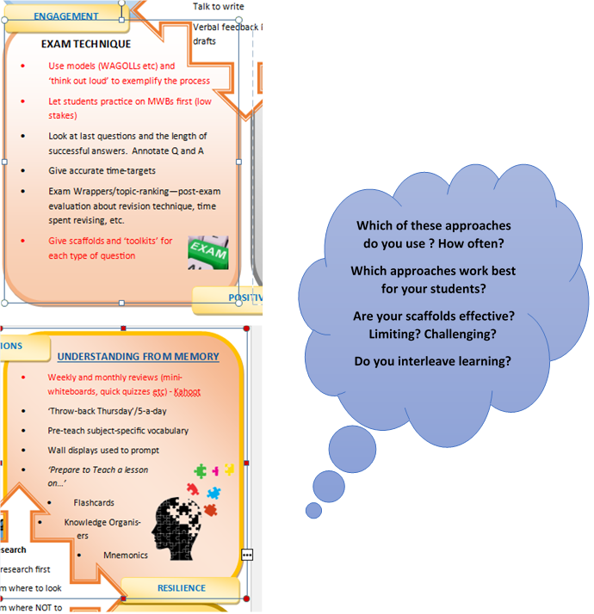

**Which of these approaches do you use ? How often?**

**Which approaches work best for your students?**

**Are your scaffolds effective? Limiting? Challenging?**

**Do you interleave learning?**

**Talk-Talk!  Structure of the Week: ‘JOT THOUGHTS’**

This strategy works well and can be completed with minimal chat.

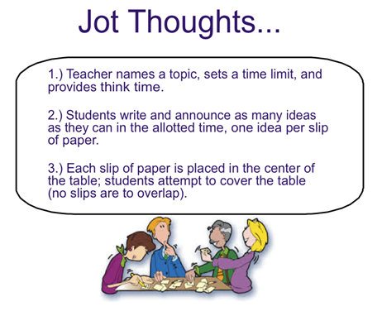

# Top Tips in Two this Half-Term

Please check the schedule below and let me know if there is a problem in advance. Thanks for delivering a top tip.

|  |  |  |
| --- | --- | --- |
| **W/C** |  | |
| **25/03/2019** | WED | **English** |
| **1/04/2019** | FRI | **Technology** |

**DRAFT: Next half-term – Please check and let me know if you anticipate a problem.**

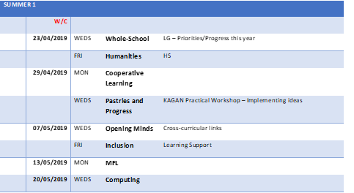

**CPD Cascade**

One of my Year 11s expressed that he had found the Seneca resources really useful and that he wouldn’t have revised so much if he hadn’t found them.

Set up courses for your Year 10s and 11s and see how they find the resources. They won’t work for everyone, but it is worth doing for those independent learners who want to push themselves further. Don’t let the setting up aspect put you off – it takes seconds. If you need help with this, many of us are using this so ask colleagues about it.

<https://www.senecalearning.com/>

|  |  |
| --- | --- |
| [https://d17hukvrbysd4e.cloudfront.net/rsz_sharinglinkimage.png](https://www.senecalearning.com/) | [Learn Better, Faster, Free. - Seneca | Free Revision & Homework Tool for A Level, GCSE, KS3 & KS2](https://www.senecalearning.com/)  [www.senecalearning.com](http://www.senecalearning.com)  Free revision for your GCSE & A Level exams. Join over 1,000,000 students revising 2x faster across 250+ exam board specific A Level, GCSE & KS3 Courses. |