**WLD Teaching and Learning Digest – w/c 26th November 2018**

|  |  |
| --- | --- |
| **COMMUNICATION FOCUSES**    Use the ‘rally robin’ approach to allow students to take it in turns to say words connected to a topic out loud. | **INCLUSION FOR ALL**    Allow take-up time… Pause before prompting further. |

**This week:**

* The **thought for the week** this week is **‘Random Acts of Kindness Calendars’ in preparation for the start of advent next week.** Please fill in the blank calendar in registers with your forms and display on noticeboards.
* **New staff and NQTs –** No CPD session this week as it is a short week.
* **NQTs** – scheduled meetings with LG this week (LG’s office) to discuss progress against standards. Exemplars emailed out last week and format discussed.
* **10th December –** Walton le Dale Staff Christmas market @3.15
* **19th December – *‘Pastries and Progress’* –** bring a marked exercisebook/process work (rather than a one-off assessment), sit with a colleague and discuss the student’s work, evidence of progress, presentation etc – and enjoy a pastry!

**Think about this…vocabulary matters!**

As I said last week, Alex Quigley grapples with vocabulary in his book *‘Closing the Vocabulary Gap’* and he provides food-for-thought around the value of exploring the roots of words and where they come from (etymology).

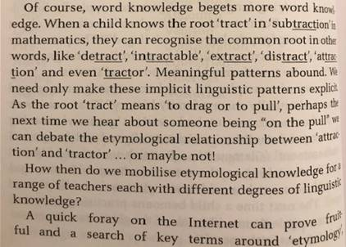

***Top Tip!*** This week, try silent starts around the subject-specific vocabulary of your lesson. Give student a section of a word (i.e. ‘tract’ from the example, subtract’ above and ask them to mind-map as many other examples of words containing this section as possible. A discussion could then follow around the meaning of this part of the word (i.e. ‘tract’).

I observed a good example of this in Science last week as the teacher explored the meaning of ‘bio’ in ‘biodegradable’. It is easy to do and takes a matter of minutes. However the collective impact that we could all have is huge!

Talk-Talk! Structure of the Week: Stand Up, Hand Up, Pair Up

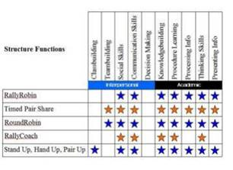

This week, try another of the Kagan top five, by using **stand up-hand up-pair** up to make paired work less monotonous and predictable. It allows different people to work together and is easy to organise. Judge your class, as this could cause anxiety in some cases. Here is a recap:

[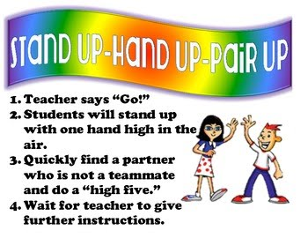](https://www.google.co.uk/url?sa=i&rct=j&q=&esrc=s&source=images&cd=&cad=rja&uact=8&ved=2ahUKEwj08u-1yfDeAhUP1RoKHTOrCqAQjRx6BAgBEAU&url=https://sites.google.com/a/hillmanschools.com/kagan-stuctures/stand-up-hands-up-pair-up&psig=AOvVaw1tlkodv5kITRzzVhDegUA1&ust=1543270673817103)

Remember that we have books on cooperative learning in our CPD library. Feel free to sign out and borrow.

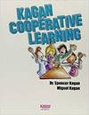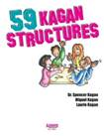

**Top Tips in Two this Term (HoDs please organise who will share and let me know)**

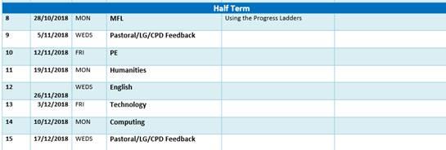

**CPD Cascade**

Those desiring to attend the twilight CPD sessions offered through the PTSA have been registered and should receive an email over the next few days.

Paula attended a mental health conference last week and offered this ‘tip’ from her day:

*‘One speaker focused on feedback and how we always refer to what students need to do to improve and not congratulating what they have done well. Could we have a focus on maybe just writing positive comments…?’*

Thanks for reading.