**WLD Teaching and Learning Digest – w/c 28th January 2019**

|  |  |
| --- | --- |
| **COMMUNICATION FOCUSES**    Pre-teach the key words for the next lesson. Give them for homework or as a plenary activity. | **INCLUSION FOR ALL**    Use your seating plan wisely to include everyone (KAGAN words well for this). |

Thanks for a very busy Teaching and Learning Week! I hope that you found it productive.

**This week:**

* The **thought for the week** this week is **‘Chinese New Year’,** which is on February 5th.Please use the PPT and mini-video in form time; it would even work in the background whilst you are signing planners.
* **NQTs** – Meetings will resume this week as usual.
* **PTSA** – JM will be in Monday, Tuesday and Thursday this week and will be shadowing MC and AD on Thursday (MC AM and AD PM).
* **Presents!** – Please collect your pack of whiteboard pens and rubbers to start using them immediately. One per teacher. Do not leave them in your room if you are peripatetic. They are yours to use wherever you go.

**•         Brilliant teaching and learning**

**•         Literacy * Challenge**

**•         Progress for students with low starting points**

**•         OM CLIPs – cross-curricular**

# Our T&L Targets:

* **Brilliant teaching and learning**
* Literacy
* Challenge
* Progress for students with low starting points
* OM CLIPs – cross-curricular

**Try This!**

We are focusing on UNDERSTANDING FROM MEMORY.

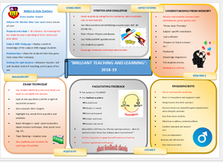

Friday provided lots of food-for-thought. I gleaned the most ideas from the key-note speaker, Phil Beadle (and not just because he was talking about literacy and I am an English teacher). Like you, I sat there and questioned some of the things that were said. However, the most important message that emerged for me was that we need to use high level language in the classroom when we are SPEAKING. So this week, let’s try and ‘leave our dialect at the door’ and use ‘elevated standard English’ when we talk to the students. We should also expect them to do the same.

# Talk-Talk!  Structure of the Week: Rally Robin

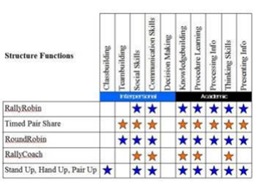

## Mini-Whiteboards

So this week, you will all collect your mini-whiteboards and rubbers and use them with the whiteboards you have or the ones in planners. They are a great way of promoting our current T&L focus from the ‘Brilliant T&L Toolkit’: UNDERSTANDING FROM MEMORY. Popular uses are:

* Vocab spelling/meaning test
* Quick quizzes
* Interleaved questions
* Encourage students to note further questions throughout lesson
* Sketching a diagram to represent the structure/flow of a text/process  
    
  You will have many more uses for them. Please discuss how you use them at departmental level and let me know of any further ways in which they can be utilised before half term.

# Top Tips in Two this Half-Term     changes

|  |  |  |  |
| --- | --- | --- | --- |
| **17** | **14/01/19** | **WEDS** | **~~MY~~** |
| **18** | **21/01/19** | WEDS | **Pastries and Progress** |
| **19** | **28/01/19** | MON | **HL and SZ** |
|  | **30/01/19** | WEDS | **TU** |
|  |  | FRI | **HD and TU** |
| **20** | **4/02/19** | WEDS | **HS and MY** |
|  |  | FRI | **CN and LY** |
| **21** | **11/02/19** | WEDS | **HC and MO** |

**CPD Cascade**

Reminder – if you have attended any CPD recently (I know several of you have attended Twilights), I would appreciate any one-liners.

It would also be useful to know ONE key thing that you learned and are going to try (or re-try) following Friday’s conference.

**Open Door Week**

Thanks to those of you who took advantage of this. Even if one person wanders, I think it is useful. If you could reply to this email, if you did wander (even a blank message), that would be useful. Just to give me an idea. I know of a number already – thanks for this.

**Date for next ODW: 11th March 2019**