**WLD Teaching and Learning Digest – w/c 4th February 2019**

|  |  |
| --- | --- |
| **COMMUNICATION FOCUSES**    Ask students to define key words for the lesson on mini-whiteboards as a silent starter. | **INCLUSION FOR ALL**    Use your seating plan wisely to include everyone (KAGAN words well for this). |

**This week:**

* The **thought for the week** this week is **‘Internet Safety’.** Please use the PPT and mini-video in form time; it would even work in the background whilst you are signing planners.
* **NQTs** – Meetings this week as usual.
* **PTSA** – JM is now in school Monday to Thursday.
* Presents! Reminder – please collect your mini-whiteboard pens and rubbers from reception if you haven’t already as you need to be using them.

# Our T&L Targets:

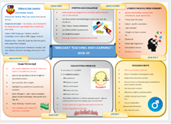

* **Brilliant teaching and learning**
  + Literacy
  + Challenge for all
  + Progress for students with low starting points
  + OM CLIPs – cross-curricular

# Try This! Mini-Whiteboards – Making your rules clear

So last week, most of you collected your mini-whiteboard pens and it was great to see many of you using them around school. As I said last week, they are a great way of promoting our current T&L focus from the ‘Brilliant T&L Toolkit’: UNDERSTANDING FROM MEMORY and you will, no doubt, discuss their uses before half-term within your departments.

There are many approaches to using MWBs in lessons and much has been written the subject. I have attached links to some useful blogs below and have summarised some of the useful practices:

* Formulate the questions in advance
* Make it clear that you want the answer to fill their board
* Decide on whether you will say ‘3-2-1 show me’ or whether students can show immediately

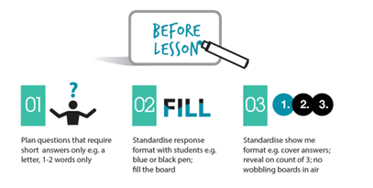

<https://joeybagstock.wordpress.com/2017/10/21/show-me-maximising-the-use-of-mini-whiteboards-in-lessons/>

|  |  |
| --- | --- |
| [https://joeybagstock.files.wordpress.com/2017/10/screenshot-2017-10-21-10-57-33.png](https://joeybagstock.wordpress.com/2017/10/21/show-me-maximising-the-use-of-mini-whiteboards-in-lessons/) | [Show Me: Maximising the Use of Mini Whiteboards in Lessons – must do better… - must do better… | thoughts about English teaching and education in general](https://joeybagstock.wordpress.com/2017/10/21/show-me-maximising-the-use-of-mini-whiteboards-in-lessons/)  joeybagstock.wordpress.com  Mini whiteboards can be an excellent way to gather information about class ‘understanding’ quickly and efficiently. When used badly, however, they cease to be an effective responsive teaching tool, and they can get in the way of learning and become a distraction. |

This blog is also useful and uses a Science lesson to demonstrate.

<https://ndhsblogspot.wordpress.com/2017/05/05/how-i-use-mwbs/>

## Open or Closed: That is the Question

Educators have also spent years discussing the use of questioning techniques. In recent times, it has been deemed negative to use ‘closed questions’. However, Barak Rosenshine says that *‘questions help students to practice new information and connect new material to their learning…[and] allows a teacher to determine how well the material has been learned and whether there is a need for further instruction.’*

Clearly, this links to MWB usage. Think about how you use closed questions to determine the level of UNDERSTANDING FROM MEMORY.

# Talk-Talk!  KAGAN Card

**Another present!** In your pigeonhole this week, you will find a KAGAN structures card to remind you of how to use them. As organising group talk so that it is purposeful is clearly a focus (as it counteracts off-task chat), this should be useful. *Middle Leaders, you may wish to discuss this at department level and select three to push within their areas*. This will be discussed at a later date.

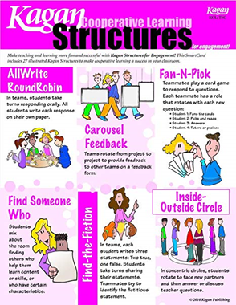

# Top Tips in Two this Half-Term     changes

|  |  |  |  |
| --- | --- | --- | --- |
| **20** | **4/02/19** | **WEDS** | **HS and MY** |
|  |  | FRI | **CN and LY** |
| **21** | **11/02/19** | MON | **CS** |
|  |  | WEDS | **HC and MO** |
|  |  |  |  |
|  |  |  |  |
|  |  |  |  |

I am currently creating our Top Tip schedule for the next half term. Please let me know if there is any particular area you would like tips on and I will try to accommodate. Alternatively, if you have anything that you would like to share, please let me know.

**CPD Cascade**

**Date for next ODW: 11th March 2019**