**WLD Teaching and Learning Digest – w/c 5th November 2018**



|  |  |
| --- | --- |
| **COMMUNICATION FOCUSES**    How do you teach new, complex vocabulary? Do you ask students to write in vocab page in planners? (could you do this?) | **INCLUSION FOR ALL**    Provide MAD/DIRT time so that students have chance to work on their weaknesses. |

**This week:**

* The **thought for the week** this week is **‘Remembrance’.** Materials circulated as usual. Feel free to use your own as this is a really poignant occasion for many.
* **Friday briefing** – please could you all bring an idea to share around how you boost vocabulary/teach new words to your students. We will have a swap shop.
* **New staff and NQTs –** CPD session with TU on ICT systems will run on Thursday at 3.15. Please let TU know if you cannot attend.
* **NQTs** – scheduled meetings with LG this week (LG’s office).

**Teaching Approach of the Week**

Over the last few weeks, you may have heard the terms ‘tier 1, tier 2 and tier 3 vocabulary’ or you may have read about it previously.

 In case you haven’t come across this before, here is an explanation of the different tiers: 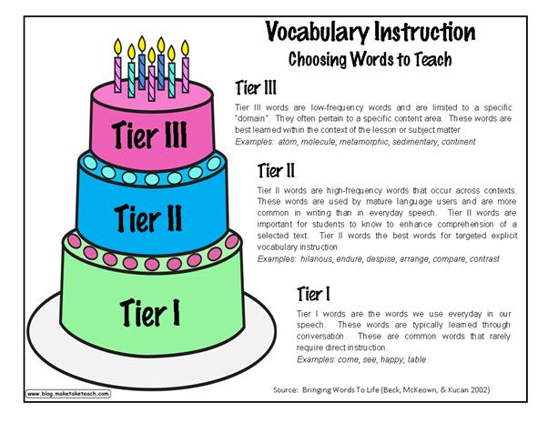

The ***tier 2 words***, the words that we use when teaching our students every lesson, are important in developing comprehension skills as they are the ones that often cause confusion (if students have not been exposed to them before).

Importantly, ***the tier 3 words*** are the new words related to new topics etc that we have to explicitly teach and allow students the opportunity to use in context.

Think about the language that you use when speaking to students: could you use more sophisticated vocabulary (tier 2 words)? Are you exposing students to a full range of vocabulary?

***NEW SECTION…***Talk-Talk!

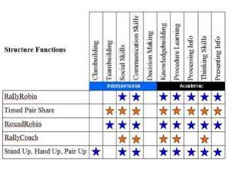

Last week, we focused on ***think-pair-share***. As we all know, this works well if we allow that silent thinking time first.

This week, try the ***rally robin***. It would link well with low-stakes testing at the start of a lesson to check for understanding.

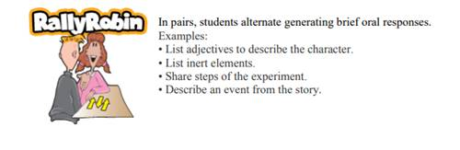

Further reading linked to KAGAN structures is available in our CPD library. Please sign out if you borrow. Thanks.

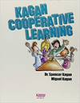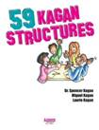

**Top Tips in Two this Term (HoDs please organise who will share and let me know)**

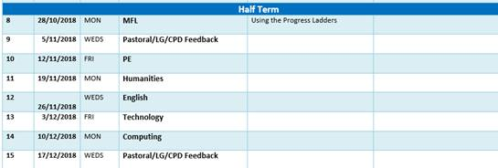

**CPD Opportunity**

Reminder that the T&L Think Tank will be meeting on Monday 19th November, 4pm – 5pm.  The focus will be engagement strategies, particularly with underachieving boys.  You are asked to take an example to share and discuss of a strategy that has worked for you / in your school. Please let me know if you plan to attend (we have two members of staff so far). Thanks.