**WLD Teaching and Learning Digest – w/c 8th October 2018**

|  |  |
| --- | --- |
| **COMMUNICATION FOCUSES**    U  P  C  What do these marking codes mean? Test yourself! (answers to be enlarged below)  Underline, punctuation, capital letter missing | **INCLUSION FOR ALL**    Cue in attention using names and then pause… |

**This week:**

* The **thought for the week** this week is **‘Technology: Changing Lives’.** I have put an extract from ‘Frankenstein’ in registers – it is the moment when technology succeeds in making the ‘monster’ open its eyes for the first time.
* **New staff and NQTs –** CPD session on Learning Support and behaviour management will be this Friday at lunch. Venue TBC (email to follow).
* **Top Tip this week –** the Science department is leading this week with AY on Wednesday.
* **Reminders:** 
  + **Study Groups** – Teaching staff CPD session on Monday 8th October to launch this year’s Study Group research projects. We will start at 3:15 in B7 for 5 minutes at then disperse to groups.
* **Thank you!** Over the last few weeks, we have had the PP Review. As clichéd as it sounds, I feel absolutely privileged to visit lessons and see my colleagues doing what they do best and really enjoying showing visitors what the teachers at WLD have to offer.  If we ***maintain high standards within and beyond the classroom***, we will be able to lead our students anywhere within their learning.  Uniform, equipment, presentation of work, jewellery, etc etc – all of this matters to us.  One thing that I did learn as I walked last week was that our students really do have a thirst for knowledge…they want to learn.

**Teaching Approach of the Week**

<https://heartsandmindsteaching.wordpress.com/>

|  |  |
| --- | --- |
| [https://s0.wp.com/i/blank.jpg](https://heartsandmindsteaching.wordpress.com/) | [Hearts and Minds](https://heartsandmindsteaching.wordpress.com/)  heartsandmindsteaching.wordpress.com  Exploring ideas about teaching English and school culture |

Ever tried ‘Sampling’?  The following article provides an approach to feedback designed to reduce time spent on ‘marking’ which is not acted upon, and to therefore allow for more meaningful planning to counter misconceptions etc.  Let’s face it, anything that cuts workload and helps students to improve must be worth a look.

I have used class feedback and I know others have also tried it with mixed success. I will attach my templates for you to use (there are also WAGOLLs of the best work for each assignment on the reverse). I am also using one period 2 on Monday, if anyone is curious.

**Top Tips in Two this Term (HoDs please organise who will share and let me know)**

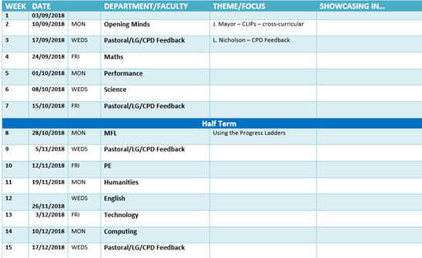

**CPD Opportunities**

REMINDER – PLEASE! I know that a few members of staff have offered to lead voluntary CPD sessions on various things. If you have any pedagogy/skills that you would like to share, let me know and we can offer to everyone. Thanks to those who have already.

**CPD Opportunities:**

* T&L Think Tank – it is meeting Monday 19th November, 4pm-5pm at Balshaws. It is open to anyone who has an interest in T&L. The focus for this first meeting will be engagement strategies, particularly with under-achieving boys. This may link to study groups quite well.
* **Research Ed** – I know several of you attend this each year. If anyone would like to accompany me next March, please let me know.



Thanks for reading.