**WLD Teaching and Learning Digest – w/c 9th July 2018**

|  |  |
| --- | --- |
| **COMMUNICATION FOCUSES**    **Audit** – try asking your students to mind-map all of the key subject-specific words that they have used this year in your subject.  Then ask them to prioritise the top ten.  Practise spelling them. | **DYSLEXIA-FRIENDLY STRATEGY**    Give students take up time.  Use POSE – PAUSE – POUNCE and BOUNCE for this. |

**This week:**

* The **thought for the week** this week is **‘Achievement** – and end of year evaluation’. Use form time this week to evaluate the achievements that your students have made this year. Please use the PPT and article circulated or feel free to share your own materials.
* **Teaching and learning – Walton le Dale style:** Please could subject leads discuss the teaching and learning toolkit with department areas and provide feedback/amendment (preferably by the holidays, otherwise by the end of the first week back). I would like to re-issue asap.
* **CPD Update –** 
  + Please let James or I know of research areas for study groups next year by the ***end of the week*** so that we can organise the groups ready for September.
  + Thanks for signing up to your sessions for the CPD next Monday. I will email final details this week. These may form the starting point for study group research next year.
* **Trainees –** We will not be taking any trainees until after Christmas, when we will have a PE trainee from the PTSA working with Graham and his team.
* **NQTs –** we have a number of NQTs and new members of staff starting with us next year. Training schedules have been put in place and will be put onto the staff noticeboard this week. Please edit/amend by Friday if there is a problem. They have already been emailed round so should be okay.

**Teaching Approach of the Week – Try It!**

This approach links to our ***TOOLKIT: ‘Understanding from Memory’*** section.

This week, I am focusing on vocabulary building. This is obviously a skill that is crucial to our students. I am taking these ideas from Alex Quigley’s ‘Closing the Vocabulary Gap’…definitely food for thought. Please remember that we are all teachers of literacy and that we owe our students the chance to boost their skills.

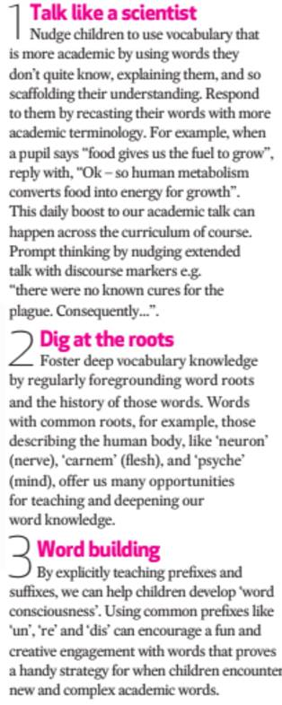

Read more here:

[*https://www.theconfidentteacher.com/category/closing-the-gap/*](https://www.theconfidentteacher.com/category/closing-the-gap/)

**Recent Top Tips (abridged)… Keep using them if they worked!**

* **Clever use of seating plans**
* **Behaviour strategies - reminders**
* **Reading strategy – sum up a paragraph at a time**
* **Calm behaviour management – wait, cue in positive role models for behaviour**
* **Competition in lessons**
* **Black dot in a white square – focus on the positives**
* **We Are Reading! – offer lots of opportunities for students to read**
* **Show the and in stages…think out loud**
* **Verbal Feedback**
* **Because, but, so – extend sentences and thinking**
* **PIE FACES – Features of good writing**
* **‘Just a Minute’ and ‘Exam Wrappers’**
* **Retrieval Practice – questions from last lesson, last week and last term**
* **The ‘BIG Question’**
* **3B4ME – promoting independence**
* **WAGOLLs (what a good one looks like – use of model work)**
* **Pose, Pause, Pounce and Bounce**
* **Reading for understanding – mini-whiteboards, quick quizzes, verbal questioning, think-pair-share etc.**

**Top Tips in Two this Half-Term**

* ~~Monday 4~~~~th~~ ~~June – A. Sam~~ Many thanks!
* ~~Friday 15~~~~th~~ ~~June – A. Lyons~~ Many thanks!
* Wednesday 27th June – E. Hand and S. Allen
* Wednesday 11th July – J. Mayor (rearranged)