**WLD Teaching and Learning Digest – w/c 17th September 2018**

|  |  |
| --- | --- |
| **COMMUNICATION FOCUSES**    Embed the literacy marking policy – ensure students are familiar with codes (printed in student and staff planners) | **INCLUSION FOR ALL**    Stick to the clear boundaries and high expectations that you have set over the last two weeks. |

**This week:**

* The **thought for the week** this week is **‘Kindness and Peace’** ahead of International Day of Peace on Friday.  Again, please can I urge you to make use of the materials emailed and in registers.
* **New staff and NQTs–**  CPD session is after school on Tuesday with LA and her team (LA’s office).
* **Extra-curricular activities** – The new timetable is now in registers. Please draw attention to it in forms and display on noticeboards.
* **Study Groups** – The Study Group information has been emailed out. Please check your groups and for any errors. I have scheduled a whole-staff CPD session on Monday 8th October to launch this year’s Study Group research projects. This will NOT count as one of the 5 hours. It will be an opportunity for you to think about how you, as a group, wish to organise your time and remember face-to-face meetings may be difficult to schedule and are not necessarily the best use of your time.

**Teaching Approach of the Week**

Last week, James spoke about the development of our students’ oracy and collaborative skills within our classrooms. This week, think about YOUR classroom rules for collaborative work and make them EXPLICIT. Direct students and tell them HOW to complete the activity that you have set. The following approach is taken from Teacher Toolkit and this source offers plenty of links to further resources if you are interested: <https://www.teachertoolkit.co.uk/2018/01/25/improving-oracy/>

|  |  |
| --- | --- |
| [https://www.teachertoolkit.co.uk/wp-content/uploads/2018/01/speech-bubble.jpg](https://www.teachertoolkit.co.uk/2018/01/25/improving-oracy/) | [6 Tips For Improving Oracy - @TeacherToolkit](https://www.teachertoolkit.co.uk/2018/01/25/improving-oracy/)  [www.teachertoolkit.co.uk](http://www.teachertoolkit.co.uk)  How do we make our classrooms hubs of high quality talk? Student talk is important and making it high-quality is transformational so how can we promote oracy? |

There is a wealth of research professing the importance of oracy:

*‘*[*Vygotsky*](https://en.wikipedia.org/wiki/Lev_Vygotsky)*suggests that talk represents our thoughts therefore the higher the quality of our students’ speech, the higher quality of their thinking.’*

*‘*[*Professor John Hattie*](http://www.education.auckland.ac.nz/en/about/staff/j.hattie.html)*also found that teaching strategies with high quality student talk prioritised produced the biggest effect sizes.’*

##### 

##### 1. Rules for Talk

Try setting out your expectations from the start. What does high quality talk look, feel and sound like?

A display or hand out like the one below might help, reinforced through teacher modelling and constant reminders. You could even appoint student ‘talk police’ to ensure the expectations are met each lesson.

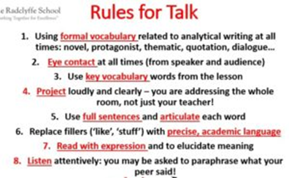

##### 2. Sophisticated Synonyms

I have found this one of the biggest game changers in my classroom: displaying academic verbs in my subject area and a list of synonyms. All I have to do is point during a discussion to encourage students to vary their vocabulary. It also opens up a dialogue about which verb is most appropriate thereby teasing out the subtle nuances between meanings.

##### 3. Paraphrasing

Students have only listened and comprehended successfully if they can paraphrase their peers’ ideas – no daydreaming allowed!

##### 4. Thought Stems

An idea stolen from [David Didau’s](http://www.learningspy.co.uk/) work around speaking like an academic or professional in the given subject area. By encouraging students to think and speak using sophisticated phrasing, they are more likely to internalize it and use it confidently in their writing. It goes without saying that the more you can model this kind of talk, the better!

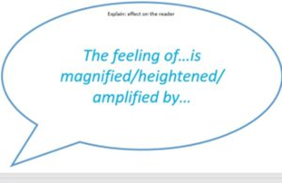

##### 5. Relentless Redrafting

By asking students to replace a word with a more specific or sophisticated synonym; add a subordinate clause or use one of the key words from the lesson in their answer, you are constantly raising the standard of their thinking and speaking.

Again, by modelling this process first, students are able to see, hear and understand the thinking behind the redrafting process. It is worth remembering that if students answer using complex sentences, their thinking becomes more complex too.

**Top Tips in Two this Term (HoDs please organise who will share and let me know)**

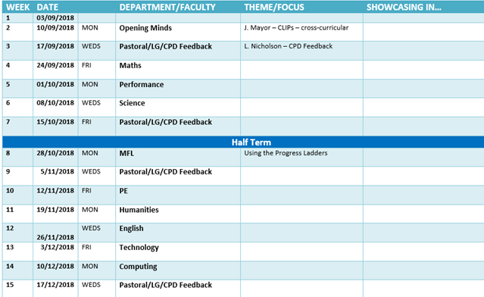

**CPD Cascade**

L. Rayner will provide this week’s Top Tip to feedback on CPD.

Thanks for reading. ‘