**WLD Teaching and Learning Digest – w/c 4th March 2019**

**SOUND BITES:**

•         Expectations

•         Chat

•         Mini-whiteboards

•         Literacy Policy

•         KAGAN Structures

|  |  |
| --- | --- |
| **COMMUNICATION FOCUSES**    **Promote active reading strategies**: **skimming** – looking for something in particular (i.e. negatives or positives). | **INCLUSION FOR ALL**    Mini-whiteboards to answer questions |

***\*\*\*NEXT WEEK – PASTRIES AND PROGRESS AND OPEN DOOR WEEK!*** (see note at end for format)***

**This week:**

* The **thought for the week** this week is **‘World Book Day’ which is on Thursday March 7th.** A PPT quiz has been emailed out and an answer grid will be in registers.
  + **We Are Reading**: *Your* Recommended Reads – you will receive a laminated poster this week.  Please display the poster on your classroom door and add in a book title that you would recommend.
* **NQTs** – CJ – Monday after school; AW – no meeting this week; JS – meeting as usual.
* **NEW TOOLKIT LAUNCHED! –** Please ensure that you use the new toolkit for planning purposes and to reflect on your lessons/teaching. You have each had an input into this document and it contains great ideas.
* **Maths Review –** takes place over the course of the next two weeks.

# Our T&L Targets:

**Brilliant teaching and learning**

* + Literacy – book looks will look at how well the literacy marking policy is implemented (i.e. sp, u, p, np, etc).
  + Challenge for all
  + Progress for students with low starting points
  + OM CLIPs – cross-curricular

# Think about this…

<https://teachingbattleground.wordpress.com/2019/02/09/noise/>

|  |  |
| --- | --- |
| [https://s0.wp.com/i/blank.jpg](https://teachingbattleground.wordpress.com/2019/02/09/noise/) | [Noise](https://teachingbattleground.wordpress.com/2019/02/09/noise/)  teachingbattleground.wordpress.com  Children are noisy. This is something people often don’t appreciate if they don’t work in schools, as can be seen by the recurring experiments with “open plan classrooms” th… |

This year, we all know that we are striving for zero off-task chatter and we also know that this can be hard, especially when we have such positive relationships with our students. In this blog, the writer considers whether ***any*** noise is needed in classrooms and also contemplates the question of whether the most effective problem-solving occurs when working independently, as opposed to in groups.

There are many reasons for allowing students to talk in our lessons: to share ideas, to deepen understanding, to extend interpretations and to offer guidance to those who need it. I suppose the question for us all is: ***are students gaining more from talking, than from being in silence;*** if the answer is yes, then we must make sure that it is structured and formatted (i.e. using KAGAN structures).

**Talk-Talk!  Structure of the Week: ‘PAIRS COMPARE’**

Try using this, if you feel that students would gain more from using it rather than working independently. Make sure that you outline the rules of effective group (pair) work first.

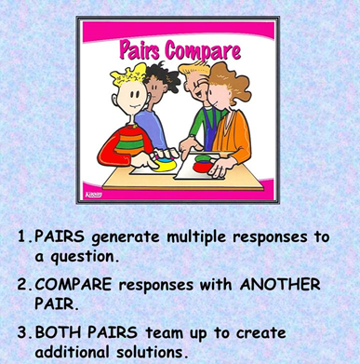

# Top Tips in Two this Half-Term

Please check the schedule below and let me know if there is a problem in advance. Thanks for delivering a top tip.

|  |  |  |  |
| --- | --- | --- | --- |
| **W/C** |  | |  |
| **25/02/2019** | WEDS | **Internet Safety** | TU |
| **4/03/2019** | MON | **Maths** | WS – Knowledge organisers |
| **11/03/2018** | WEDS | **All Staff** | Pastries and Progress – Embedding the literacy marking policy |
|  | FRI | **Science** |  |
| **18/03/2019** | MON | **PE** |  |
| **25/03/2019** | WED | **English** |  |
| **1/04/2019** | FRI | **Technology** |  |

**CPD Cascade**

**NEXT WEEK is Open Door Week!** Make sure you take the opportunity to wander the school when you have chance. Colleagues who wandered last time, found it very useful. My door is always open.

**Pastries and Progress will also be on Wednesday next week**. This will be a ‘showcase’. A few members of each department are asked to stand at a desk in B7 during briefing containing a couple of examples of effective feedback in their areas; staff will then rotate around each subject and gather ideas. This can then be filtered back to departments in meeting time.