**WLD Teaching and Learning Digest – w/c 15th October 2018**

|  |  |
| --- | --- |
| **COMMUNICATION FOCUSES**    Look back at your books this half term…is the presentation of work consistently good? | **INCLUSION FOR ALL**    Use the ‘thought for the week’ to spark discussion – don’t just read out the thought from notices. |

**This week:**

* The **thought for the week** this week is **Mental Health.** This issue is prevalent and mental illness is believed to affect 1 in 4 of young people and adults.Materials have been sent in registers and by email.
* **New staff and NQTs –** CPD session on behaviour management will run this Thursday lunch time (for those who missed it last Friday) with A. Snape in D1.
* **NQTs** – scheduled meetings with LG this week (LG’s office) unless this coincides with student shadowing activity (timetables from LG).
* **Reminders:** 
  + **Study Groups – these are now on the way. Please ensure that you log any time spent on this as you will need to account for it at the end.**
  + **1st November** – Staff meeting – PP Review feedback

**Teaching Approach of the Week - Reflection**

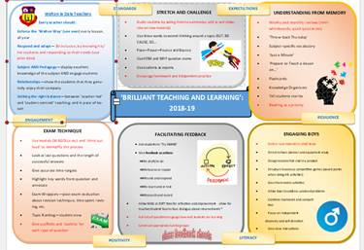

So over the last six weeks, we have (hopefully) been using our ‘Toolkit’ to enhance teaching and learning within our classrooms. This is our mantra, our policy and what we expect to see when we walk around school.

If we look at the focuses (priorities), where would you be able to evidence that you have tried them in your teaching over the last six weeks:

* **Stretch and challenge** – where have you tried ‘but, because, so’ or ‘pose-pause-pounce-bounce’?
* **Understanding from memory** – where have you used mini-whiteboards, flashcards etc?
* **Exam Technique** – where have you used WAGOLLs or WABOLLs?
* **What about feedback** – where have you planned in MAD or DIRT time?
* **Engaging boys** – have you focused on self-directed learning or independent learning? Where?

What about the ‘Walton Way’ or key standards? Are you still sticking to them rigidly?

**Bright Spots**

Whilst our focus over the first six weeks has been on standards and consistency, quite rightly, I have seen some examples of creativity and great teaching on my wanderings. Below are some snippets of memories gathered from my walks around school:

In Art, students silently engrossed in their work, not WANTING to talk to one another… Now this is what we want! Over in PE, clear explanations and effective modelling of skills has been seen on a regular basis. Music, students engaged in creating a rhythm together whilst the teacher conducts - enthralled! Over in English, the level of calm has been evident in classrooms. However on one day, a ‘snow ball’ activity added to the excitement (students enjoyed this!). In MFL, students have enjoyed being challenged to learn new languages lower down the school. Seeing them grapple with German and engaging with the teachers has been uplifting (and also the clicking of dice on the table – great!). Over in Science, students have engaged with a range of well-managed practical experiments (the dissection of the pig’s heart – a personal favourite), whilst in Mathematics, effective questioning has been seen, pushing students further in their learning. In Technology, effective questioning has also been evident forcing students to think about the choices that they are making. In Humanities, a range of active and engaging learning activities have been seen, simultaneously allowing students to grapple with difficult concepts. This is similar in OM, where group work has also been effectively organised to allow everyone to have a role and focus.

Sorry for the ramblings – just my thoughts as I reflect on my journey around school over the last half term.

**Top Tips in Two this Term (HoDs please organise who will share and let me know)**

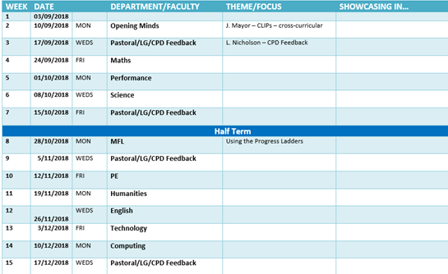

**CPD Cascade**

I attended a CPD session on Friday morning and it contained talks by Ofsted HMIs. It was interesting but one quote that I liked and that made a lot of sense was that Ofsted’s focus was that they basically want students to ***‘know more and to remember more’*** – simple as that. This made me think of the importance of learning (teaching) both skills AND knowledge – one is redundant without the other.

For example, if you try to teach the skill of ‘evaluation’ in isolation, students will then not be able to evaluate who was responsible for WWI, for example. The knowledge is what gives the evaluation depth.

Thanks for reading.