**WLD Teaching and Learning Digest – w/c 17th June 2019**

|  |  |
| --- | --- |
| **COMMUNICATION FOCUSES**    ***Quick starter*:** ask students to swap books.    Highlight the key subject-specific words in a partner’s book. Then write a list of the words on mini-whiteboards.  Test one another on spellings and meanings. | **INCLUSION FOR ALL**    Adopt a no-hands up policy and ensure that you ask everyone at least one question in the lesson. |

***KEY FOCUSES: behaviour for learning, use of mini-whiteboards, expectations***

# This week:

* The **thought for the week** this week is **‘Refugees’** as Refugee Week 2019 is this Thursday.  Please discuss this issue with your forms and use the PPT circulated.
* **NQTs** – AW – no meeting due to interviews; CJ – as usual; JS – Thurs 1.
* **PTSA Trainee** – Joe leaves us on Friday.  We will miss him but wish him well.
* **Reminder: Literacy Policy needs to be evident in all books (Sp, P, C, U)**.

# Our T&L Targets:

* **Brilliant teaching and learning**
  + Literacy – book looks will look at how well the literacy marking policy is implemented (i.e. sp, u, p, np, etc).
  + Challenge for all
  + Progress for students with low starting points
  + OM CLIPs – cross-curricular

# Think about this…

*‘engagement – pupils appearing interested and motivated – is a poor proxy for learning.  As is pupils being busy and doing lots of work…learning is invisible.’ (Professor Rob Coe)*

***‘Boys Don’t Try’ by Matt Pinkett and Mark Roberts, pg 20.***

I, for one am currently reading the book *‘Boys Don’t Try’* by Matt Pinkett and Mark Roberts.  Although I am only half-way through, some of the debunked myths are interesting.  I came across this one and thought it was useful to share as it supports a document that we circulated and endorsed at the beginning of the year and links it to how boys learn: ‘Rosenshine’s Principles of Instruction.

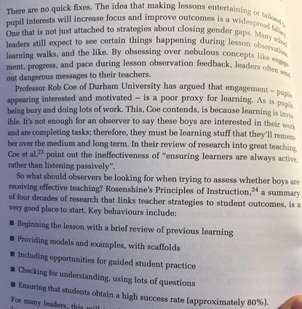

This week, during your planning, ask yourself the question: are your students **engaged**, or are they **learning**?

This book will be in our CPD library soon (as soon as I have finished reading it!). I know that others are reading it, too, so ask around if you are interested.

# Talk-Talk!  Three Structures

Please use these (or other) structures when doing anything other than teacher-led instruction:

* Think-Pair-Share OR Timed-Pair-Share
* Silent conversation OR Continuous Rally Robin
* Jigsaw groups

The PowerPoint for this Top Tip is stored in the ‘WLD Teachers’ Team under ‘Teaching and Learning’.

[Kagan Three Structures](https://teams.microsoft.com/l/file/E16AD0B5-81AF-4C89-9917-4E4608013119?tenantId=e2c1c4a9-e444-46de-bc3b-a98c82527d33&fileType=pptx&objectUrl=https%3A%2F%2F8884150.sharepoint.com%2Fsites%2FWLDTeachers%2FShared%20Documents%2FTeaching%20and%20Learning%2FTop%20Tips%20in%20Two%20Minutes%2FkAGAN%20top%20tip.pptx&baseUrl=https%3A%2F%2F8884150.sharepoint.com%2Fsites%2FWLDTeachers&serviceName=teams&threadId=19:88af73d36e4e44118029bbd9832c463b@thread.skype&groupId=334f6390-7bf8-4407-bcd2-d73698bc5d63)

# Top Tips in Two this Half-Term

Here is our schedule for this half-term.  Please give me advanced notice of any changes. Many thanks for your support with this. I know that staff always find them useful (and entertaining).

|  |  |  |  |  |
| --- | --- | --- | --- | --- |
| **SUMMER 2** | | | | |
|  | **W/C** |  |  |  |
|  | **~~3/06/19~~** | ~~WEDS~~ | **~~Technology~~** | ~~Sh – revision idea~~ |
|  | **~~10/6/19~~** | ~~MON~~ | **~~MFL~~** | ~~Classroom Keys~~ |
|  | **17/06/19** | FRI | **Science** | AY |
|  | **24/06/19** | MON | **LG** |  |
|  |  | WEDS | **Pastries and Progress** | ALL – discuss effective revision strategies for teaching skills and content.  How have you used mini-whiteboards in the revision process? |
|  | **1/07/19** | FRI | **TU** | Internet Safety |
|  | **8/07/19** | MON | **NQTs** | JS |
|  | **15/07/19** | WEDS | **LG** |  |

# CPD Cascade

**Literacy Workshops** – **next Monday 3:15-4:15 (at the latest)**

The rooms for these workshops are as follows:

CX and AL – D8

CN and RI – D10

GA and WL – D11

CJ and LG – D12

**😎😎Summer Reading😎😎**

We have purchased a number of great reads for our CPD library.  If anyone would like to recommend a good read in the field of educational research, or to volunteer to read and complete a mini-review of an educational book that they have read for September, please let me know.  I will then compile a list and you can choose which book to review.