**WLD Teaching and Learning Digest – w/c 1st April 2019**

|  |  |
| --- | --- |
| **COMMUNICATION FOCUSES**    **Allow 15 minutes MAD time this week, allowing students to check their exercise books alongside the Communication Policy. They should use pens to correct errors.** | **INCLUSION FOR ALL**    Challenge low-level off-task chat. Do not leave it unchecked as it ruins the learning of others. |

***Happy Easter everyone!***

**This week:**

* The **thought for the week** this week is **‘Autism Awareness Week’.** This is clearly something that affects us all, directly or indirectly. PPT circulated. Please use in forms.
* **Monday:** J. Doyle in to look at Teaching and Learning period 1.
* **Egg-cellent Easter Reads**: Point your students in the right direction for reading material this holiday.
* **NQTs** – Assessments and observations completed. Many thanks to Subject Mentors and NQTs for their hard work with this.
* **PTSA Trainee** – CPD session this Wednesday lunch time in D13 (FBV through OM).
* **Mini-whiteboards:** we have invested in these for everyone and expect to see them being used in lessons please. Replacement pens can be collected from G. Roberts in the office.

# Our T&L Targets:

**Brilliant teaching and learning**

* + Literacy – book looks will look at how well the literacy marking policy is implemented (i.e. sp, u, p, np, etc).
  + Challenge for all
  + Progress for students with low starting points
  + OM CLIPs – cross-curricular

# Think about this…

<https://www.academia.edu/6445527/Getting_the_max_out_of_mini-whiteboards>

|  |  |
| --- | --- |
| [http://a.academia-assets.com/images/open-graph-icons/fb-paper.gif](https://www.academia.edu/6445527/Getting_the_max_out_of_mini-whiteboards) | [(PDF) Getting the max out of mini-whiteboards | Jason Skeet - Academia.edu](https://www.academia.edu/6445527/Getting_the_max_out_of_mini-whiteboards)  [www.academia.edu](http://www.academia.edu)  CLIL Magazine Issue 1: Winter 2012 <http://clilmagazine.nl/> Getting the max out of mini-whiteboards By Jason Skeet A mini-whiteboard is an A4 sized double-sided ... |

This week, focus on using mini-whiteboards. Some of the barriers to using them may be: if they are used everywhere, all of the time, the students will not like using them; or they are a ‘faff’ to give out and get back. These reasons, though valid, are outweighed by the benefits. They promote independence, engagement, challenge and ‘learning’. We are all capable of designing a simple entry and exit routine to ensure that the logistics don’t interfere with learning. Make them a **regular** feature of the lesson and disruption becomes less frequent.

**Promoting Challenge?**

Use ‘Bloom’s Question Matrix’ disseminated last year, to nudge students to think about wider questions and to develop their thinking:

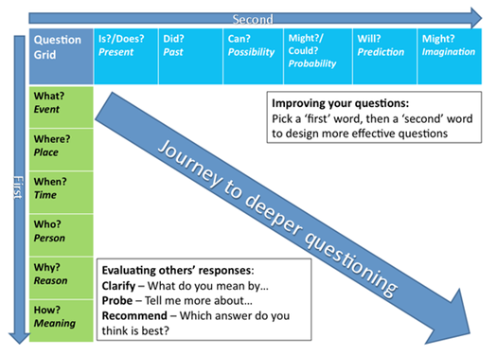

Talk-Talk! Structure of the Week: Silent Conversation (Rally Table)

Not all learners are equally comfortable or adept at participating in large- or even small-group verbal discussions. Silent conversations capitalise on the social nature of learning by asking students to **share their thinking** and **to build from and reflect on the thinking of others**, but they do so by allowing students to use writing for additional time to think and refine their ideas.

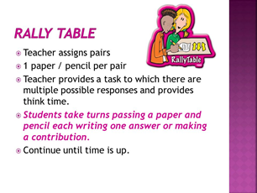

Use **mini-whiteboards** to complete this activity. This makes it low-risk and low-threat for students.

# Top Tips in Two

I have attached the Top Tip schedule for the next half-term. Please let me know if any of these are a problem.

|  |  |  |  |
| --- | --- | --- | --- |
| **W/C** |  |  |  |
| **23/04/2019** | WEDS | **Whole-School** | LG – Priorities/Progress this year |
|  | FRI | **Humanities** | HS - interleaving |
| **29/04/2019** | MON | **Cooperative Learning** | CN, WL, LG |
|  | WEDS | **Pastries and Progress** | KAGAN – Implementing ideas |
| **07/05/2019** | WEDS | **Opening Minds** | Cross-curricular links |
|  | FRI | **Inclusion** | Learning Support |
| **13/05/2019** | MON | **MFL** |  |
| **20/05/2019** | WEDS | **Computing** |  |

**CPD Cascade**

Last week, I had the privilege of observing a member of staff and he did something so brilliant but so simple, I just had to share. As students passed their books to the end of a row, he wrapped them in an elastic band so that they were ready to give out next time. A simple time-saver to get the next lesson off to a speedy, organised start.