**WLD Teaching and Learning Digest – w/c 4th December 2017**

**This week:**

* Thought for the week this week is **ADVENT**. There is a PowerPoint as usual and also a blank ‘alternative’ advent calendar for you to fill in with your forms; hopefully it will be *fun* as well as effective.
* This week, YF will be talking to new staff about numeracy approaches in school.
* Dyslexia Friendly School status – MY and LG gathering evidence, informally, this week (MY has provided further information – emailed).

**Teaching Resource of the Week**

***RE-PUBLISHED DUE TO SHORT WEEK -* Homework planners** - we all use them for different reasons.  Try tapping into their motivational power by asking students to have them out at the start of the lesson; for each class, choose the student working the hardest and write in a positive note.  Even add in a sticker/stamp.  See if it motivates them!

**Teaching Approach of the Week – Try It!**

I have seen this in practice in Geography recently and think it would transfer to other subject areas.  As it is mock exam fortnight, it would certainly benefit those taking exams.  The idea is using the acronym BUG to allow students to access the question and answer it correctly:

[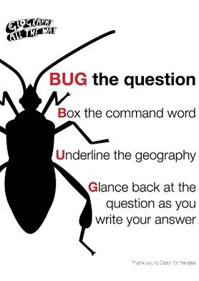](http://www.google.co.uk/url?sa=i&rct=j&q=&esrc=s&source=images&cd=&cad=rja&uact=8&ved=0ahUKEwjl3Iipiu_XAhWRJVAKHbeFA3YQjRwIBw&url=http://www.geographyalltheway.com/support/geography_display.htm&psig=AOvVaw0r0leoQe6qvgP6qbkLw4tr&ust=1512433041247355)

**In Previous Digests… Keep using them if they worked!**

* **Unlocking key words – discussing possible meanings**
* **The ‘BIG Question’**
* **Whole-school marking policy – please display the new pink poster in rooms (spares with LG)**
* **3B4ME – promoting independence**
* **Feedback – using exemplar work so students can compare with their own. Allowing students time to ask you questions about their work (make use of MAD time).**
* **Pose, Pause, Pounce and Bounce**
* **Developing recall skills: short quizzes, mini-whiteboards, etc.**
* **Starter cards**
* **Reading for understanding – mini-whiteboards, quick quizzes, verbal questioning, think-pair-share etc.**

**Coming Soon… Teaching and Learning Exchanges**

* Wednesday 13th December – SW

I would like to put together a rota for the next half-term; please drop me an email if you would be happy to share something that did (or didn’t!) work.  Much appreciated.

**Reminder - CPD Opportunity**

* **Middle Leaders** – If anyone would like feedback from the Leadership Conference attended by MC last week, please let me know as MC is happy to share her feedback. Many thanks to MC for providing this soundbite from the course: ‘Understand your core beliefs about education; they determine your drive.’
* **All staff** - Reminder - The Teaching and Learning think tank is **this Wednesday 6th December** at Balshaws.  The focus is stretch and challenge; and also boys.  It is great to have us represented at these meetings and is useful (and free) CPD. Let me know if you are interested. Thanks to those who have expressed an interest but cannot make it on this occasion.