TOPIC: Weather and Climate

Books available to loan through our school library

Title | Author | Where | Description | Image | Dewey/Classification | Barcode
Graphing Weather and Climate | Oxlade, Chris | Library |  | 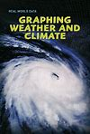 | 551.60 | 14277
Geog.123: Level 2: Student's Book | Gallagher, RoseMarie | Library | See sub section on Weather and climate page 22 | 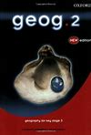 | 910 | 15818
Eyewitness Weather | Cosgrove Brian | Library | From hurricanes to droughts - be an eyewitness to Mother Nature Discover everything from why deserts are dry to what makes raindrops grow and how to put together your own weather forecast. | 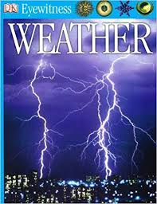 | 551.6 | 12899
Weather and Climate | Pipe, Jim | Library | This book explores Earth's weather: what happens and why it happens. | 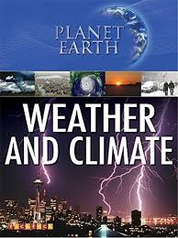 | 551.6 | 14218
Work of the Wind, The | Lambert, D | Library | Effects of winds, how and why they blow, and how they can be measured | 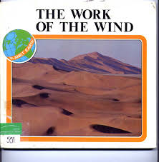 | 551.6 | 3019
Air, Water and Weather | Pollard, M | Library | The nature of air and water and such aspects of weather as wind, rain, snow and thunderstorms |  | 551.5 | 2920
Tsumanis | Spilsbury, Richard | Library | Natural disasters - uses a case study approach to investigate the devastating effects of natural phenomena. | 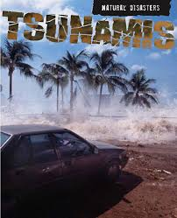 | 551.46 | 14247
Weatherbirds | Dewan, T | Library | An atmospheric journey by Captain Goose explains the origins and effects of the weather in an unusual and entertaining way. | 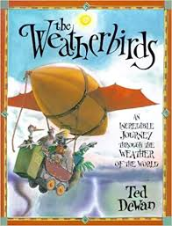 | 551.5 | 9034
Storm | Whipple, A B C | Library | Planet Earth Series books examines the workings of the planet Earth, from the geological wonders of its continents to the marvels of its atmosphere and its ocean depths. This book describes and explores thunderstorms, super storms, tornados, hurricanes, blizzards, cyclones, weather forecasting rainstorms, and some of the biggest weather events in history. | 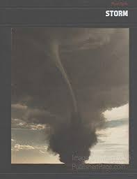 | 551.55 | 4053
Exploring Weather | Catherall, E | Library | Taken from a series which is aimed at the National Curriculum Science 5-16 levels 3 to 6, this book looks at weather. It contains a detailed description of the development of weather, and discusses the importance of weather in our lives, how it is predicted and the range of weather on our planet. |  | 551.5 | 5486
Weather and Climate | Purvis, G | Library |  |  | 551.5 | 2906

Other web sources

Met office links
https://www.metoffice.gov.uk/weather/learn-about/met-office-for-schools/resources-for-11-14

Weather Warnings
https://www.metoffice.gov.uk/weather/warnings-and-advice/uk-warnings#?date=2020-06-26

Extreme Weather
https://www.metoffice.gov.uk/weather/learn-about/met-office-for-schools/themes-for-11-14/extreme-weather

Exploring extreme weather DIY activity
https://www.metoffice.gov.uk/weather/learn-about/met-office-for-schools/other-content/exploring-extreme-weather-diy-activity

Technology and innovation in weather
https://www.metoffice.gov.uk/weather/learn-about/met-office-for-schools/themes-for-11-14/technology-and-innovation-in-weather

Bringing date to life
https://www.metoffice.gov.uk/binaries/content/assets/metofficegovuk/pdf/weather/learn-about/met-office-for-schools/diy-activities/bringingdatatolife_diyactivitypack_final.pdf

