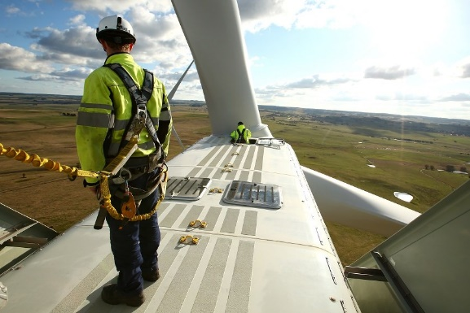
Job title: Wind Turbine Technician
Job title: Wind turbine technician  Renewable energy technician | Wind turbine technicians maintain and repair wind farm turbines on land and at sea.
Entry requirements: | University:  You can do a foundation degree, higher national diploma or degree in:  - renewable energy engineering  - electrical or mechanical engineering  - electrical power engineering  You'll usually need:  - 1 or 2 A levels for a foundation degree or higher national diploma  - 2 to 3 A levels for a degree  College:  You can do a college course, which can help you to get a trainee job with a wind turbine engineering company. Courses include:  Level 3 Certificate in Mechanical or Electrical Engineering  Level 3 Diploma in Maintenance Engineering Technology  You'll usually need:  5 GCSEs at grades 9 to 4 (A* to C), including English, maths and science  Apprenticeship:  You can do an engineering technician, or maintenance and operations engineering technician, advanced apprenticeship.  You can also complete a higher apprenticeship in manufacturing engineering: wind generation.  You'll usually need:  - 5 GCSEs at grades 9 to 4 (A* to C) including maths, English, science, design and technology, or equivalent qualifications, for an advanced apprenticeship  - 4 or 5 GCSEs at grades 9 to 4 (A* to C) and A levels, or equivalent, for a higher or degree apprenticeship  Work:  You can apply directly for jobs if you've got qualifications and experience in electrical or mechanical engineering from another industry, or from the armed forces.  Career tips  Demand for wind turbine technicians is predicted to grow over the next 10 years, with older wind farms being replaced or refurbished, as they come to the end of their working lives.
Skills required: | You'll need:  - the ability to use, repair and maintain machines and tools  - knowledge of engineering science and technology  - problem-solving skills  - to be thorough and pay attention to detail  - the ability to repair machines or systems  - knowledge of computer operating systems, hardware and software  - knowledge of maths  - the ability to work well with others  - to be able to use a computer and the main software packages competently
What you'll do: | Your day-to-day tasks may include:  - installing wind turbine towers on land or at sea  - fitting electrical, mechanical and hydraulic equipment  - testing turbine blades and control systems  - carrying out planned maintenance work  - finding faults and fixing them  - recording job details and filling in safety reports  - running safety checks on electrical substations and cables
What you’ll earn: | £23,000 Starter to £42,000 Experienced
Working hours, patterns and environment: | - 37-40 hours per week  - You could work on call occasionally  - You could work in remote rural areas or at sea.  - Your working environment may be at height and outdoors in all weathers.  - You may need to wear protective clothing.
Career path and progression: | You could become an authorised technician, with responsibility for supervising a technical team, and dealing with health and safety.  With further training, you could work as an operations and maintenance manager, control systems engineer or energy engineer.

