Women in Football

By Gemma Russell and Milly Whittle.

Professional footballers. Who comes to mind when you hear this phrase? Any women? We highly doubt so. Did you know that only 1 in 5 people think of women footballers first? Isn’t this wrong?

We feel like this is extremely unfair and that girls deserve the chance to be in the limelight for once! There are many girls who equal and better their male-counterparts- yet they get no recognition. 

This is the famous Jodie Taylor celebrating her goal, this lead to England Ladies being successful in the World Cup.

However, even though Jodie is celebrating, not many people join her. The stadium is never full, despite being significantly smaller than the men’s. The England Ladies Team aren’t even allowed to play at Wembley Stadium, even though many of the men’s games are played there.

Why don’t women get the opportunity to be as successful as men? Although some people think they deserve to be equal, many old-fashioned people believe it is just for men.

In a recent survey from FIFPro, which interviewed over 3000 women footballers, it was brought to light that almost two thirds of female footballers are not getting paid at all! Can you imagine 1 in 4 players in the Premier League having to buy their own kit?! Hard to imagine, isn’t it? Many women do have to buy their own kit, whereas men have the opportunity to get a free kit! This is absurd. We are supposed to live in a society bursting with gender equality; but when it comes to football this is simply not the case.

It would seem that female footballers are victim of a lack of exposure and respect, not only from the media but from society as a whole.

Maybe it is not just simply society attitudes but also the fact, that a predominately male sport is reluctant to share the limelight-for once! They don’t like to be overshadowed in a sport that they feel is theirs. Every match day they show the highlights and scores on a worldwide TV show called Match of the Day however they never show the women’s highlights or scores, how suspicious?!

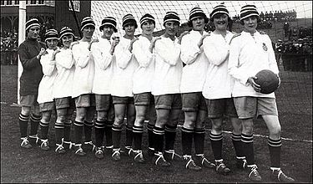Take the case of Dick Kerr ladies football team. An all-female football squad, in the 1950’s, who threatened the men and the FA by their amazing success and the huge crowds of over 50,000! The FA tried to implement a ban of them laying for 50 years; but after many protests, they gave in and allowed them to play. This attitude has existed for many decades since, with Britain lagging behind many other nations when it comes to women football.

With the FA now investing over 17 million into the sport, it is time to convert TV audiences into gate receipts. The sport itself needs better marketing, accessible grounds, sensible kick off times and a stronger grassroots movement. We feel that it is time that young girls get the chance to prove that they are just as good as boys and that they can look up to the positive role models.